

Rosary School – Marj Elhamam
Worksheet 4
Name: _________________ |  | Date: / / 2025
Grade: 5 (A, B, C, D, E) |  | Subject: Science
Question 1: Put a tick (✓) next to the processes that are reversible:
Melting Burning
Evaporation Dissolving
Rusting

Question 2: Will a block of ice melt quicker in a plastic dish or in a metal dish of the same size? Say why.
______________________________________________________________________________________________________________________________________________________________________________________________________

Question 3:
a. When Marcus pumps air into his football, the ball expands. Say why this happens.
__________________________________________________________________
b. What other change to the football could Marcus measure?
__________________________________________________________________
Question 4: Mike investigates how well materials conduct electricity. He connects different materials to an electrical circuit containing a lamp. He looks at the brightness of the lamp. Here are his results.
Material | Brightness of lamp in circuit
Lead | Lamp is very dim
Brass | Lamp is just brighter than when using lead
Copper | Lamp is bright
Plastic | Lamp does not work
Silver | Lamp is very bright
- Brass conducts electricity. Name one material that is a better conductor of electricity.
_____________________________________________________________
- Which material is the best conductor of electricity? _____________________________________________________________
Question 5:
Rita investigates electrical conductors. She uses different materials in an electrical circuit. She tested each substance three times.
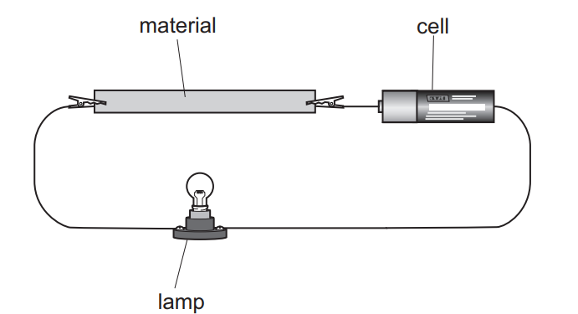
- Explain how she can tell if a material is an electrical conductor.
_____________________________________________________________
- Substances have properties. Complete the sentence.
Two different properties are electrical conductivity and _____________ conductivity.
- Are her results reliable? Explain your answer?
_____________________________________________________________

