

Rosary School – Marj Elhamam
Worksheet (2)
Name: |  | Date: / / 2025
Grade: 8 (A,B,C,D) |  | Subject: Chemistry

Question one:
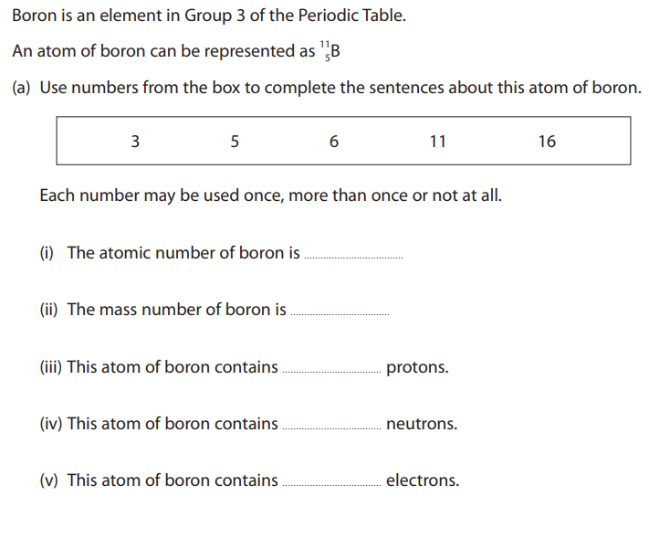
(b)
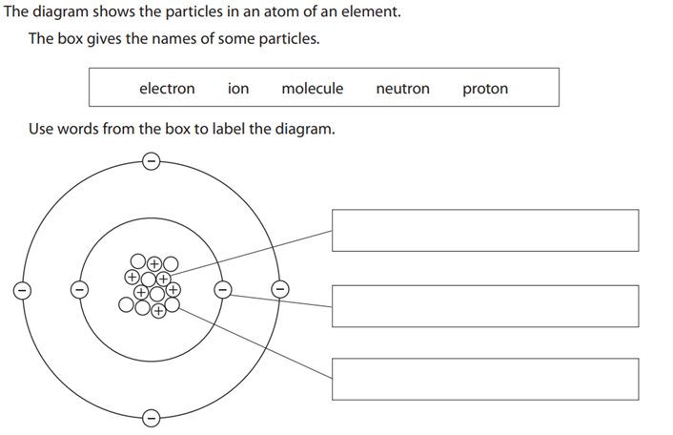
Question two:
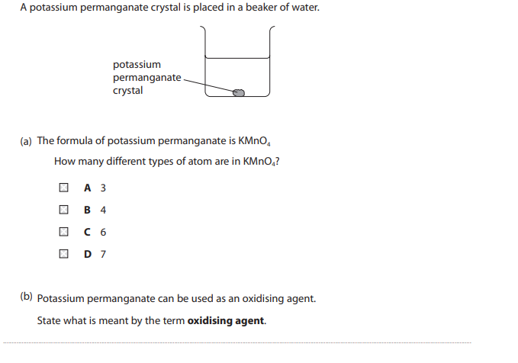 (c) In fireworks, magnesium powder reacts quickly with oxygen in the air.
During this reaction heat energy is produced.
- Explain why this reaction is exothermic in terms of bond breaking and bond making.
__________________________________________________________________
- Name the compound formed when magnesium reacts with oxygen.
__________________________________________________________________

Question three:
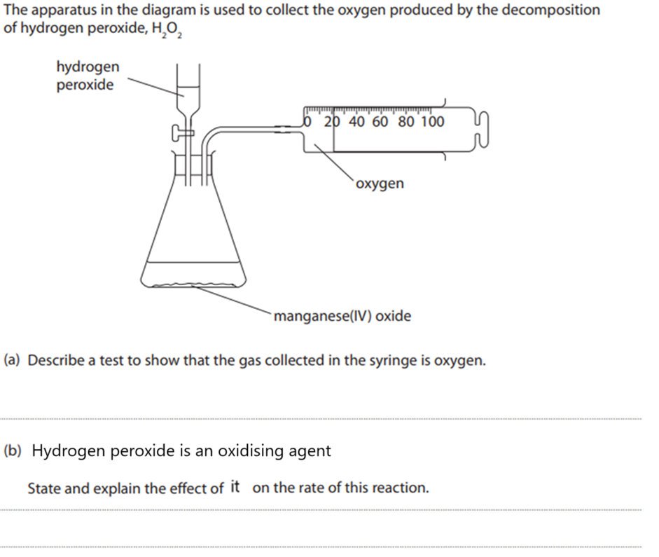
Question four:
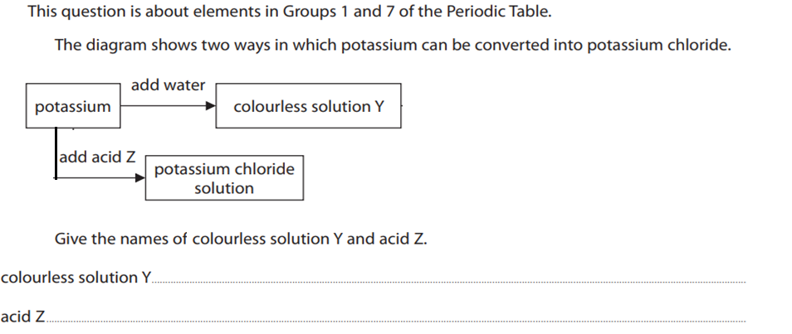

Question five:
