

International GCSE Business studies Cambridge code: (0450)
Teacher: Mr. Mohammad Salim
Section (2): People in the organization.

Disclaimer: this is only a summarization; use both the notes & the book

Managers are the individuals in the business who get things done, sometimes through other people.
What do managers do?
- Acting on behalf of owners
- Setting objectives
- Making sure objectives are achieved

The functions of management
- Planning: includes setting objectives and strategies, they get input from staff and use their experience and skills to achieve the objectives.
- Organizing: making sure the right people are doing the right job and that these people have the resources to get the job done
- Commanding: guide with concern, give instructions to achieve tasks efficiently, also includes the ability to promote, demote, arrange etc.
- Co-ordinate: bring the skills and experience of different departments together in order to achieve objectives.
- Controlling: monitor progress of work, make sure no problems occur, and if they do, know the best way to solve them and discipline staff

Leadership
A leader is a person who provides leadership and guidance to encourage the achievement of objectives and tasks.
Characteristics of leaders include
- Intelligence
- Adaptability
- Expertise in a variety of aspects
- Ability to solve problems
- Creativity

Terms to know
- Organizational structure: the way in which the positions are arranged and set up in the business
- Organizational chart: a map or diagram of the organizational structure
- Hierarchy: the different levels of the organizations and their levels of authority
- Chain of command: the line of authority of power that is passed down from upper to lower management of the business, it can be described as either long or short
- Span of control: the number of subordinates which work under the authority of a manager of supervisor, it can be described as wide or narrow
- Subordinate is a person who works under a manager or a person of authority in the company.
- Hierarchical structures can be flat or tall, which brings the topic of the affect of long/short chain of command and wide/narrow span of control on many consideration.
- Some considerations that we can derive advantages and disadvantages from on long/short chain of command, and wide/narrow span of control
- Time taken to deliver message
- Efficient communication
- Risk of demotivation and alienated workers (distance from upper management)
- Delays and its effect on the company’s operations.
- Ease or difficulty of delegation.

Tall structures allow for more formal operations, less likely to commit mistakes, communication is structured and targets are achieved, however, workers who are at the bottom of the organizational structure are likely going to feel demotivated since there is lack of communication and care from upper management due to the distance between them, although communication is structured, the message may take a long time to reach the lower levels or be distorted or even not reach at all, this affects how workers produce and how they reach deadlines, not to mention they operate mostly on an autocratic leadership, which is more strict and doesn’t allow for delegation, workers have more limited skills and are not as experienced or attainable of growth, since it is more democratic, it might be time consuming to involve all workers in decisions.

Flat structures have more people in each department (wider span of control) so it allows the manager to give tasks (delegate) and reduce his/her stress, messages are also received much more quickly due to the closeness between levels (short chain of command), workers will feel more valued and increase their efforts and motivation, however having many workers per department can create conflict, and require more managerial staff to be hired adding costs, also if any workers make mistakes, the manager is responsible for corrections.

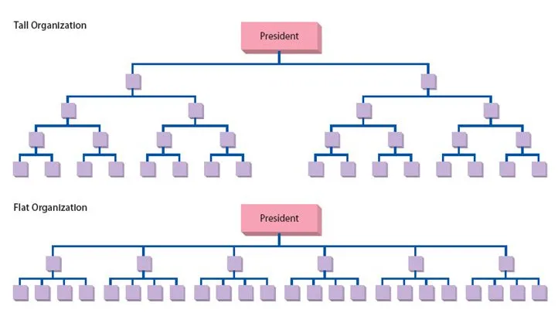

      - Tall structure has many levels in the organization, it is distinguished by a long chain of command and a narrow span of control
      - Flat structure has few levels in the organization, it is distinguished by a wide span of control, and a short chain of command

      - an approach to fixing problems arising from narrow, tall hierarchical structures include delayering
      - delayering is removing whole layers of management to create shorter structures.
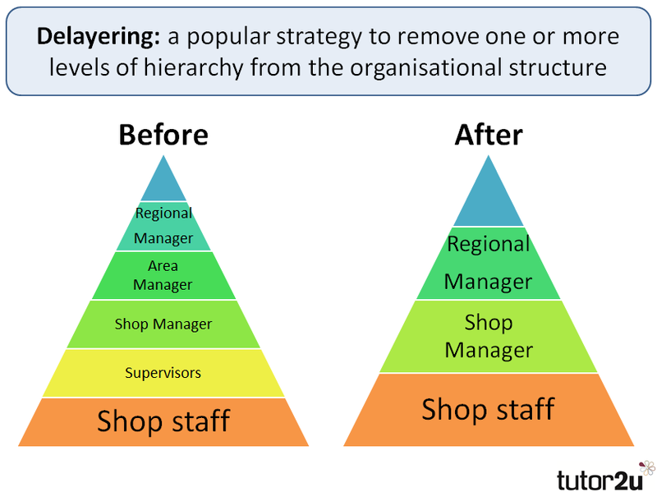

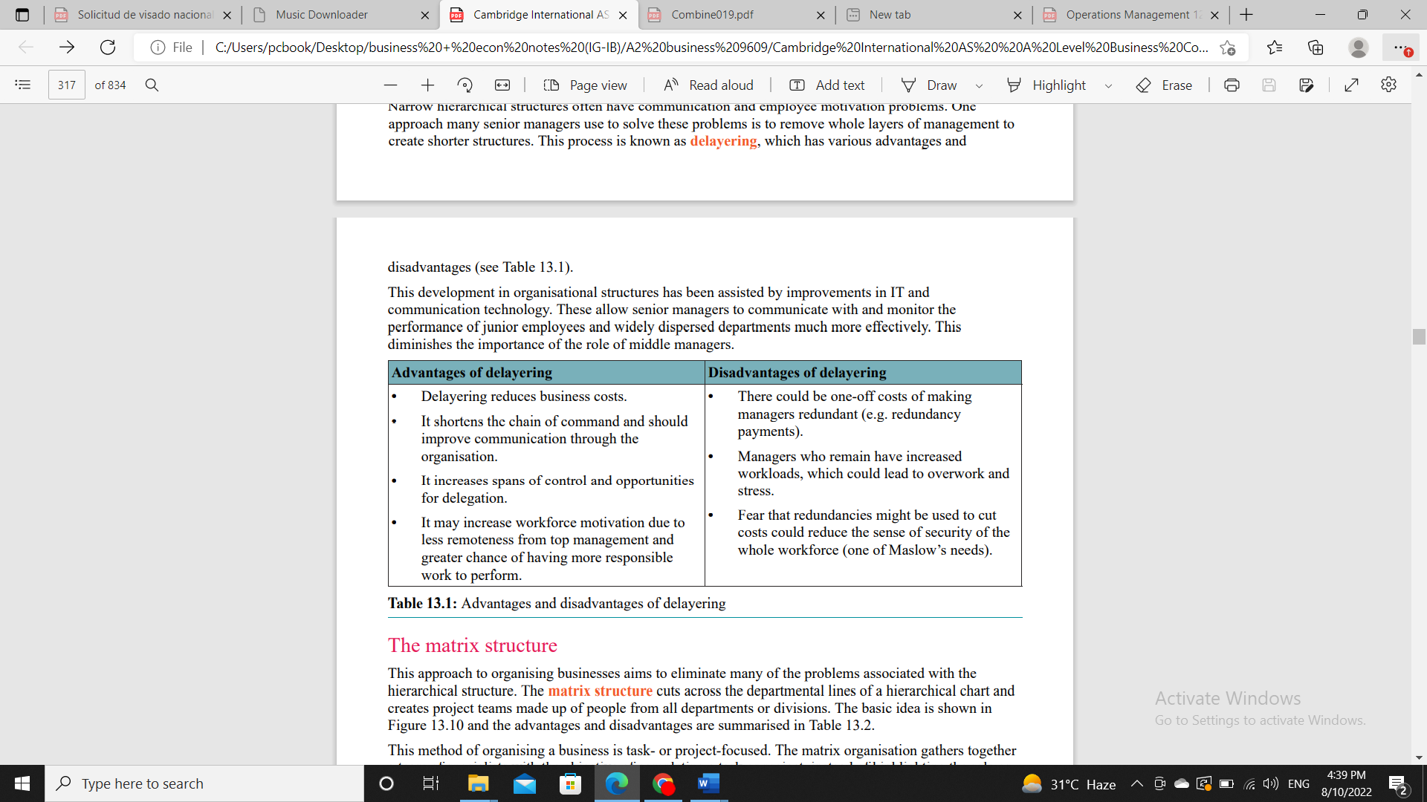

Leadership styles
- Autocratic (centralized): this is when a manager is responsible for all decision making, the manager sets objectives and instructs workers on how to help achieve them, there is little to no delegation (giving authority to do certain tasks) and workers are expected to obey orders, there is no two-way communication, only one way

Advantages to autocratic leadership:
- fewer mistakes because workers are not given much authority to do tasks
- workers may be strictly monitored to hit the target production instead of being left to work at their own pace.
- Quick decision making since the manager is the only party involved in decision making

Disadvantages of autocratic leadership:
- the manager may be stressed and overworked because he is responsible for all decisions and tasks
- the subordinates (workers who report to the manager) may feel mistrusted because they are not given any chance for recognition and achievement
- they may have low skills as a result because they don’t do a lot of tasks and will not be efficient
- lastly the productivity can fall if workers get sick of the job and start being more absent or quitting (labor turnover).
Democratic leadership style (decentralized): it is when subordinates are encouraged to give feedback (two-way communication) and are allowed to do specific tasks because the manager is delegating them more responsibilities.

Advantages of democratic leadership:
- workers are more motivated because they feel important and trusted by managers, they will likely be more loyal to the company, and will not quit or give out company secrets, therefore labor turnover and absenteeism will be low
- since workers are motivated, their productivity is higher, so customer satisfaction may improve
- and problems can be solved due to the increased experience and responsibilities of managers
- the manager will be less stressed because he/she will have less tasks to worry about.
Disadvantages of democratic leadership:
- decision making will take longer than autocratic because the manager takes the opinion of all workers and host meetings instead of making the decision on his own
- mistakes can occur because workers are delegated tasks but are not as experienced and skilled as the manager
- the manager is responsible for all mistakes made by the subordinates because he/she is in charge.

Laissez-fair leadership style: this occurs when managers provide little to no interference, employees are encouraged to work freely and at their own pace, they do not have as much rules and limitations as other leadership styles.
Advantages of laissez-fair:
- it can lead to high motivation because workers feel trusted
- workers can be less stressed because managers are not pressuring them to be productive.
Disadvantages of laissez-fair:

- some employees may take advantage of the lack of supervision and not be productive which can cause delays and wastes, increasing costs.

Motivation
Motivation is the reason employees work hard and effectively for the company; it helps initiate goal-oriented behaviors by stimulating the desire to take actions to achieve these goals
Advantages of good motivation:
- Increase in productivity
- Fewer mistakes
- Higher quality
- Less wastes of materials, decreases cost and reduces profit margin
- Increases employee loyalty, which reduces absenteeism and labor turnover

Disadvantages of low motivation
- Productivity decreases
- Mistakes will be made affecting quality, reducing customer satisfaction
- Waste of time and material, increasing costs and lowers profit margin
- Absenteeism and labor turnover will increase.

Motivation theories
- the first motivation theory is the scientific management theory by Fredrick Taylor (F.W Taylor): he believed money was the factor that motivates workers the most to work hard (theory of the economic man), so he divided their work to smaller tasks so he can measure how much time it took to complete the task.
Advantages: helps set output targets and pay workers piece rate (payment for each unit produced by the worker), it also increases productivity which can stimulate an increase in sales.
Disadvantages: not everyone is motivated by money, some people like other things such as recognition and job security, or health insurance

- another motivation theory is by Abraham Maslow, he constructed a hierarchy/pyramid of needs, the lower levels must be achieved before the higher levels can be accomplished, this can indicate for managers which level each worker is in and how best to motivate him/her

- Frederick Herzberg proposed a theory that he believed humans have two sets of needs which are called the hygiene/maintenance factors and the motivators, hygiene factors must be achieved first, if they are not satisfied the worker will not be motivated and prevented from achieving the motivators.
- Below is a diagram of Herzberg’s two sets of needs and compared with Abraham Maslow’s hierarchy of needs.

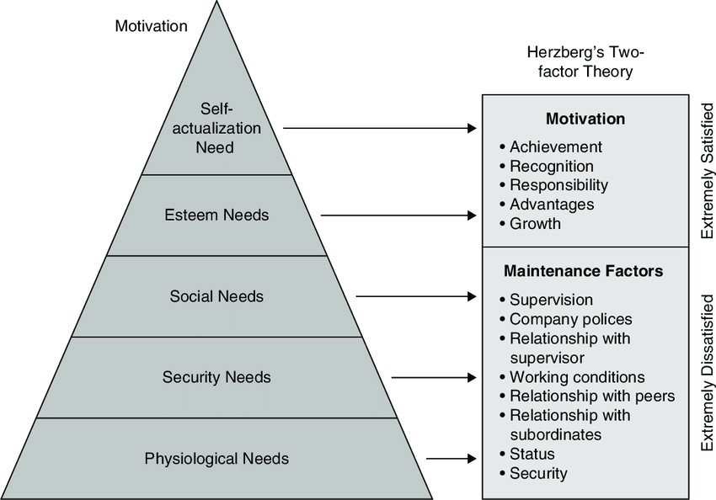

Employee payment & financial methods of motivation
Financial rewards are monetary payments that are provided for work completed.
- Wages: fixed sum usually paid weekly,
advantages include workers not waiting a lot to get paid so they are easily motivated and satisfied, the worker is also happy because they get paid regardless of performance, disadvantages include paperwork because it is calculated weekly, also workers who work extra are paid over-time which is added cost to the company.
- Time-rate: a fixed hourly rate that is multiplied by total hours worked
Advantages include how easy it is to calculate time rate, workers also get paid regardless of their performance
Disadvantages include time to calculate, and overtime payments.

- Piece-rate: workers are paid a fixed rate for each unit produced.
Advantages include it being easy to calculate, workers will increase productivity to earn money, and there is no overtime so less costs for the company.
Disadvantages include more mistakes because workers only care about speed in production to earn more money, quality may fall which will negatively affect customer satisfaction, some workers will not be as fast and be paid less, they will feel it is unfair and it will reduce morale and can cause problems and arguments.
- Salaries are a fixed wage paid monthly
Advantages include easy to calculate, can be deposited into banks to reduce paperwork, no overtime payment.
Disadvantages include workers potentially being lazy or in-efficient, because their pay isn’t linked to productivity or efficiency.
Financial rewards that are added to the basic salary
- Commission: involves sale staff, it is a percentage of sales revenue made by a salesperson.
Advantages include sellers working harder to gain commission, so increased sales occur because workers want more money, profits and market share can rise.
Disadvantages include workers possibly resulting to write fake sales receipt, sellers may be too pushy and force customers to buy something which can lead to returns and customer dis-satisfaction, during recessions or slow seasons, demand is reduced and sellers will feel stressed because they are not earning as much money.
- Profit-sharing is when employees are paid a sum of the company’s profits, usually a percentage of a worker’s salary
Advantages include increased productivity because workers will be more efficient to earn more profits, communication between departments will improve because as a team the company will make more profits,
Disadvantages include reduced profits to be distributed to shareholders as dividends, they can become dis-satisfied and vote for another board of directors at the annual general meeting, reduced profits can also affect plans for expansion.
- Bonus is a sum of money given to workers when they work well, the company needs to be profitable to handle giving bonuses without losing money.
- Performance related pay is payments given to workers based on the effectiveness of their work
- Share ownership is when employees are given shares of the company.
- Advantages and disadvantages for bonuses, performance related pay, and share ownership are the same as profit sharing.
Non-financial rewards
These are non-monetary rewards offered to workers in addition to the financial rewards.
- Fringe benefits: non-financial rewards that have monetary value such as free healthcare.
- Job satisfaction: the enjoyment derived and received from doing a job well
- Job rotation: learning a variety of tasks involved in the job then switch to another, it relates to division of labor.
- Job enlargement: giving employees extra tasks in the same level of ability
- job enrichment is giving workers more tasks that require greater skills
- Job re-design: reorganizing tasks and duties to make it more interesting and exciting for the workers than repetitive, it can include job rotation, enlargement, and enrichment
- Empowerment: giving skills and authority to make workers satisfied and motivated, this includes delegation and making them responsible for actions and tasks.
- Teamwork: combining skills with fellow colleagues to achieve goals
- Participation: allowing workers to be involved in decision making, (2-way communication) and related to democratic leadership.
- Quality circles: employees meeting regularly to discuss work related problems.

Trade unions
is a group of employees who have joined together to ensure their interests are protected

advantages to the worker
- Negotiate better potential pay
- negotiates working conditions
- add power in number (collective bargaining), communication with management, strength, and value as an employee.
- Can gain benefits from the union, such as discounts, social relations, connections and networking
- Helps with advice and consulting on what actions to take
- Encourages industrial actions to prevent workers from being made redundant.
Disadvantages to the worker
- include potential need for industrial actions, and may cause even bigger conflict with the company.
- the risk of low morale, discomfort around superiors due to some disagreements that may have been solved through trade unions
- it can be expensive or pressuring to join a trade union.
Advantage to the company
- include better communication and higher productivity of workers influencing the flow of work through less mistakes and reduced delays
- the company can use the trade unions actions as advice or guide on their operations
- negotiations may be less time consuming as the company negotiates with one party rather than many workers.
Disadvantages to the company
- potential strikes or industrial actions would ruin the company’s reputation
- additional pressure both financially and ethically to fulfill demands

- Part time workers are employees who work less than the standards 40 – 45 hour work week
- Full time workers are employees who work a full work week, typically between 40-45 hours.

Advantages of full-time workers
- Available at all times, so the customers are always satisfied
- Paid more, making them more motivated
- More experienced, so they can handle problems better
Disadvantages of full-time workers
- Because of their higher wages, labor costs rise
- The company must pay fringe benefits and other rewards, more costs
- Workers work many hours, adding to their stress and overwork

Advantages of part time workers
- they work less hours so they are less likely to make mistakes due to being tired
- they are paid less, so the company saves money
- they don’t earn fringe benefits; the company can use excess cash on other business activities

disadvantages of part time workers
- they are not available at all times, so the company can lose sales and suffer delays
- they are not as experienced so their skills may be limited causing wastes
- most part time students are young students or parents and may have other responsibilities, causing a lack of loyalty to the company (absenteeism and labor turnover may rise)

Human resource management (HRM)
It is the system used by companies to manage those inside the organization and ensure maximum performance; HRM is involved in 3 roles
- Staffing
- Employee compensation
- Defining work
What are HRM’s objectives: minimizing labor costs, maintaining good relationship between workers and managers.
Productivity and effectiveness
Labor productivity: output per worker
Capital productivity: output per machine
Calculation: total output/number of employees

Absenteeism: the number of days a worker is absent in a period of one year, it can be negative because other workers must fill in for you, which will make the other workers stressed and overworked, causing poor quality, also if you cannot find other workers, production may stop and cause customer dissatisfaction.
Labor turnover: the percentage of staff who leave/quit the company over the span of one year, it can be negative because, recruitment costs are high, and new workers will take longer to be trained and get used to the company, new workers will be less productive at first because they are still learning and can cause increased costs and lower sales, a company will be known for its bad reputation if workers are always quitting.

Why do workers become absent or quit? Some reasons are:
- Low wages
- No benefits
- Lack of training
- Poor working conditions
- Lack of job security and satisfaction
- Low motivation

Communication

Communication is the process of transferring a message from the sender towards the receiver.

- Communication can be internal or external.

Internal communication occurs between members within the same organization, it can be useful for communicating instructions, policies, and tends to show improvement in efficiency, discipline, and a reduction in errors.
External communication occurs between the organization and other organizations and/or individuals, this provides a potential promotional and communication ability with external stakeholders such as customers and suppliers etc.., improving relations and satisfaction
- General improvement in communication tends to reduce delays, and improve chances of success and misunderstandings and conflicts are resolved and/or eliminated.

The process of effective communication includes a number of variables
- A transmitter or sender: the person starting the communication process by issuing the message.
- A medium of communication: which Is the method used for sending the message such as email, text, call.
- A receiver of the message: which is the person who the message is intended for and should be sent towards.
- Feedback refers to the response by the receiver, it can indicate the message has been sent, received, understood, and may even be acted upon.
one-way communication is when the sender sends the message and does not expect to receive any feedback
two-way communication is when the sender expects feedback from the receiver, it encourages participation and allows for confirmation if the message was received and understood.

Methods of communication
- Verbal: oral communication such as face to face, telephone, and video conferencing
It is a good way to meet with larger groups and can be less time consuming than sending each workers a message, body language and tone can be shown and provides more clarity than other methods of communication, feedback is immediate (two-way), employees may feel more cared for and less alienated improving motivation.
However not everyone may be listening, and with no ability to save or go back to the message, delays and conflicts can occur, especially if the message was too long, the time may not be enough to host meetings and will interfere with regular operations and business activities.

- Written: when the message is written by letter, memos, email, or other forms that allow for types content to be sent.

There is evidence for the message and can be referred to if it was forgotten, policies and laws are more appropriate to be issued in messages for all to read, it can be copied and sent to larger groups, if any details are complicated, it can be written down and simplified.

However language may be unclear if it is too long, includes foreign languages, or S-lang (short-language) or jargon, feedback is typically not given unless it is requested, furthermore, body language and tone is not present, causing potential misunderstandings about mood and attitude of the sender.
- Visual: forms where the message is seen by receiver such as signs, posters, charts.
It can be more appealing and easier to remember, it is effective for shorter messages than meetings or written forms, it can clarify written messages when using graphs or other visual tools, such as using breakeven or diagrams.
However there is no feedback so there cant be a guarantee that the message is understood, and some types of charts are not easy to understand for some individuals and group.

Barriers to communication
- in some cases there can be a failure in one or more parts of the communication process, this prevents effective communication, therefore the message is misunderstood, not received or not acted upon.

- Communication can be vertical (upward/downward) and horizontal

- Upward communication is the communication of subordinates with upper management, the message goes upward in the organizational structure.
- Downward communication is the communication of superiors or people in higher levels in the organization with individuals or groups in lower levels
- Horizontal communication is the communication between parties in the same level within the organizational structure.

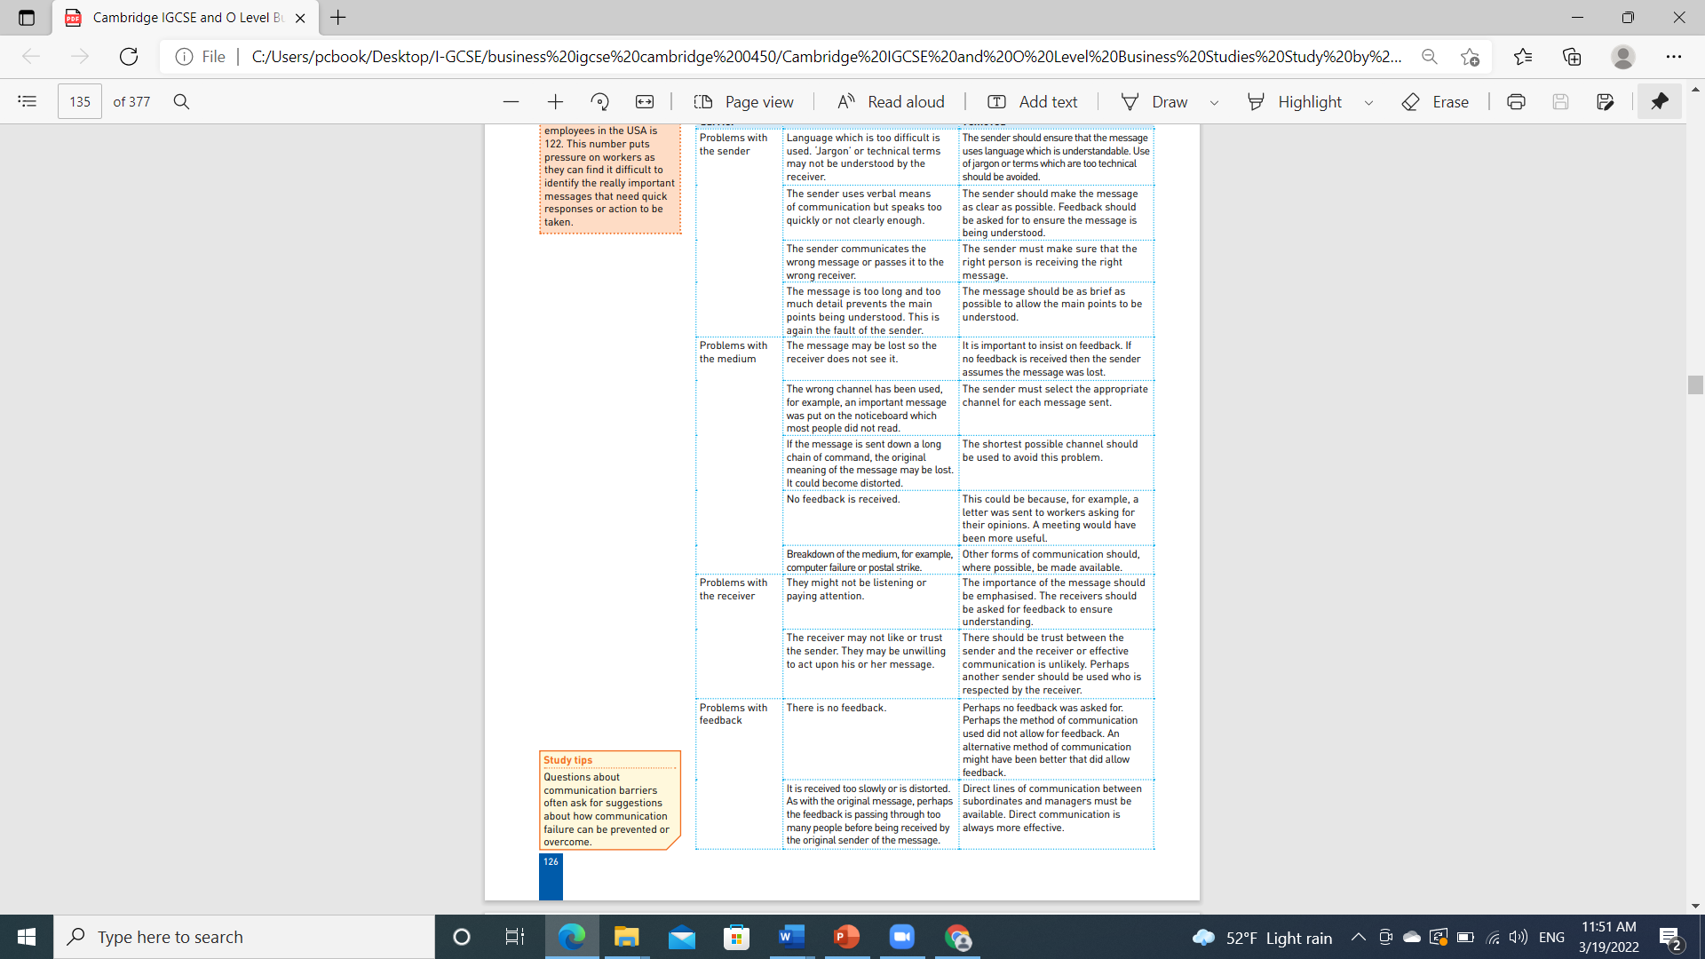

Recruitment process
Recruitment: the process of attracting candidates for jobs and selecting the most suitable. It can provide an advantage if done right because the right workers will help the company achieve their objectives, HRM are responsible for recruiting workers.
Internal recruitment is when a worker is hired and appointed from inside the business
Advantages include: the worker is already known, so there is less surprises, furthermore, recruitment cost and time consumption are decreased.
Disadvantages include: jealousy between workers could occur because some workers will be promoted over others, decreasing morale, new ideas are limited because the worker is already known.
External recruitment is when a worker is hired from outside the company, the position is advertised on newspapers or and magazines
Advantages include: newer ideas, potentially more experience,
Disadvantages: the new worker may not work well with existing employees, causing conflicts, hiring has expensive advertising and labor cost.
Steps of recruiting a work
- Carrying out a job analysis, this explains the skills and tasks required to do the job
- Job description is a document that states the tasks that employees are responsible for,
- Job specification identifies the characteristics and education and experience that best fits the position.
- Job advertisement: a notification that informs people of the job opening/vacancy, it can include information about the requirements and duties needed and can be made both internally (inside the company) and externally (newspapers and internet)
- Application: filling of forms by candidates and are collected by HRM, they review it and choose the best and invite them for interviews.
- An interview is when the potential recruit it called in for a meeting to determine if he/she is a good fit for the position/company, HR asks detailed questions.
- would later select their best fit for the position and offer them an employment contract

An employment contract is a written agreement between the employee and the employer, which states the terms of employment, it can also include the wage/salary of the worker, and other information such as responsibilities and benefits, in addition to sick days etc.
In more detail , it includes:
- Name of employer
- Name of employee
- Date of employment
- Amount to be paid to employee
- Number of hours expected to work
- Job title and responsibilities
- Days of holidays
- Period of notice (time to give before the employee wishes to leave the company)
- Grievance and disciplinary procedures

Advantages of a contract: it doesn’t allow the employee to suddenly leave/quit, it prevents employee from giving out company secrets, gives the employer control over employee
Disadvantages of a contract: both parties are bound to the contract, the contract usually implies that the employer will act in good manners and professional ways but that is not always the case.

Termination

Termination: refers to an end of an employee contract, it can be ended by both parties and below are the reasons of termination
- Changing job/promotion: if a worker finds a new job and decides to leave (resignation) from the company, he/she will hand in a letter or resignation stating the intent and reason, a “Notice” must be given to give the business enough time to find a suitable replacement, if the worker was promoted, he will still terminate the old contract and begin a new one.
- Dismissal: an employee is fired, and reasons for that include inability to do job at the optimum ability, even after training, or breaking company policies/breach of contract, or problems that make it hard for him/her to work well with others, criminal activity, or any poor behavior that can cause poor reputation and negative effect on the company
- Redundancy: this is when employees are let go because the company is unprofitable and at risk of going out of business or voluntarily shutting down, and can no longer keep or afford the workers to stay.
- Retirement: some employees leave work to retire at certain ages, they retire voluntarily in most cases, some workers work longer years over the retirement age while some work less.
- Legal controls are rules provided in many countries to ensure improved relations with employers and employees and protection of workers under these conditions.
- employment contracts
- unfair dismissal
- discrimination
- health and safety
- legal minimum wage

Training
Training is the process in which both new and existing workers develop new skills and improve existing skills and knowledge in order to increase awareness and improve behavior.
Purpose of training:

- Reduce risk of accidents
- Increase employee value
- Increase opportunities for advancement
- Reduce need for supervision
- Introduce new policies/machinery/techniques etc.
- Improve productivity and reduce mistakes/wastes

- Training leads to specialization, which refers to a focus or emphasis where an individual, group, or organization focuses on a task or product through repetitive work.

Types of training
- Induction training: this is for new workers, they are given a tour and introduced to the company, policies and techniques are explained, the workers meets his/her colleagues and supervisor, it can be one day or several days

Advantages of induction training:
- the worker feels welcomed and it may reduce stress
- he/she will learn about the company from the first day and can ask question to clarify any problems

Disadvantages of induction training: training period may not be enough for learning and attaining useful info.

- On the job training: this is when the worker is trained by an experienced employee during working hours.

Advantages of on-the-job training:
- less expensive than off the job training because there is less costs of sending the worker to a training facility and hiring trainers
- in addition, it is usually one on one so its quick and efficient

Disadvantages of on-the-job training:
- the productivity will be low at first because the employee is still learning and not skilled
- In addition to the fact that the trainer may pass on poor technique or teach the worker wrong.

- Off the job training: this is when the employee is sent to a training center to learn the necessary skills.

Advantages of off the job training:
- the employee may be introduced to more people from outside the company and would learn new ideas that can benefit them and the company,
- the environment is more professional and can be more suitable for complex skills than the place of employment,
- Training is usually done at night so their productivity and job will not be affected.

Disadvantages of off the job training:

- it can be expensive because the company is responsible for paying the training fees and transportation
- The employee may learn data that is not useful, and it would be a waste of training.

