
Rosary School – Marj Elhamam

Physics Quiz
No. of Pages: (4) | No. of Questions: ( 2 ) | Mark: (______/ 14 )
Name: _________________ |  | Date: 27/ 9 / 2025
Grade: 9 ( ) |  | Duration: 15 min.

Question 1: ( / 10 )
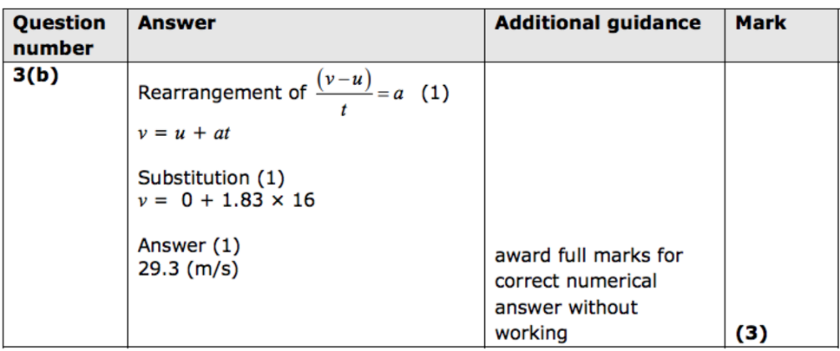
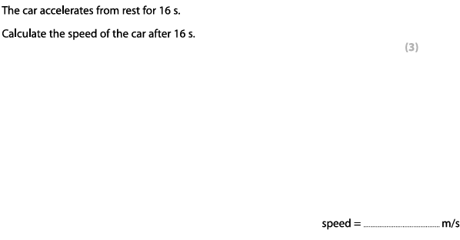

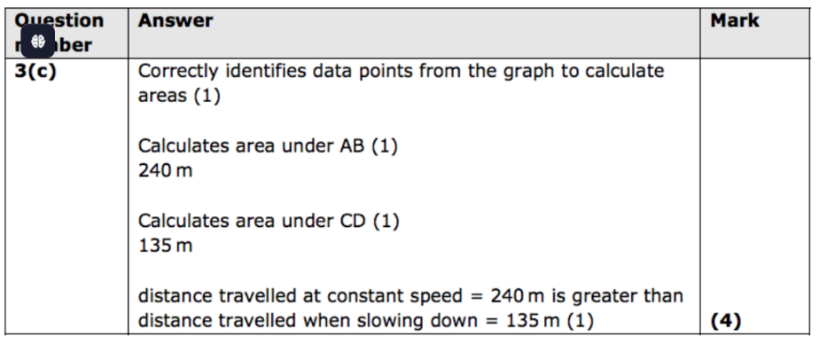
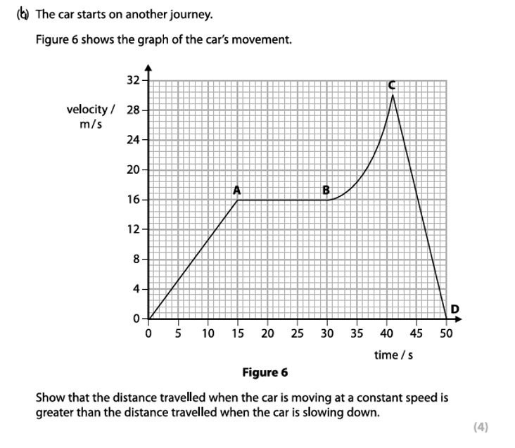

(c) Explain from the graph the motion of the car between B and C. [3]
changing / increasing acceleration
Gradient = acceleration
Changing gradient
Increasing gradient
Question 2: ( / 4 )
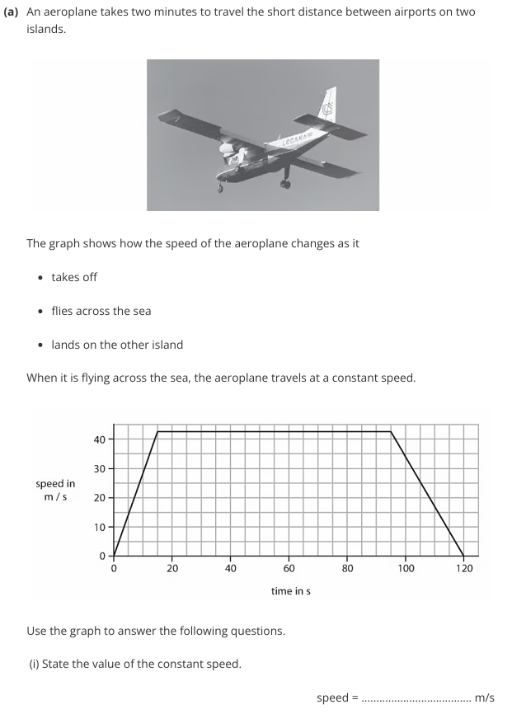
42.5 (42 – 43)
[1]

(c) Calculate the acceleration as the airplane lands on the other island and state its unit.
0 – 42.5 / 25
= -1.7 m/s²
[3]

acceleration =……………………….. unit ………………..

Teacher : Zeina Abu Manneh

