2.3 Reversible changes
Getting started p49
1 a The ice has started to melt
2 Heat causes the ice to melt because it makes the particles in the ice move faster and further apart until they have enough energy to become a liquid.
3 If we put the melted ice back in the freezer it will become solid ice again because it loses heat energy. As the particles in the liquid lose heat energy, they slow down and move closer together until they form a solid.

Questions P50
1 We can make solid jelly become liquid by heating it.
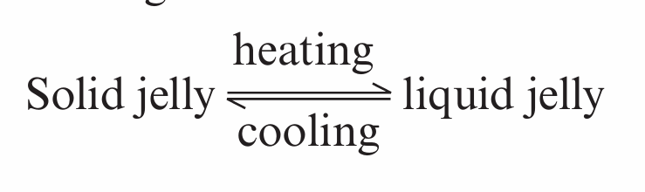
2 An irreversible change. The liquid egg white and yolk become solid and cannot be changed back to liquids.

Activity P52: Describe dissolving
1 The copper sulfate – I can see it spreading out in the water.
2 The water
3 Learners’ drawings should show a uniform solution.
4 the solute particles move and spread out between the solvent particles until they are evenly spread.
5 Dissolving is a reversible change. We can get back the solute by evaporating the solvent. We can change the evaporated solvent back into a liquid by allowing it to condense on a cooler surface.

Think like a scientist 2 P54: Does water temperature affect the rate of dissolving?
1 a the sugar dissolves more quickly in the jar of hot water. The hot water makes the particles move faster so the solute and the solvent particles come into contact with each more quickly.
b yes
2 The same amount of solute and solvent were used in each test, only the water temperature was changed. Stir both solutions the same number of times.
3 A solute dissolves faster in hot water or that heat makes a solute dissolve faster.

Questions P54
1 How fast a substance dissolves
2 Stirring and temperature
3 a Heating makes the particles of the solvent move faster and spread out more. When the solute is added to the heated solvent, the solute particles also gain heat energy and move faster.
b The solute particles spread out and move more quickly into the spaces between the solvent particles. This makes the solute dissolve faster.
4 The sugar will eventually dissolve because the movement of the water particles and sugar particles will bring enough of them into contact with one another, so that the sugar particles can spread out between the water particles without stirring or heating the solution.

