 |   Rosary School – Marj Elhamam  Worksheet 1 | 
Name: _________________ |  | Date: / 9 / 2025
Grade: 7(A,B,C,D,E)

Q1: Circle the correct answer:
- Which of these is digested by protease?
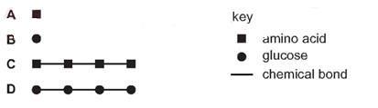
- Which disease can be caused by a deficiency of vitamin C in the diet?
a-anaemia b-kwashiorkor c-scurvy d- rickets
- Solid food enters the mouth at P and enters the oesophagus at Q.
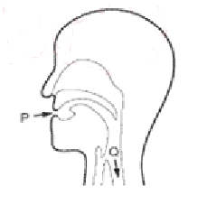
How does the food at Q differ from the food at P?
- It contains less fibre.
- It contains less vitamin D
- It contains less protein
- It contains less starch

- Poor nutrition can lead to a condition called rickets in which bones fail to develop properly.
The table shows some minerals and vitamins present in four foods.
Which food would be best for a child who has rickets?
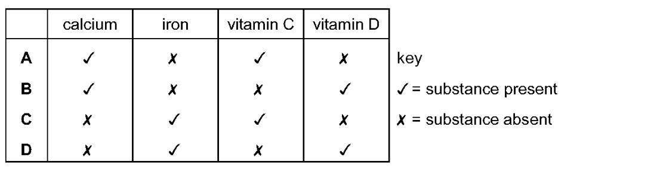
- What is the function of the anus?
- Assimilation b- digestion c- egestion d- excretion

- The following symptoms can be caused by a dietary deficiency:
Bone pain, fragile bones and skeletal deformities
A lack of which nutrient is most likely to cause these symptoms?
- Iron b-protein c-vitamin C d- vitamin D

- In which structure does faceas storage occur?
- Liver b- mouth c- pancreas d- rectum

- What is the correct order of the process that take place in the alimentary canal?
- Absorption, digestion, ingestion, egestion
- Digestion, ingestion, egestion, absorption
- Egestion, digestion, absorption, ingestion
- Ingestion, digestion, absorption, egestion

Question 2:
Q1: Look at the nutritional information on the food label below.
Typical values | Per 100 g | Per 175 g portion
protein | 2 g | 3.5 g
carbohydrates | 9.2 g | 16.1 g
of which sugars | 4.5 g | 0.5 g
fat | 1.8 g | 3.2 g
of which saturated | 0.3 g | 0.5 g
fibre | 2.3 g | - G

- What do scientists mean by diet?________________________________
- How many grams of carbohydrates are in 100 g of the food?_______________________
- How many grams of protein do 200 g of this food contain?________________________
- Calculate the grams of fat in two portions of the food.____________________________
- Give the names of two nutrients not found in this food.
________________________________________________________________________
- State three reasons why we need energy from food for?
________________________________________________________________________________________________________________________________________________________________________________________________________________________
- Give one reason why we need to eat fibre.
________________________________________________________________________________________________________________________________________________

Question 3:
- Enzymes are necessary for many biological processes.
Amylase is a digestive enzyme found in the small intestine.
Name the food nutrient that amylase digests and name the end product of this digestion.
Food nutrient: _______________ End product: __________________
- State two functions of the saliva.
_____________________________________________________________________
- Before food can be absorbed it should be digested. Explain why.
_____________________________________________________________________
Question 4: Fig. 4.1 shows a pie chart of a person’s diet.
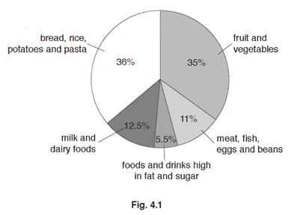
- Fat is an important component of a balanced diet.
Draw circles around two foods that are a good source of fat.
Beans butter pasta egg rice olive oil

- State the foods shown in Fig, 4.1 that are rich in protein and state why proteins are important to the body.
________________________________________________________________________________________________________________________________________________
- Only 5.5% of this diet is made up of food and drinks that are high in fat and sugar.
Describe one harmful effect of eating too much fat.
____________________________________________________________________

Question 5: Fig. 2.1 is a diagram of the alimentary canal.
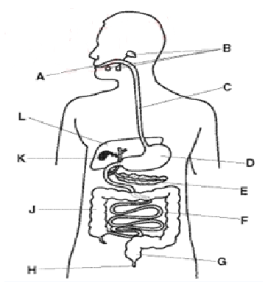
- Use the letters in Fig. 2.1 to identify where the processes occur.
Write the answers in the table.
Process | letter
Ingestion
Digestion of starch
Absorption of water
Egestion

