

Rosary School – Marj Elhamam
Unit 1: Chapter 4
Name: _________________ |  | Date: ____ /____ / 2025
Grade: 9( A,B,C ,D) |  | Chemistry Summary Notes

Periodic Table
Objectives:
- 1.18 understand how elements are arranged in the Periodic Table:
* in order of atomic number
*in groups and periods
- 1.19 understand how to deduce the electronic configurations of the first 20 elements from their positions in the Periodic Table.
- 1.20 understand how to use electrical conductivity and the acid-base character of oxides to classify elements as metals or non-metals.
- 1.21 identify an element as a metal or a non-metal according to its position in the Periodic Table.
- 1.22 understand how the electronic configuration of a main group element is related to its position in the Periodic Table.
- 1.23 understand why elements in the same group of the Periodic Table have similar chemical properties.
- 1.24 understand why the noble gases (Group 0) do not readily react
- Elements are arranged on the Periodic table in order of increasing atomic number. Each element has one proton more than the element preceding it.
-This is done so that elements end up in columns with other elements which have similar properties.
- The table is arranged in vertical columns called groups and in rows called periods.
- Period: These are the horizontal rows that show the number of shells of electrons an atom has and are numbered from 1 - 7
E.g. Elements in Period 2 have two electron shells; elements in Period 3 have three electron shells.
* Elements in the same period have the same number of electron shells but different number of electrons.
- Group: These are the vertical columns that show how many outer electrons each atom has and are numbered from 1 – 7, with a final group called Group 0 (instead of group 8)
E.g. Group 4 elements have atoms with 4 electrons in the outermost shell, Group 6 elements have atoms with 6 electrons in the outermost shell and so on…
- Moving down a group, the number of shells increases.
- Elements in the same group have the same number of electrons in their outer shell, but different number of electron shells.
Exam style question:
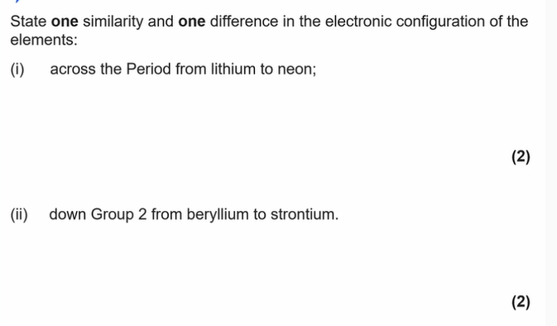
Exam Tip:
- The atomic number is unique to each element and could be considered as an element’s “fingerprint”
- The number of electrons changes during chemical reactions, but the atomic number does not change.
- Count across a period from left to right to get the correct number of electrons.

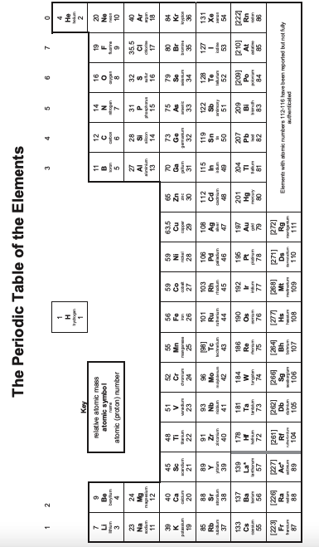

*Electronic configuration of the first 20 elements
- Electronic configuration is a way to show how the electrons are arranged in an atom.
- We can represent the structure of the atom in two ways: using diagrams called electron shell diagrams or by writing out a special notation called the electronic configuration (or electronic structure or electron distribution).
- Electrons orbit the nucleus in shells (or energy levels) and each shell has a different amount of energy associated with it.
-The further away from the nucleus, the more energy a shell has
-Electrons fill the lowest energy or innermost shell first (closest to nucleus).
Electrons are arranged in shells:
-The first shell can hold a maximum of 2 electrons.
-The second shell can hold a maximum of 8 electrons.
-The third shell can contain a maximum of 8 electrons.
-For the first 20 elements, once the third shell has 8 electrons, the fourth shell begins to fill.
- The fourth shell is slightly different & this model only works for potassium and calcium.
A simplified model showing the electron shells
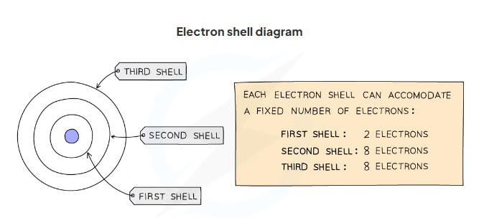

-The arrangement of electrons in shells can also be explained using numbers.
-Instead of drawing electron shell diagrams, the number of electrons in each electron shell can be written down, separated by commas.
This notation is called the electronic configuration (or electronic structure).
-The electronic structure of carbon is 6 electrons, 2 in the 1st shell and 4 in the 2nd shell.
So, its electronic configuration is 2, 4.
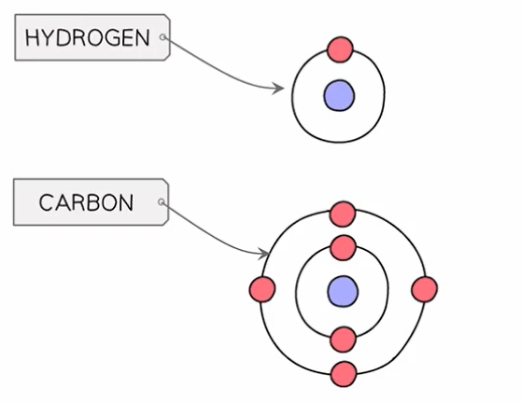
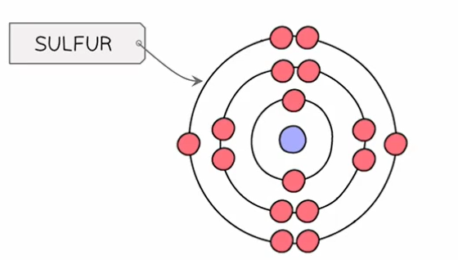

*You should be able to write the electron configuration for the first twenty elements
Element | Atomic number | Electronic configuration
Hydrogen | 1 | 1
Helium | 2 | 2
Lithium | 3
Beryllium | 4
Boron |  | 2,3
Carbon | 6
Nitrogen | 7
Oxygen | 8
Fluorine |  | 2,7
Neon | 10
Sodium | 11
Magnesium |  | 2,8,2
Aluminium | 13
Silicon | 14
Phosphorus | 15
Sulfur | 16
Chlorine | 17
Argon | 18
Potassium |  | 2,8,8,1
Calcium | 20

Note:
** The number of digits in the electronic configuration is the number of electron shells and the actual digits is the number of electrons in each shell.
Exam Tips:
1) You should be able to represent the first 20 elements using either electron shell diagrams or written electronic configuration.
2) Double check that the electronic configuration adds up to the atomic number of the element.
Question:
Draw diagrams to show the arrangement of the electrons in:
1) F 2) Ne

3) K 4) Ca

Exam style question:
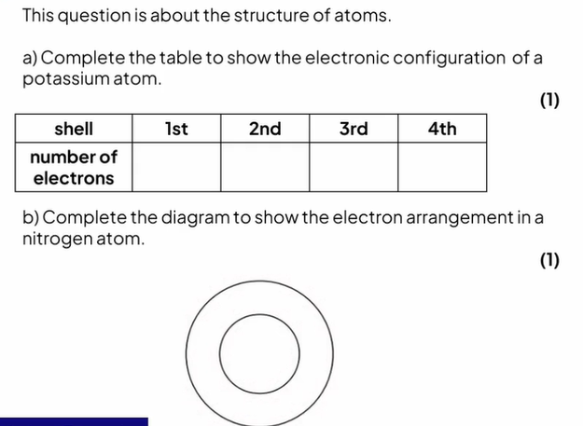

Electronic configurations and the periodic table
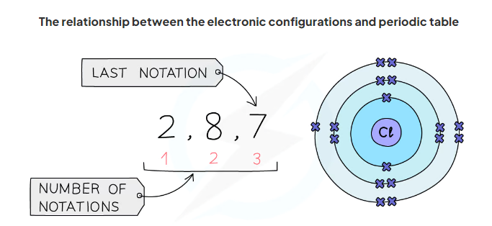
Period: The numbers at the bottom show the number of notations
The number of notations is 3
Therefore chlorine has 3 occupied shells
Group: The last notation, in this case 7
This means that chlorine has 7 electrons in its outer shell
Chlorine is therefore in Group 7
Exam Tip
The group number will be labelled on the Periodic Table you are given in your exam, but the period number isn't so it is a good idea to write this on yourself at the beginning.

Properties of metals and non-metals
We can use properties such as electrical conductivity and acid-base character to classify elements as metals or non-metals
-The metals are on the left hand-side of the periodic table and non-metals are on the right hand-side.

Property | Metals | Non-metals
Electron arrangement | 1-3 outer shell electrons | 4-7 outer shell electrons
Electrical conductivity | Good conductor of electricity | Poor conductors of electricity because there are no electrons that are free to move except graphite and silicon.
Types of oxide | Basic oxides (reacts with acid to form salt.) | Acidic oxides(reacts with bases/alkalis to form salts.)
Heat conductivity | Good conductors of heat | Poor conductors of heat (except: diamond)
Physical characteristics | -Shiny  -Solid at room temperature (excluding mercury)  -Malleable (can be bent and shaped).  -High melting and boiling points.  -High densities.  -Ductile (can be drawn into wires). | - Dull  -Different states at room temperature  *Iodine (Solid)  *Bromine( liquid)  *Nitrogen (gas)  -Brittle when they are solid.  -low boiling and melting points (exception: Carbon and Silicon).

Notes:
Metals form positive ions in their compounds, and they form ionic compounds.
Non- metals tend to form negative ions in ionic compounds and they form both ionic and covalent compounds.

Key points:
1) You may have noticed by now that hydrogen does not really fit into the Periodic Table properly. Although it has 1 electron in its outer shell, it is not in Group 1 because it does not have similar properties to the other elements in Group 1, it is not a metal and does not have similar chemical properties to the alkali metals.
2) If a basic oxide is soluble in water it will dissolve to form an alkali. For example, sodium oxide reacts with water to form sodium hydroxide solution, an alkali.
If an acidic oxide is soluble in water it will dissolve to form an acidic solution. For example, sulfur(IV) oxide reacts with water to form sulfurous acid.
3)There are some exceptions to the rules. For example, some metals form amphoteric oxides (e.g. Al₂O₃), which react with acids and bases, and some non-metal oxides (e.g. CO) are neutral.
Chemical properties
Chemical properties of elements in the same group
Elements in the same group in the Periodic Table will have similar chemical properties, this is because they have the same number of outer electrons so will react and bond similarly.
For example:
- All the elements in group 1 react vigorously with water to form hydrogen and hydroxides with similar formulae: LiOH (lithium hydroxide), NaOH (sodium hydroxide), KOH (potassium hydroxide).
- All the elements in group 7 react with hydrogen to form compounds with similar formulae: HF (hydrogen fluoride), HCl (hydrogen chloride) , HBr (hydrogen bromide).
- All the elements in group 2 form chlorides with similar formulae, MgCl₂, CaCl₂.
-The group number of an element which is given on the Periodic Table indicates the number of electrons in the outer shell

Notes:
- This rule holds true for all elements except helium; although is in Group 0, it has only one shell, the first and innermost shell, which holds only 2 electrons.
- The group 1 metals become more reactive as you move down the group while the group 7 elements show a decrease in reactivity moving down the group.

The Noble Gases
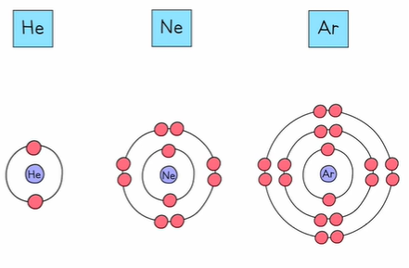
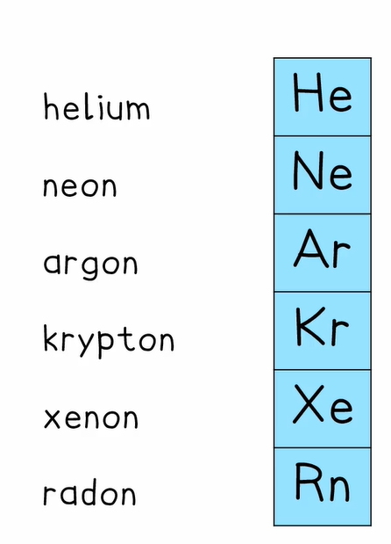

*The group ‘0’ elements are known as the noble gases because they are almost completely unreactive.
Why are noble gases unreactive?
Because the outer shell is full, and so there is no tendency to lose, gain or share electrons in a chemical reaction.

Example exam questions:
- Explain the chemical reactivity of xenon. (2 marks)
________________________________________________________________________________________________________________________________________
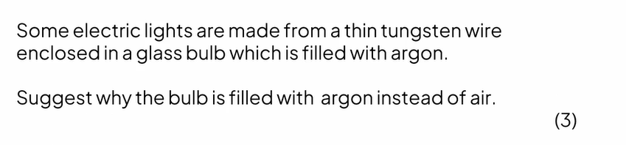
2)

___________________________________________________________________________________________________________________________________________________________________________________________________________

Past paper questions:
Question one:
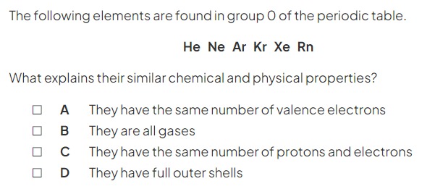
Question two:
a)
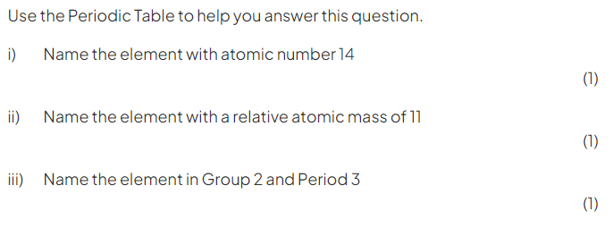

b)
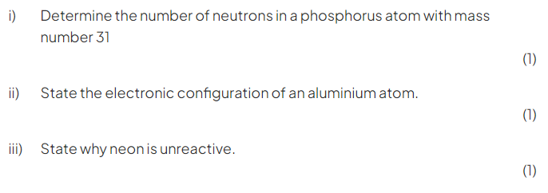
Question three:
