

Rosary School – Marj Elhamam
Past paper questions
Name: _________________ |  | Date: ____ /____ / 2025
Grade: 9( A,B,C ,D) |  | Subject : Chemistry
Periodic Table
Question one:
A)
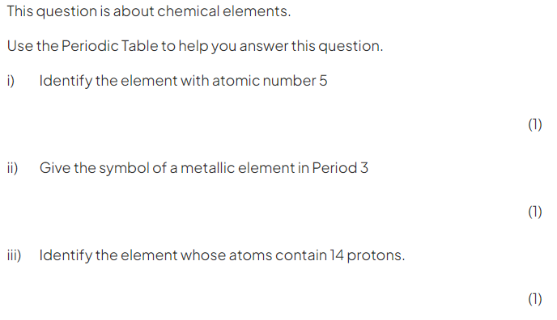
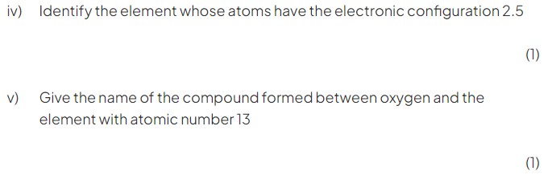

B)
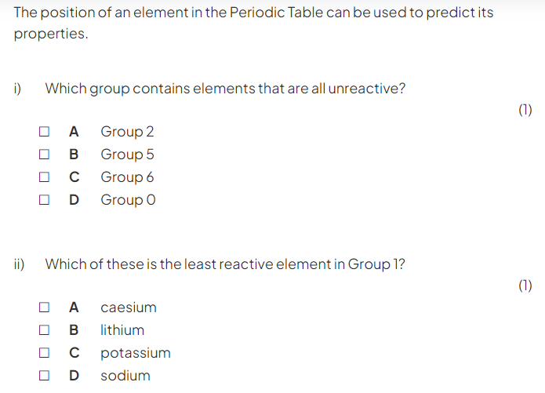

Question two:
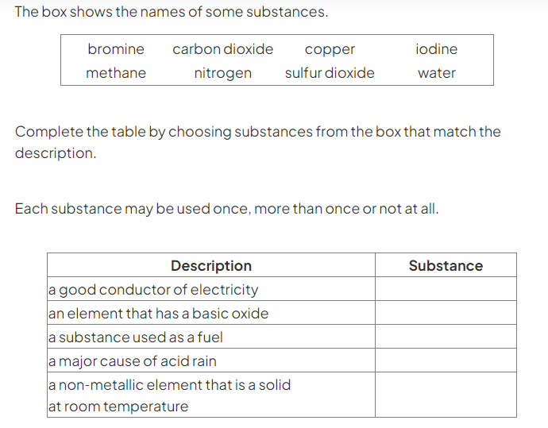

Description | Substance
A good conductor of electricity
An element that had a basic oxide
A non- metallic element that is solid at room temperature
(3 marks)

Question three:
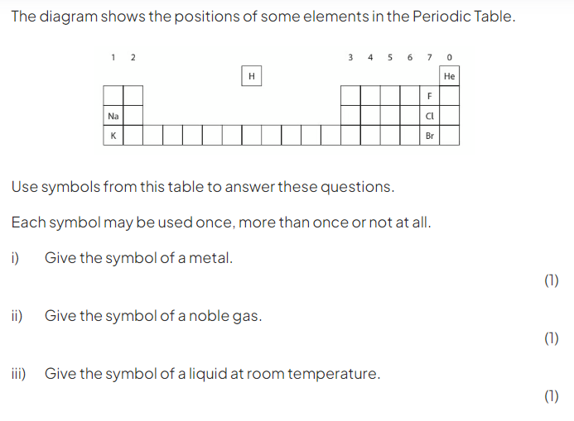
b) (1)
Question four:
A)
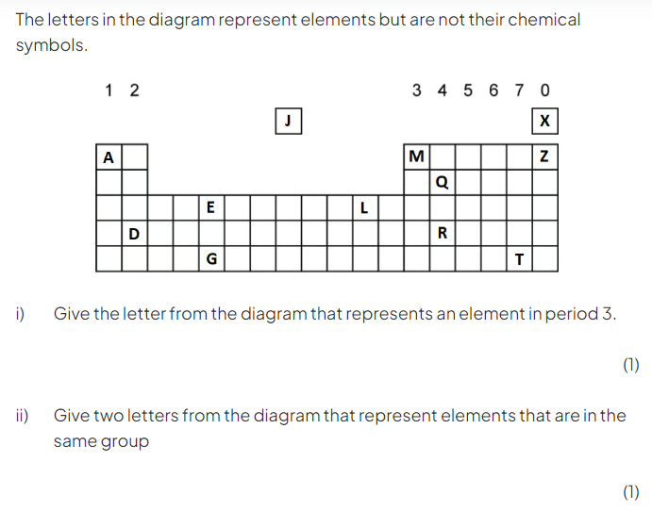

b)
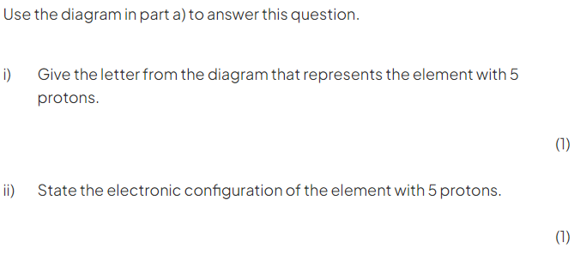
c)
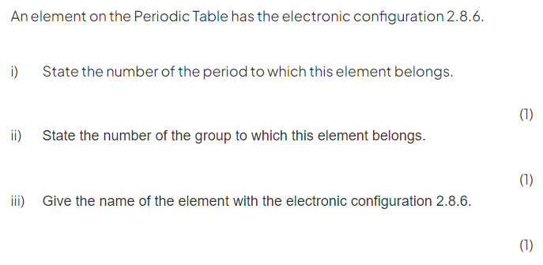
Question five:
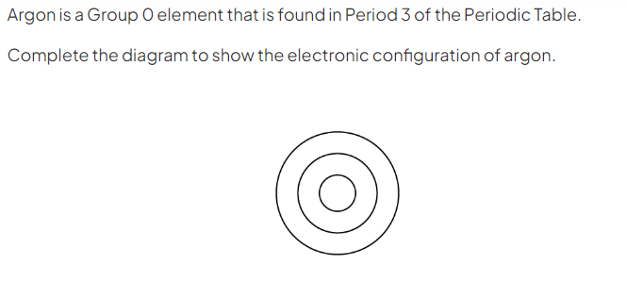

(1)

Question six:
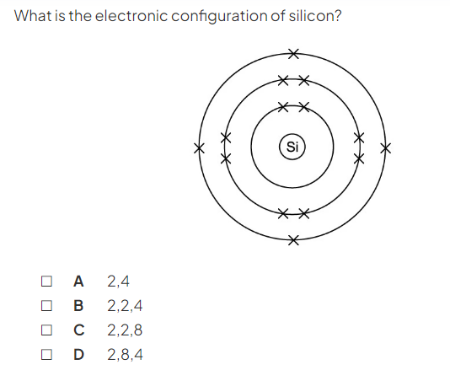(1)

Question seven:
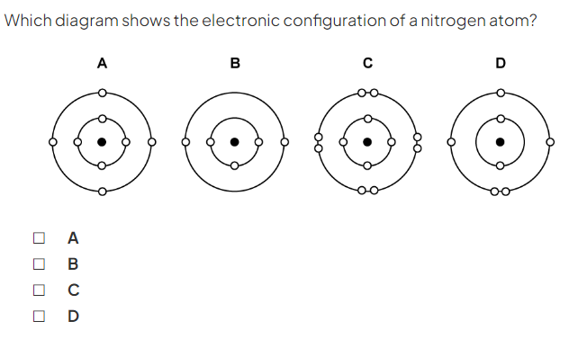

(1)

Question eight:
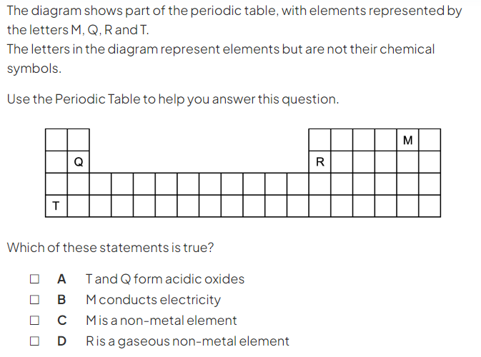

Question nine:
A)
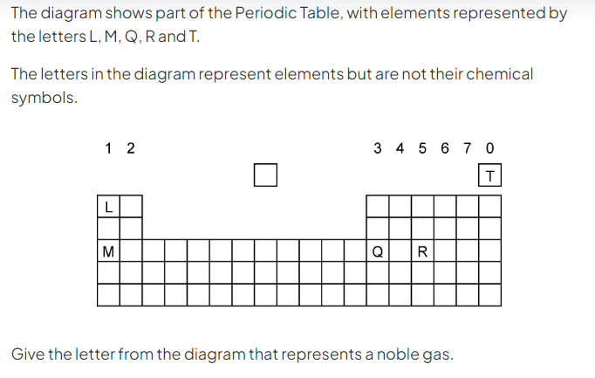
B)
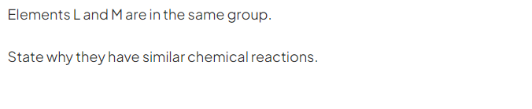(1)

C)
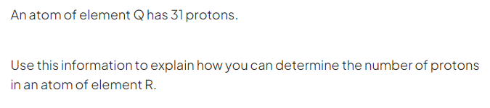(2)
Question ten:
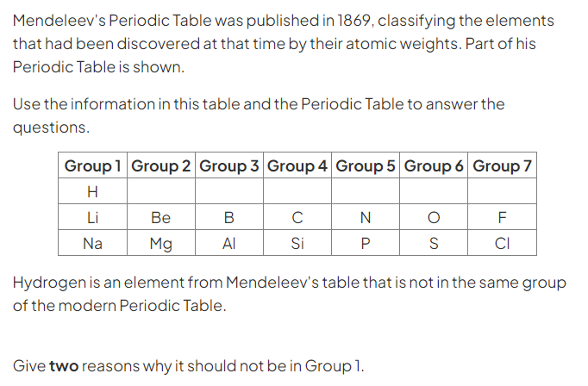
a)
(2)
b)
(2)

Question eleven:
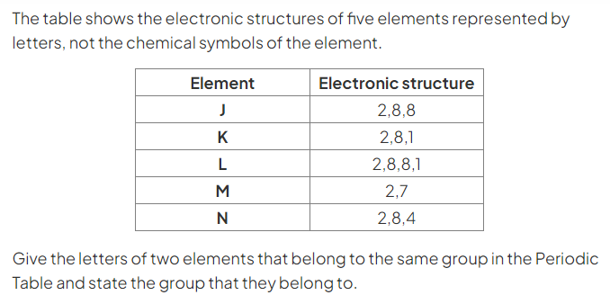

Question twelve:
Use the periodic table to answer this question.
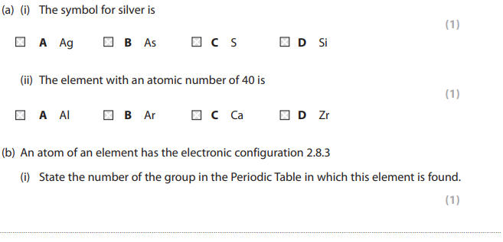
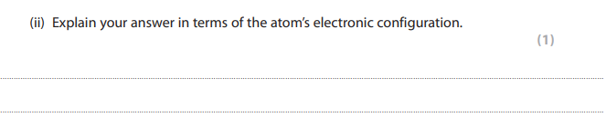
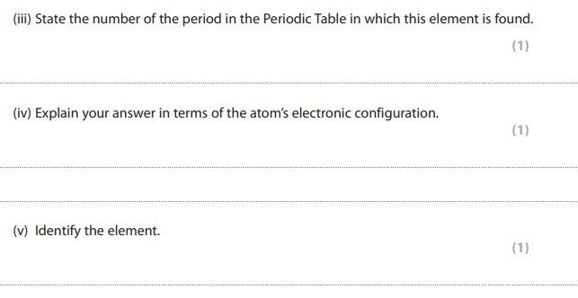

Question thirteen:
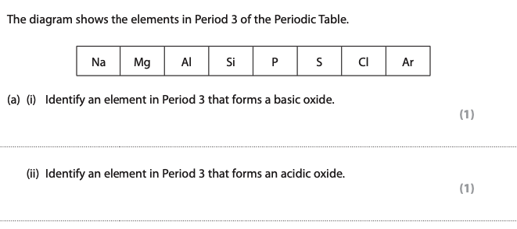

Question fourteen:
