

Rosary School – Marj Elhamam
Study Sheet (1)
Name: _________________ |  | Date: / / 2025
Grade: 6 ( A,B,C,D,E) |  | Subject : Science

7E: Mixtures & separation
7Ea: mixtures.
A mixture consists of two or more substances mixed together. The substances in a mixture can often be separated from each other.
Example Waste water is not a pure substance. It is a mixture of water and solid substances.
There are different kinds of mixtures:
1) A Solution is a mixture in which solids dissolve in liquids, and the mixture is clear (transparent).
2) Suspension is a mixture of two substances that separate if the mixture is not stirred. These two substances are often solids and liquids.
The solids settle out of the mixture over time.
Example sand mixed with water
Filtration is the process by which insoluble solids (residue) can be removed from a liquid (the filtrate) by using filter paper.
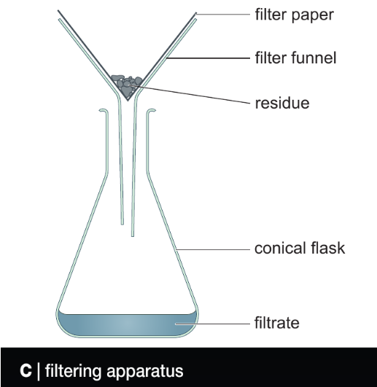
Note: Suspension can be separated using the filtration method.
3) Colloid is a mixture of a solid, liquid, or gas in a solid liquid or gas, where substances do not settle out if left to stand. The mixture looks cloudy or opaque.
Example milk and paint.
*Question: Give three other examples of colloids.
_________________________________________________________
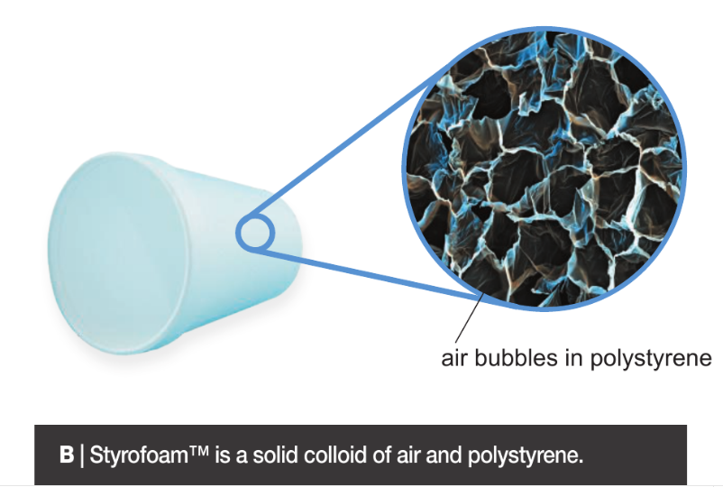
- Complete the table:
Type of mixture | Solution | Suspension | Colloid
Description of solid
Appearance
Separated if not stirred(yes ,no)
Example
Separation process
**Waste water contains large solids such as leaves, rubbish and lumps of human waste in addition to small solids.
The stages of waste water treatment:
1) Waste water from homes, offices, and street drains passes through a screen, which acts as a sieve to remove large solids.
2) Water is passed through filters (filtration) or by using settlement to remove smaller solids.
3) Water is treated with chemicals to clump the finest solids.
4) Clumps are removed by using filtration or settlement.
Questions :
Course book : Q3, Q5 & Q6 pages 72 & 73.
Workbook pages 53 & 54.

7Eb: solutions
Some solids dissolve in water to make a solution. These solids are soluble. A solution is made from a solute (usually a solid) and a solvent (liquid). Some gases, such as oxygen and carbon dioxide, can also dissolve in water.
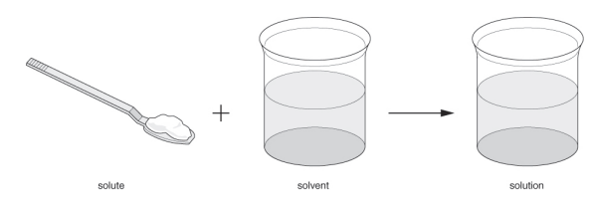
Substances that do not dissolve in a solvent are insoluble. When an insoluble substance is mixed with water, the mixture formed may be a suspension or a colloid.
The total mass of a solution equals the mass of solvent added to the mass of solute.
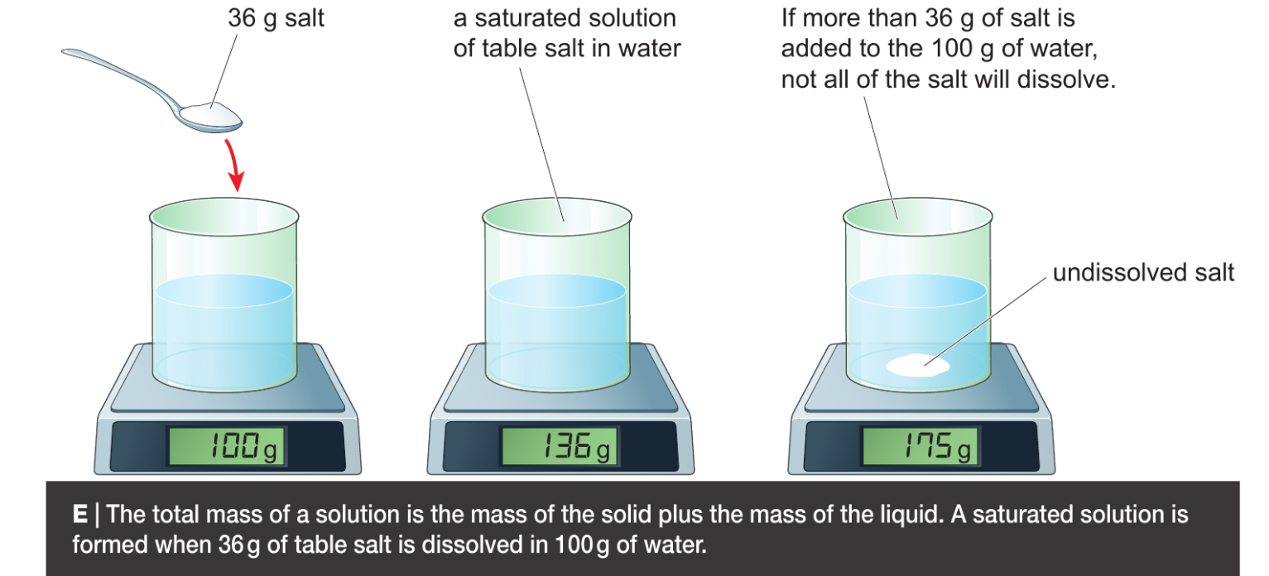
The amount of solute dissolved a certain volume of solvent is the concentration of the solution. The higher the concentration, the more solute is dissolved.
Water dissolves many different solutes. Other liquids (e.g. white spirit, ethanol) can also be used as solvents. Solutes that are insoluble in water may dissolve in other solvents.
If you keep adding solutes to a solvent, you will get to a point where no more will dissolve. The solution is saturated with solute. More solid may dissolve if you add more solvent (e.g. water) or increase the temperature.
The solubility of a solute is the amount that will dissolve in 100 g of a solvent at a particular temperature.
The solubility depends on
- The solvent :
For example, 36 g of table salt will dissolve in water at 20 °C but only 0.1 g will dissolve in ethanol at the same temperature.
- Temperature: It usually increases with temperature.
Question:
- The Solubility of blue copper sulfate is 40 grams per 100 grams of water at 60 degrees Celsius.
- State the largest mass of copper sulfate that would dissolve in 300 grams of water at 60 degrees Celsius.

B) A saturated solution of copper sulfate at 60 degrees Celsius is cooled to 30 degrees Celsius. Describe what you see when the solution cools. Explain your answer.
___________________________________________________________________________________________________________________________________________________________________________________________________________________________________________________
2- The solubility of copper chloride in ethanol is 53 g in 100 cm³ at 15 º C.
What would you see if you added the following amounts of copper chloride to ethanol
and stirred? Explain your answers.
- 48 g copper chloride to 100 cm³ ethanol at 15 ºC.
__________________________________________________________________________________________________________________________________________________________________
- 60 g copper chloride to 100 cm³ ethanol at 15 ºC.
___________________________________________________________________________________________________________________________________________________________________________________________________________________________________________________
- 48 g copper chloride to 50 cm³ ethanol at 15 ºC.
_________________________________________________________________________________________________________________________________________________________________________________________________________________________________

- 22g of silver sulfate is added to 200g of water. What is the mass of the solution formed? Show your working

Questions:
- Course book: Q4 & Q5 page 75
- Work book page 55

7Ec: Evaporation
During the evaporation of a solution, the liquid turns into a gas, which escapes into the air, leaving behind the solids that were dissolved in it.
Evaporation is used to separate solid substances from a solution.
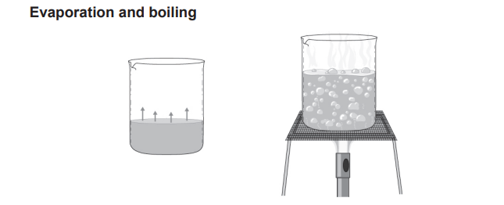
Example separating salt from a salt solution.

Evaporation is when a liquid turns to a gas at its surface. | Boiling is when a liquid turns to a gas throughout its volume.
It happens at any temperature. | Gas formed inside the liquid makes bubbles that rise to the surface.
It is faster when the temperature is higher. | Pure liquids have a distinct boiling point, which can be used to identify a liquid or to test whether a known liquid is pure. The boiling point of pure water is 100 °C.
Questions:
- Course book: Q1, Q4, Q6 page 79
- Workbook page 58

7Ed: Chromatography

Chromatography is used to separate substances dissolved in a mixture (individual solutes from a mixture of solutes in a solvent).
This method makes it easier to identify and analyze each substance.
Paper chromatography is the simplest method of chromatography; it can be used to find out which colours are mixed together in different paints, dyes and inks.
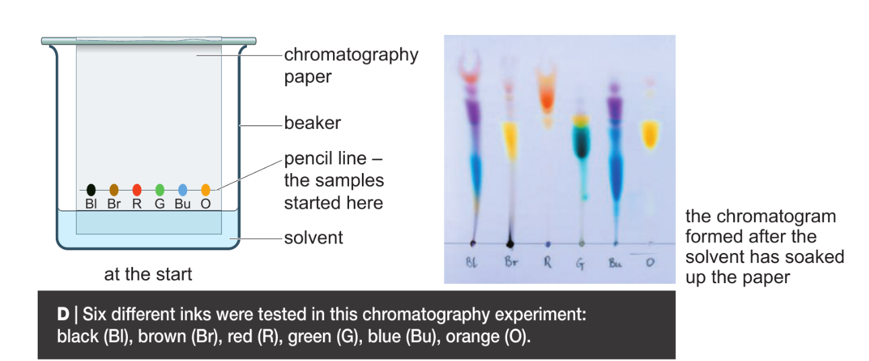
Question: Describe how the experiment is set up.
1) Dots of ink were placed on the base of the paper.
2) The paper was placed in the beaker.
3) A small amount of solvent was placed in the beaker, so the level of solvent was below the ink dots on the paper.
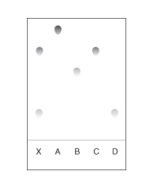
The solvent carries the coloured substances in the ink up the paper to form a pattern called a chromatogram.
Interpreting a chromatogram
Chromatograms help to identify substances in a mixture.
This paper chromatogram shows that A, B, C and D are
all single substances and that X is a mixture of C and D.

Note: Chromatography can be done with colourless substances. Ultraviolet light might make the substances glow. This makes the substances visible.
Question:
A student investigated the colours in three different flowers, A, B and C.
The colours are soluble in ethanol but are insoluble in water.
This is the method used.
1. Crush flower
2. Add ethanol to flower
3. Filter the mixture.
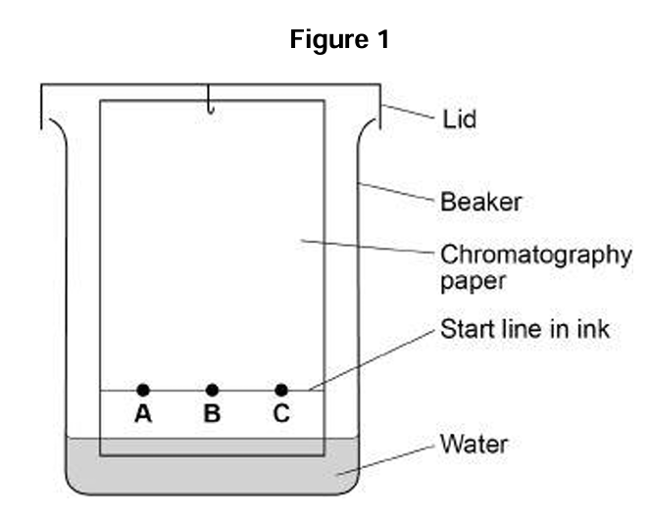
4. . Put spots of the coloured filtrate on to the chromatography paper.
5. Repeat steps 1-4 with flowers B and C.
Figure 1 shows the apparatus used.
(a)The student made many mistakes in setting up the apparatus. Name two mistakes that the students made.
1. _________________________________________
2. _________________________________________

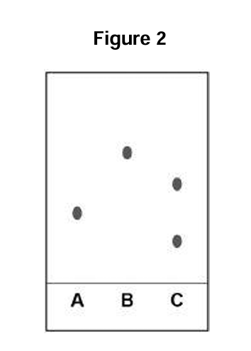
(b) Another student set up the apparatus correctly. Figure 2 represents the student’s results.
- Which flower colours is contain only one dye? ___________________________________________________
- Which flower colour was the most soluble? Explain your answer. __________________________________________________
Solve questions:
Course book: Q4, Q5, Q7 & Q8 page 81.
Workbook page 59.

7Ee: Distillation
Distillation is the process of separating a liquid from a mixture by evaporating the liquid and then condensing it so that it can be collected.
Example: distillation of pure water from a salt solution
Desalination is the process of removing dissolved solutes from seawater to make it suitable for drinking.
Apparatus used:
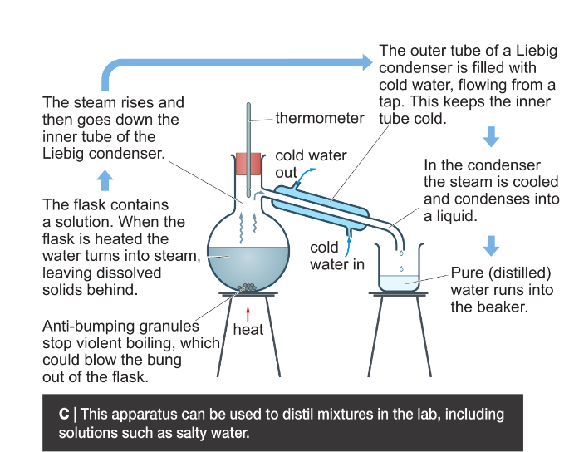

Question:
Explain why desalination plants are usually built next to the sea.
__________________________________________________________________________________________________________________________________________________________________

Questions: Workbook page 60 & 61
Summary:
