

Rosary School – Marj Elhamam
First Semester 2025/2026
Math Mid Term Exam
No. of Pages: ( 4 ) | No. of Questions: ( 7 ) | Mark: ( / 20 )
Name: _____________________ |  | Date: 18 /10 / 2025
Grade: 5 ( ) |  | Duration: (50 minutes )

Q1: Fill in the blanks.
( / 3)
a. Count on in 0.3s.

0 |  | 0.6 | 0.9

-0.012 |  |  | -0.018
b. Count back in 0.002s.

c. Count on in $\frac{2}{5}s$ .

$-\frac{3}{5}$ |  |  | $\frac{3}{5}$

Q2: Work out. ( / 5)
Show all your working.

a. 120 ÷ 2 – 4 × 8 = b. 8 + 14 ⎟ 7 – 3 =

c. 24 × 7 – 105 ÷ (47 – 42) =

Q3: Insert brackets to make the answer correct. ( / 1.5)
Show all your working.

a. 2 + 3 × 8 + 4 = 44 b. 8 + 7 - 6 × 5 = 13

c. 17 - 3 × 9 - 5 = 5

Q4: Complete. ( / 3.5)
- 300 + 25 × 12 = b. 150 – 4 $×$ 5 $×$ 6 =
300 + 25 × _______ + 25 ×2 = 150 – $_________$ $×$ 6 =
300 + ________ + 50 = 150 - _______ =
_________ + 50 = ___________
___________

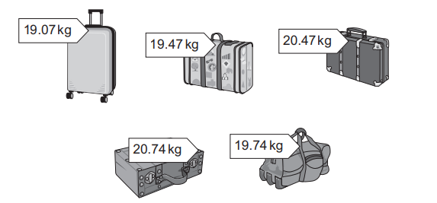
Q5: Here are some suitcases. ( / 1.5)

The mass of each suitcase is shown on the label.
Oliver rounds each mass to the nearest whole number.
a. Draw a ring around each suitcase with a mass that rounds to 20 kilograms.
b. Round the mass 20.47 to the nearest tenths. ____________________

Q6: Here are five measurements. ( / 1)
0.4 Kg , 1.6 Kg , 1.2 Kg , 0.8 Kg , 2.0 Kg
a. Use the numbers given to form an increasing sequence.
_______ , _______ , _______ , _______ , _______
b. Describe the pattern you observed.

__________________________________________________________
Q7: ( / 4.5)
a. Mia regroups the number 18.309 in the following way complete it.

18.309

2.3

b. Fill in the blanks.
i. 20.36 = _________ ones + ________ tenths + ________ hundredths.
ii. 70 + 0.005 = _____________
c. Anastasia thinks of a decimal number.
The number has
3 tens
2 ones
0 tenths
5 hundredths
1 thousandth
Write Anastasia’s number. ______________________

d. Mel has 20 blue pens and 12 green pens.
She puts all the pens equally into 4 drawers.
This word problem can be solved using only one equation.

i. Write the equation ________________________

ii How many pens are there in each drawer? __________ Pens.


Teachers: - Rand Haddadin, Rand Haddad, Qusie Hijazeen

