

Rosary School – Marj Elhamam
First Semester 2025/2026
Math Mid Term Exam
No. of Pages: ( 5 ) | No. of Questions: ( 10 ) | Mark: ( / 20 )
Name: _____________________ |  | Date: 25 / 10 / 2025
Grade: 6 ( ) |  | Duration: ( 50 minutes)
Q1: Draw a ring around the correct answer. ( /2)
a One of the following numbers is divisible by 2, 5 and 10:
i. 149 ii. 194 iii. 720345 iv. 125370
b. One of the following numbers is divisible by 4:
i. 408 ii. 143 iii. 2 iv. 153
c. 3681 is divisible by:
i. 4 ii. 9 iii. 2 iv. 10
d. One of the following numbers is divisible by 3:
i. 118 ii. 241 iii. 800 iv. 153

Q2: List all prime numbers between 10 and 20. ( /2)

______________________________________________

Q3: Find ( / 3)
a. The lowest common multiple of 9 and 12.

LCM =______________

b. The highest common factor of 14 and 28.

HCF =______________
c. The prime factors of 35.

Prime factors: ________________

Q4: Write down an estimate for $\sqrt{38}$ : ( / 1)

( / 3 )
Q5: Work out
a. - 8 + - 10 = __________ c. 15 – 22 = ____________ e. -11 – +4 = _________

b. - 9 – 32 = __________ d. - 9 × 13 = ___________ f. -17 + +6 = _________

( / 2)
Q6: The table shows the midday temperatures, in Celsius of four different cities.

New York | Rome | Moscow | Kenai
-10 | 5 | -12 | -31

a. Which city is the warmest? _____________________

b. What is the difference in temperatures between Kenai and Moscow?

________________________
c. What is the difference in temperatures between New York and Rome?

_________________________
d. If the temperature in Rome falls 8$°$C, what is the new temperature?

__________________________
Q7: Work out the area of this square. ( / 1)
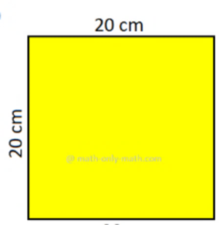

Area= _______________${cm}^{2}$

Q8: Work out. ( / 3)

a. 14² = _________ b. 60² = _________

c. 0.7² = ___________ d. $\sqrt{25}$ × $\sqrt{144}$ = _______

e. ${400}^{2 }$ = ____________ f. $\sqrt{256}$ = ______________

Q9: Here are some numbers. ( / 2)

12 1 5 4 6 3 10 2 20

- Write each of these numbers in the correct place on the Venn diagram.
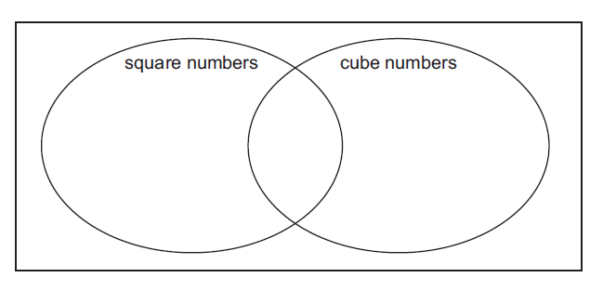

Factors of 20
Factors of 12

- Write the HCF of 12 and 20 . _______________________

Q10: Children are standing in lines. ( / 1)
They can be arranged in groups of 4 or groups of 6 with no child left out.
What is the smallest number of children?


_______________

Teachers: Eman Nabas and Qusie Hijazeen

