

Rosary School \ Marj Elhamam

Name : _______________________ Date : / 11 / 2025
Subject: study sheet 3 chapter (3) Grade : 6 ( )

- An algebraic term is made up of numbers (called coefficients),
letters (called variables) and multiplication operation sign.

Examples : 3$x$ , 2$y^{2}z$ , - 4$ab$ , 10
Note: 10 is a constant algebraic expression.

- An algebraic expression is made up of one term or more and an addition operation signs.

Examples: $(3x + 2)$ , $(4a – 7)$ , $(2x + 3x + 5)$

Note: every algebraic term is an algebraic expression but not every algebraic expression is an algebraic term.

- Like Terms
Like terms are terms that have the same variable raised to the same power.
Examples of like terms: $3x$ and $5x$
$7a$and $–2a$
-2$y^{3}$ and 5$y^{3}$
Examples of unlike terms: $4x$and $4y$ (different variables)
$x²$ and $x$ (different powers).

- Simplifying Like Terms When Adding and Subtracting
To simplify an algebraic expression, combine the numbers of the like terms.
Examples:
$2x + 5x = 7x$
$8y – 3y = 5y$
$4a + 7b – 2a + 3b =$

$\left(4a – 2a\right)+ \left(7b + 3b\right)=$
$2a + 10b$
Be careful with positive and negative signs when simplifying.
Examples:
$6x – 9x = –3x$
$–5a + 3a = –2a$
- Tips to Remember
✓ Group like terms together before simplifying.
✓ Add or subtract the coefficient of each variable.
✓ Keep the sign (+ or –) between the terms.
Examples:
Expression Form Steps Simplified Form 1. $2x + 5x 2x + 5x = (2 + 5)x 7x$
2. $8y – 3y 8y – 3y = (8 – 3)y 5y$
3. $3x + 5 + 2x – 7 (3x + 2x) + (5 – 7) 5x – 2$
4. $4a + 7b – 2a + 3b (4a – 2a) + (7b + 3b) 2a + 10b$

- Simplifying When Multiplying Variables
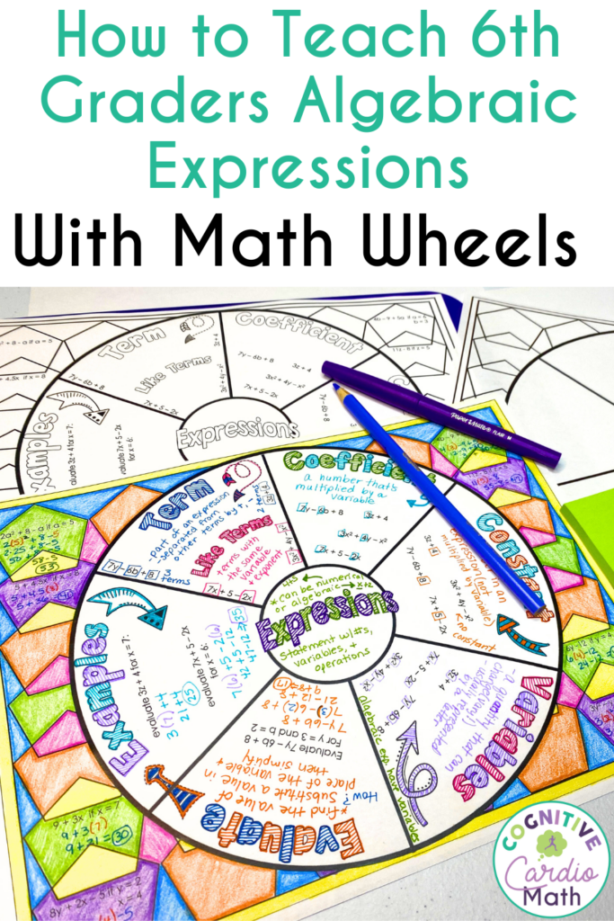
When we multiply variables, we multiply their coefficients and add the powers of the variables.
Example 1:

$2x × 3x = (2 × 3) × (x × x) = 6x²$
Example 2:
$4a × 5a × 2a = (4 × 5× 2) × (a × a× a) = 40a^{3}$
Example 3:
$3x × 2y = 6xy$
(different variables — just write them together)
Example 4:
$–2a × 3a² = (–2 × 3) × (a × a²) = –6a³$
Writing Algebraic Expressions
Words / Phrases | Operation | Example | Expression
Sum, total, more than, increased by | Addition (+) | 5 more than $x$ | $$x + 5$$
Difference, less than, decreased by | Subtraction (–) | 7 less than $x$ | $$x – 7$$
Times, product of, multiplied by | Multiplication (×) | 4 times $x$ | $$4x$$
Divided by, quotient of | Division (÷) | $x$ divided by 3 | $$x ÷ 3 or x/3$$
Double | Multiplying by 2 | double $x$ | $$2x$$

Example 1:
“A number increased by 9” → $x + 9$
“Twice a number” → $2x$
“A number decreased by 4” → $x – 4$
“The product of 3 and a number” → $3x$
“Half of a number” → $x ÷ 2 or ½x$

Example 2:
“A number doubled, then increased by 6” → $2x + 6$
“Three less than five times a number” → $5x – 3$
“A number divided by 2, then decreased by 7” → $(x ÷ 2) – 7$
“Four more than twice a number” → $2x + 4$
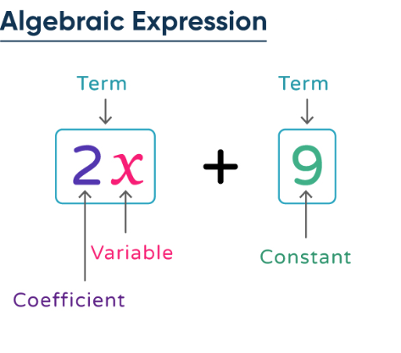

Teachers: Eman Nabas, Qusie Hijazeen

