6.1: Reflection
Getting Started
1 The Sun
2 Light travels from the Sun to the tree. Light reflects off the tree into Sofia’s eyes.

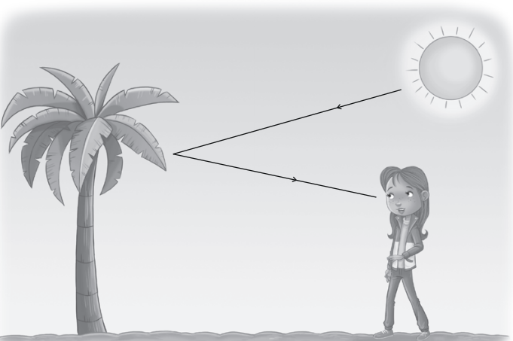
4 A smooth, shiny surface
5 Yes, all surfaces reflect some light otherwise we would not see them.

Activity: How we see reflected light
1 A mirror, a lake with clear, still water
2 A mirror image
3 A is the incident ray; B is the reflected ray.
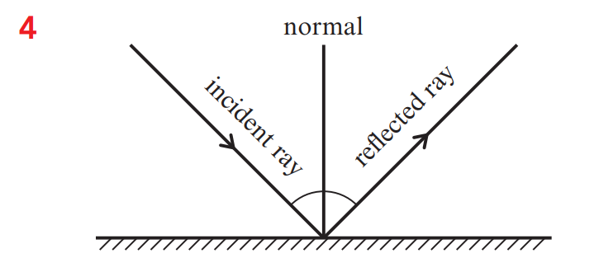
Think like a scientist 1: Demonstrate how light travels when it reflects
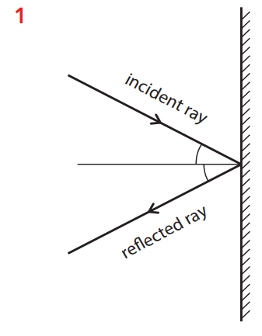
2 The angles were the same.
3 So that we could see that the light left the mirror at the same angle as it arrived for any angle.
4 When a ray of light reflects off a plane mirror it makes the same angle with the normal as it did when it arrived at the mirror

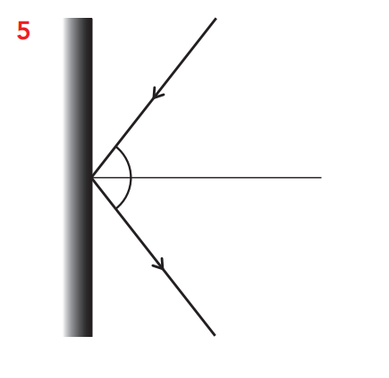

Think like a scientist 2: Make and test a periscope
1 A periscope is a device that uses mirrors to allow you to see over the top of something in front of you.
2 We looked through it and saw things that are higher up by looking straight ahead.

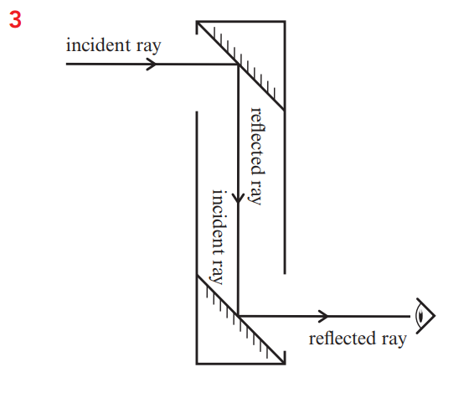
4 Because the reflected ray from the top mirror has to go straight down the periscope to the bottom mirror.
5 Light travels from the Sun to the person on the other side of the wall. Light reflects off the person to the top mirror of the periscope. Light reflects off the top mirror and travels down the periscope to the bottom mirror. Light reflects off the bottom mirror into your eye.
6 By making the periscope taller.
7 seeing the stage at a concert or seeing a procession when there are people standing in front of you, or for seeing above water in a submarine.

