Reflection
Focus
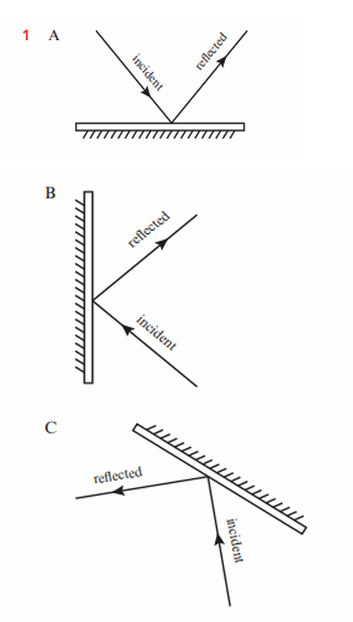
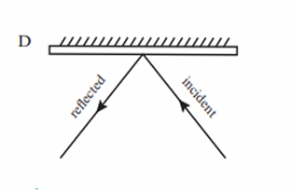
Practice
2 a Diagram B shows a periscope.
b Diagrams A and F are incorrect. c Make sure arrows are pointing in the right direction and angles equal
