

Rosary School – Marj Elhamam
Ionic bonding
Name: _________________ |  | Date: ____ /____ / 2025
Grade: 9( A,B,C ,D) |  | Past paper questions

Question one:
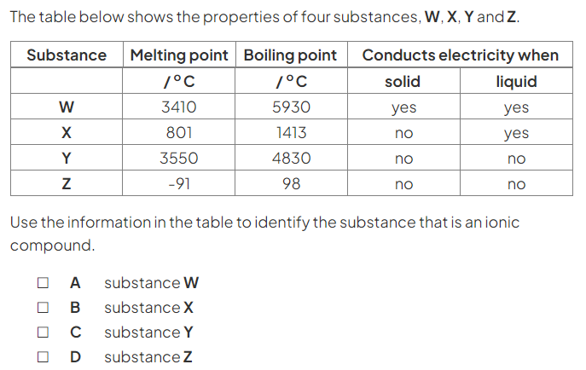
(1 mark)
Question two:
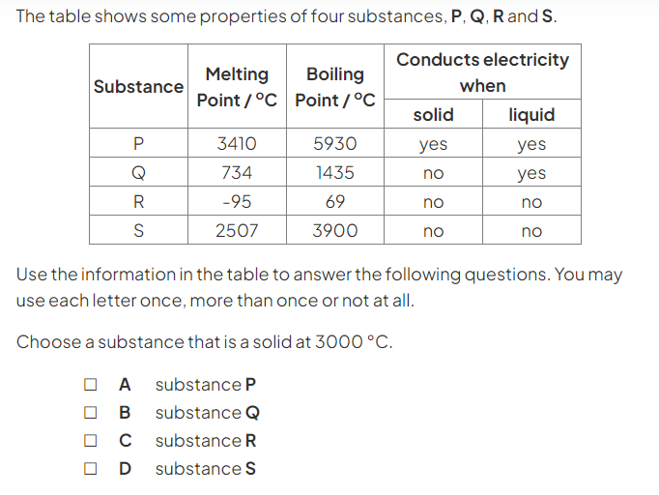
b)
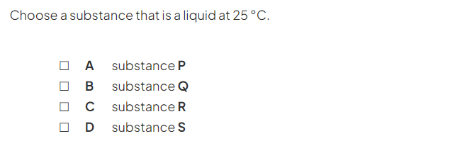
c)
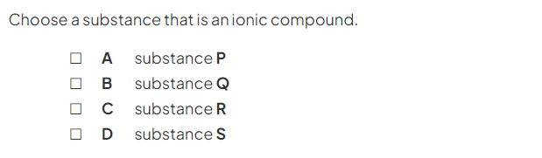
d)
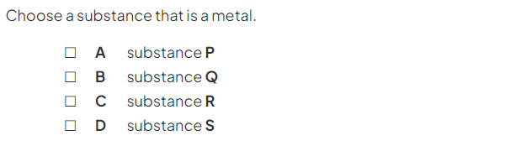
(4 marks)
Question three:
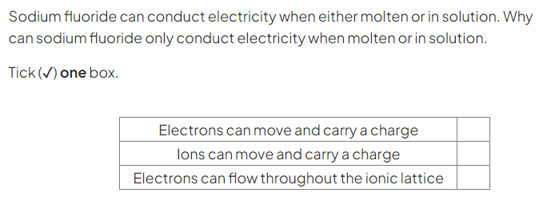(1 mark)

Question four:
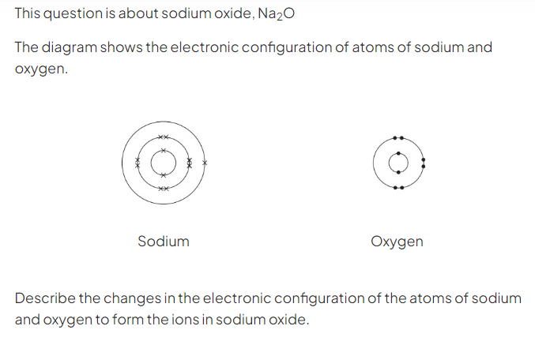(3 marks)
_______________________________________________________________
_______________________________________________________________
_______________________________________________________________
b)
(2 marks)
_______________________________________________________________
_______________________________________________________________
Question five:
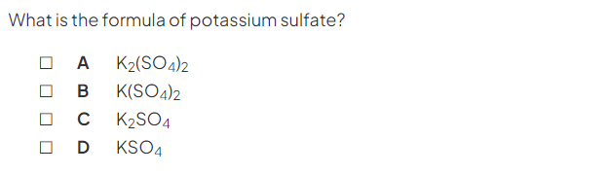(1 mark)
Question six:
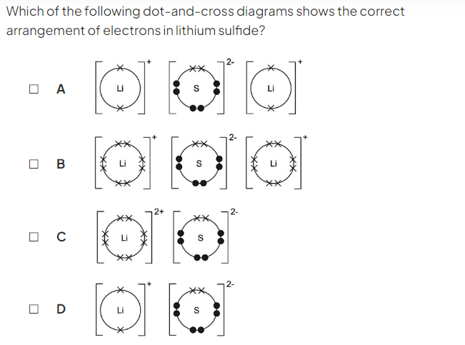(1 mark)
Question seven:
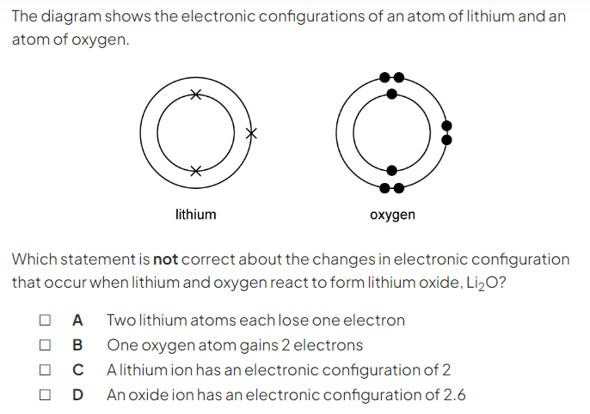(1 mark)
Question eight:
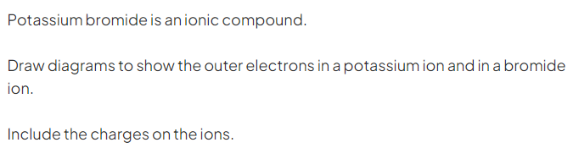
(3 marks)
Question nine:
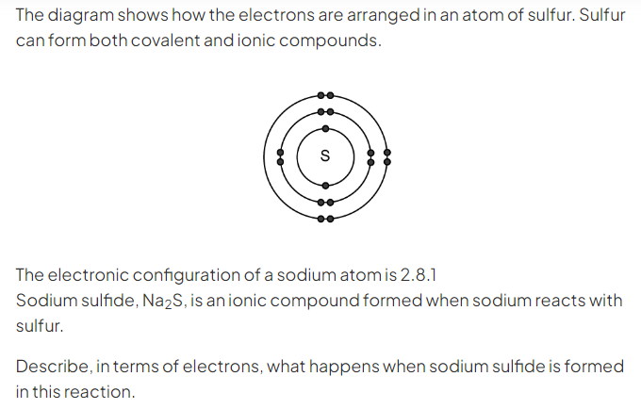
(3 marks)
_____________________________________________________________
_____________________________________________________________
_____________________________________________________________

Question ten:
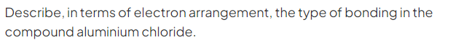(5 marks)
____________________________________________________________
____________________________________________________________
____________________________________________________________
____________________________________________________________

Question eleven:
- Work out the formulae of the following compounds: (4)
- Sodium chloride: ____________________
- Ammonium sulphate: _________________
- Zinc (II) oxide: ______________________

- Give the name of the compound with the following formula Zn(NO₃)₂:_______________________________________

Question twelve:
