

Rosary School – Marj Elhamam

Name: _________________ |  | Date: __ /__ / 2025
Grade: 9( A,B,C ,D) |  | Chemistry summary notes

Ionic bonding
Objectives:
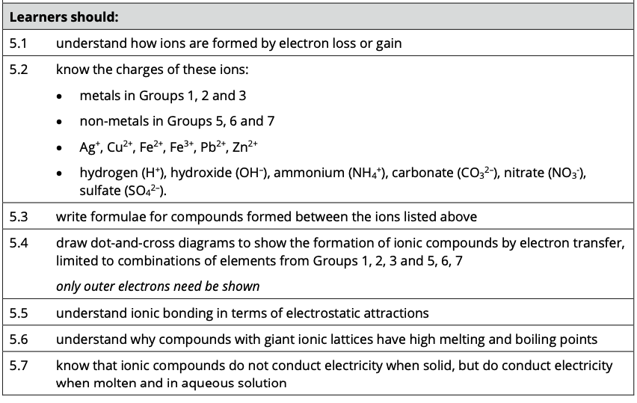
Formation of ions
- An ion is an electrically charged atom or group of atoms formed by the loss or gain of electrons.
- This loss or gain of electrons takes place to obtain a full outer shell of electrons.
- The electronic structure of ions of elements in groups 1, 2, 3, 5, 6 and 7 will be the same as that of a noble gas - such as helium, neon, and argon.
- Negative ions are called anions and form when atoms gain electrons, meaning they have more electrons than protons, for example Cl⁻.
- Positive ions are called cations and form when atoms lose electrons, meaning they have more protons than electrons, for example Na⁺.
- All metals lose electrons to other atoms to become positively charged ions.
- All non-metals gain electrons from other atoms to become negatively charged ions.
- Ions have the electronic configuration of a noble gas.

Exam Tip:
- Learn the definition of the term ion.
- 2)Anion= A Negative Ion

Why is an ion formed?
An atom with an incomplete outer shell of electrons is unstable.
An atom loses or gains electrons to become more stable.

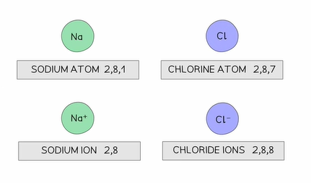

Worked example:
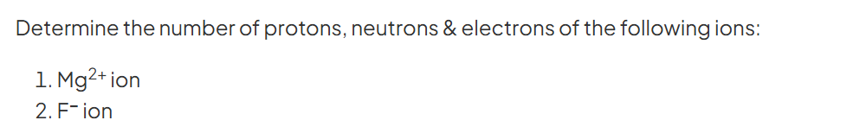

How are positive ions formed?
Metal atoms lose electrons to form positive ions.
Diagrams of ions should include square brackets and charge.

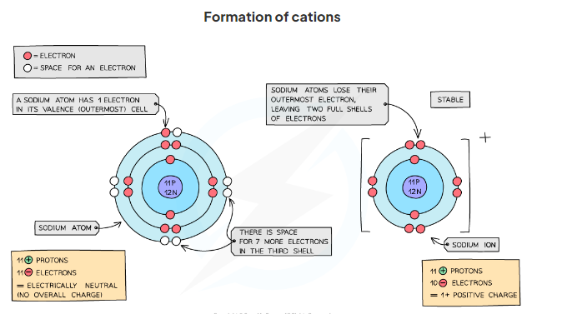
How are negative ions formed?
Non- metal atoms gain electrons to form negative ions.
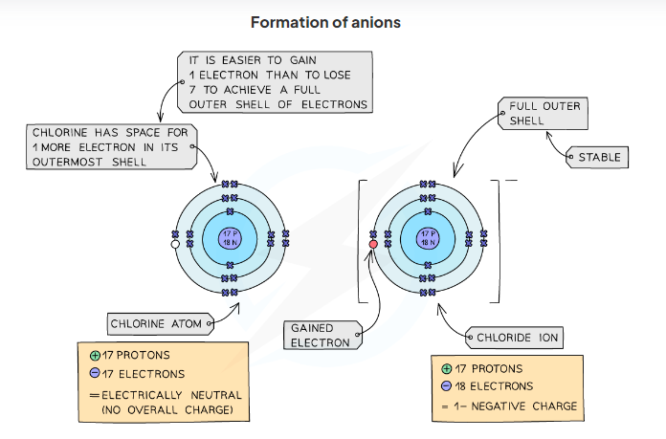

Exam Tip:
The number of electrons that an atom gains or loses is the same as the charge.
For Example, if magnesium atom loses 2 electrons, then the charge will be +2, if a bromine atom gains 1 electron then the charge will be -1.
Common Ions
Common ions with a positive charge
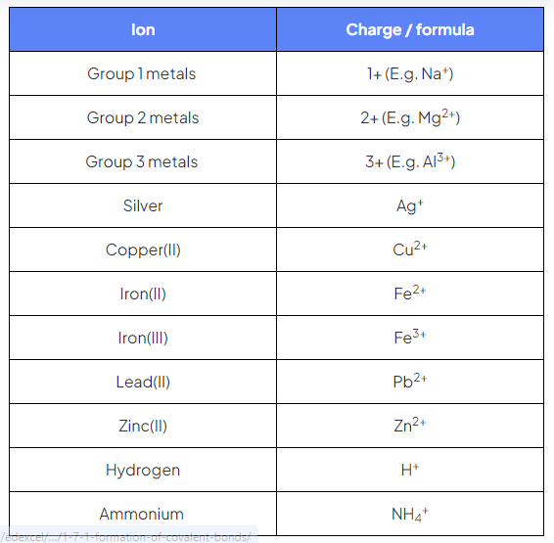
Common ions with a negative charge
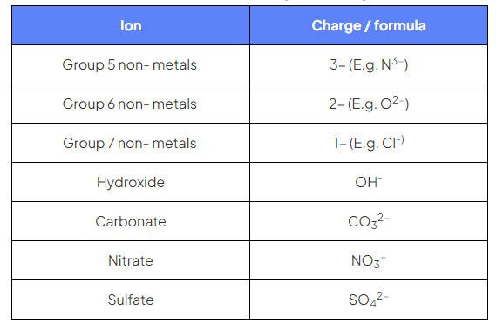
In addition to, phosphate (PO₄⁻³), sulphite (SO₃⁻²), nitrite (NO₂⁻), dichromate (Cr₂O₇⁻²).
Exam Tip
You must know the charges of all the ions shown in the above tables.

Formulae for ionic compounds
- Ionic compounds typically have no overall charge
-This means that the size of any positively charged ion is cancelled by the size of any negatively charged ion.
-Careful: This should not be confused with an atom having no overall charge.
- The formulae of simple ionic compounds can be determined if you know the charge on the ions.
- If the charges are equal and opposite the ionic formula can be written out simply.
- If the charges are different and opposite, you can use the swap and drop method and you may need to include brackets.

The swap-and-drop method
- For example, copper(II) chloride:
- The copper(II) ion is Cu²⁺, which means that it has a 2+ or +2 charge
The chloride ion is Cl⁻, which means that it has a 1– or –1 charge
The size of the charge on the copper(II) ion indicates the number of chloride ions needed, and the size of the charge on the chloride ion indicates the number of copper(II) ions needed CuCl₂
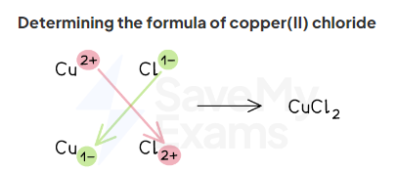

Note: Careful!!If you use this method with ions that have the same charge, then you must give the simplest whole number ratio to get the correct answer (ex. CuO)

Example exam question:
The compound produced in the reaction between iron wool and chlorine contains the ions Fe³⁺ and Cl⁻.

a) Give the formula of this compound.
__________________________________________________________

b) State the name of this compound.
___________________________________________________________
Note:
- If you are determining the formula of a compound containing a complex ion, such as carbonate, hydroxide or sulfate ions, don't forget to include brackets if needed.

- For example, when determining the ionic formula of magnesium hydroxide:
-Magnesium forms ions with a 2+ charge, and hydroxide ions have a 1- charge.
-The formula of magnesium hydroxide is therefore Mg(OH)₂.

Example exam questions:
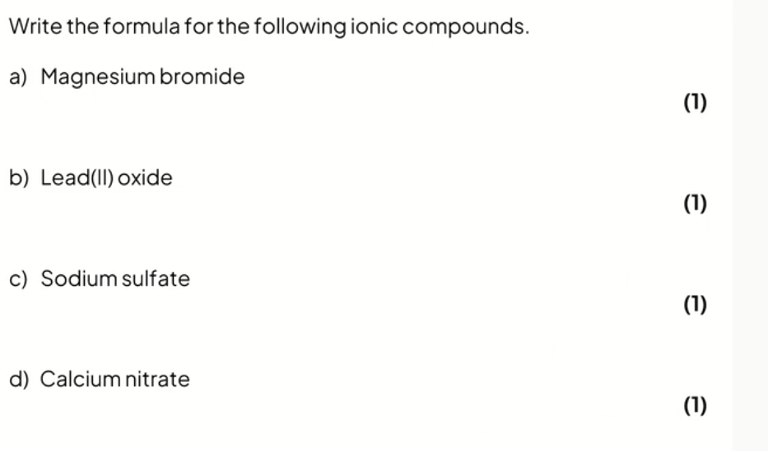
Homework: Q3 & Q4 page 84.

Dot and cross diagrams for ionic compounds
1) Dot-and -cross diagrams show the arrangement of electrons in ionic compounds.
2) You need to be able to construct the dot- and -cross diagrams for ionic compounds formed from a combination of metals from groups 1,2 or 3 with non- metals from groups 5,6 or 7.
3) Ions must have square brackets and a charge.
4) Show the symbol of each ion.
Sodium chloride dot and cross diagram
- Sodium is a Group 1 metal so will lose one outer electron to another atom to gain a full outer shell of electrons.
- A positive sodium ion with the charge 1+ is formed.
- Chlorine is a Group 7 non-metal so will need to gain an electron to have a full outer shell of electrons.
- One electron will be transferred from the outer shell of the sodium atom to the outer shell of the chlorine atom.
- A chlorine atom will gain an electron to form a negatively charged chloride ion with a charge of 1-.
- The formula of sodium chloride is NaCl.

Dot and cross diagram for sodium chloride

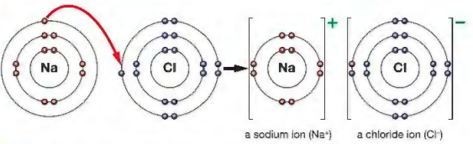
Dot cross diagram for magnesium oxide.
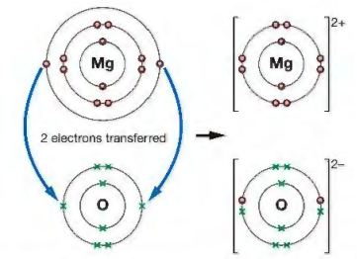
Exam Tip:
Make sure each ion has a full outer shell of electrons.

Example exam question:
Question one:
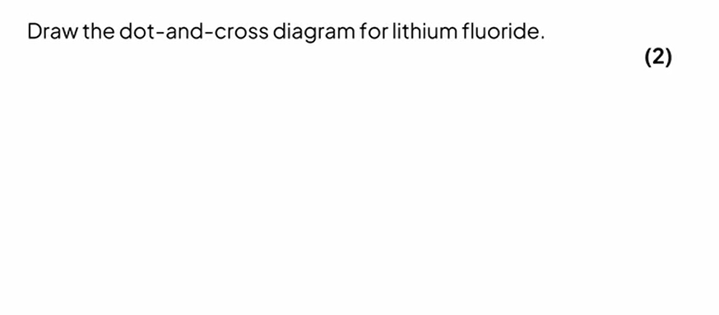
Question two:
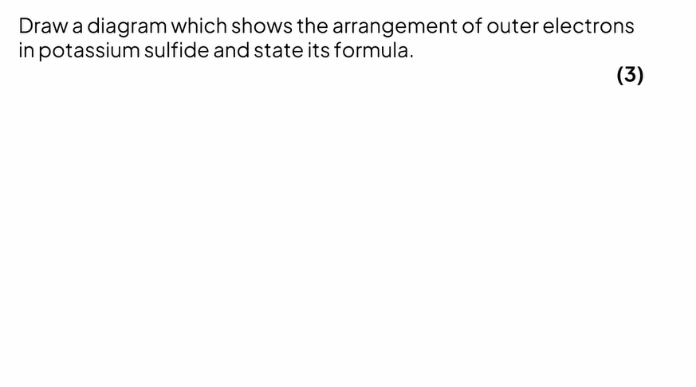
Question three:
Draw the dot-and-cross diagram for calcium chloride.

Home work: solve questions 2 pages 83.
Exam Tip:
- For exam purposes, you only need to show the outer electrons in dot and cross diagrams.
- You should be able to draw the dot and cross diagrams for combinations of ions from groups 1,2,3,5,6 & 7.

Ionic compounds: bonds, structure & properties

Ionic bonding
- An ionic compound consists of a regular arrangement of alternating positive and negative ions in which the ions are tightly packed together.
- Between positive and negative ions are strong electrostatic forces of attraction which act in all directions.
- These are what hold the ionic compound together.

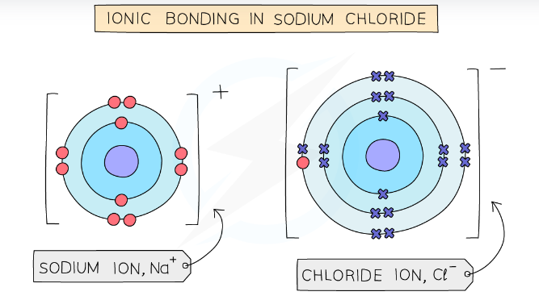
Electrostatic forces of attraction exist between the positively charged ions.

Example Exam Questions:
Question one:
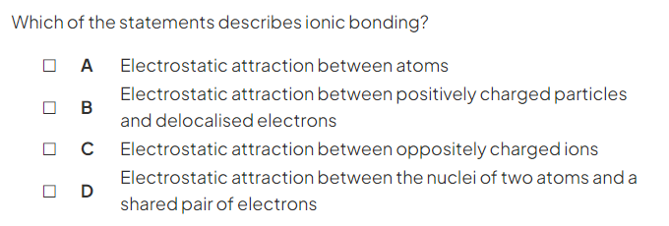

Question two:
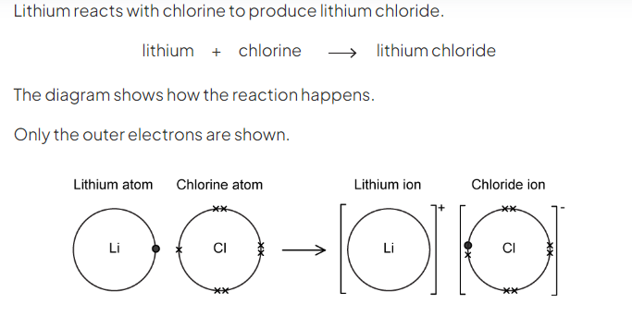
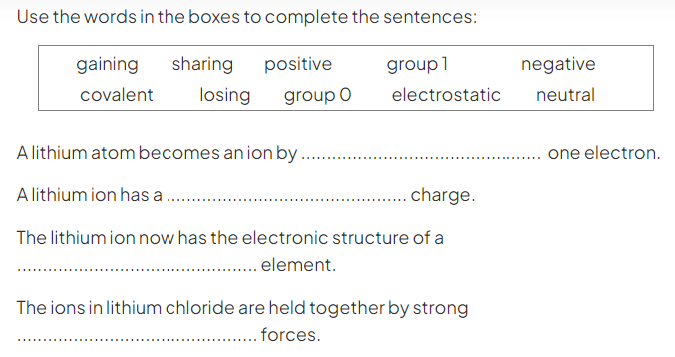

Ionic lattices
- Thousands of positive and negative ions in an ionic compound arranged in a regular, repeating pattern form a giant lattice structure.
- Compounds with giant ionic lattice have high melting points & boiling points because:
- They have giant ionic lattices
- There are strong electrostatic forces of attraction between oppositely charged ions in all directions
- The forces need lots of energy to overcome the strong forces of attraction between the oppositely charged ions in the giant lattice structure.
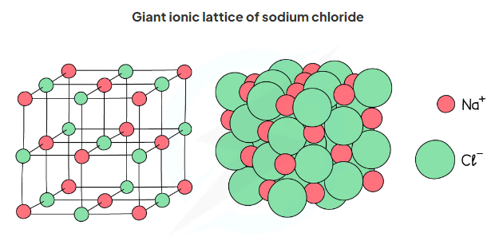

- Note: The greater the charge on the ions, the stronger the electrostatic forces and the higher the melting point will be, needing more energy to be overcome.
For example, magnesium oxide consists of Mg²⁺ and O²⁻ so will have a higher melting point than sodium chloride which contains the ions, Na⁺ and Cl⁻.

Conductivity of ionic compounds
- For electrical current to flow there must be freely moving charged particles such as electrons or ions present
- Ionic compounds are poor conductors in the solid state
-The ions are in fixed positions in the lattice
-They are therefore unable to move and carry a charge

- Ionic compounds are good conductors of electricity in the molten state or in solution
-When the ionic compound is melted or dissolved in water, the ions are able to move and carry a charge

Exam Tip
1) Make sure you can describe a giant ionic lattice.
2) A common mistake students make in exams is to say that ionic compounds conduct electricity because 'electrons' move and carry a charge, when they should say the ions can move and carry a charge. Don't make
that mistake!
3) The stronger the ionic bond, the higher the melting point.
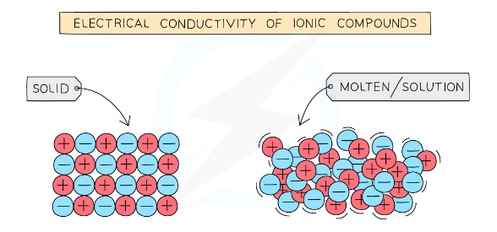

Example exam questions:

Question one:

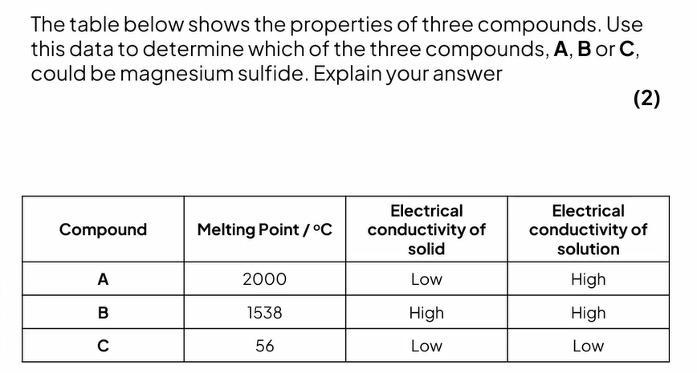

Question two:
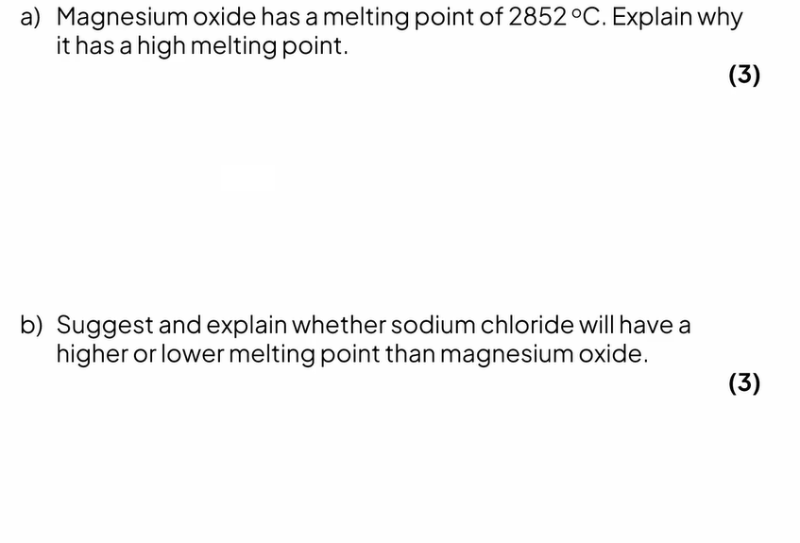
Question three:
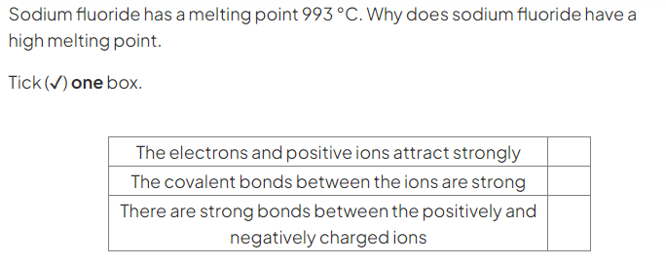
Exam Tip:
Use comparative statements, such as smaller, weaker & less.

Home work: question 5 page 84.

