

Rosary School \ Marj Elhamam

Name : _______________________ Date : / / 2025
Subject: Lesson 3.A (Quadrilaterals) Grade : 5 ( )
2 D shapes
Shape Name | Parallel sides | Equal sides | Angles | Line of symmetry
Square
Rectangle
Parallelogram
Rhombus
Trapezium
Kite
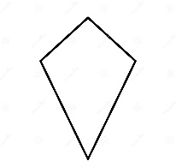

Opposite sides are parallel one pair of parallel sides No parallel sides

All sides are equal Opposite sides are equal

No equal sides Adjacent sides are equal

4 right angles 4 equal angles

4 lines of symmetry 2 lines of symmetry

No lines of symmetry 1 line of symmetry
