6.2 Refraction
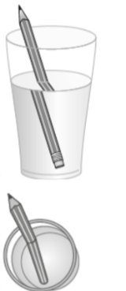
Think like a scientist 1 p150
2.

3.
4. The pencil wasn’t really bent.
5. The light passes through water, glass, and air.
6. Light from the pencil travels through the water in the glass and then bends when it passes through the glass to the air.
7. The pencil appeared to be bent because the light refracted when it moved from the water through the glass to the air.
8. The light bends once when it travelled through the glass into the water, and then it bends again when it travelled out of the water through the glass and into the air. As a result, the light rays cross and the arrows appear to be turned around.

Think like a scientist 2 p152
Questions:
1. It has the same bulging shape.
2. Light rays pass from the print through the water drop and bend inward and converge at a point just beyond the water drop. This point where the rays converge is the focus and we see the enlarged print.
3. Not included.

