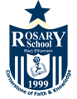

Rosary School – Marj Elhamam
Worksheet (2)
Name: _________________ |  | Date: ____ /11 / 2025
Grade: 7 (A,B,C,D,E) |  | Subject: Chemistry
The Periodic Table
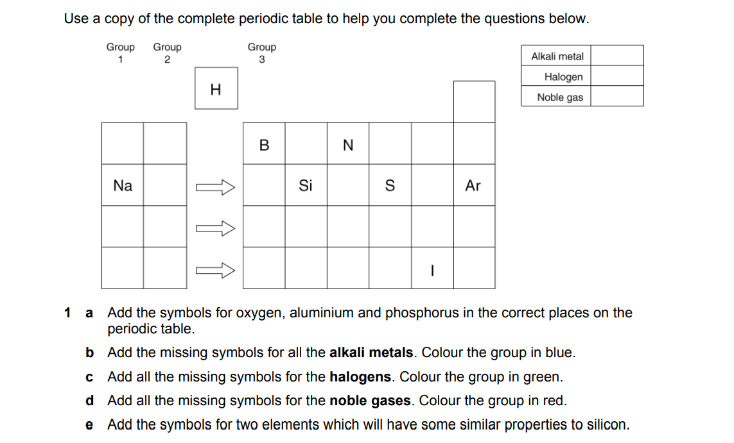
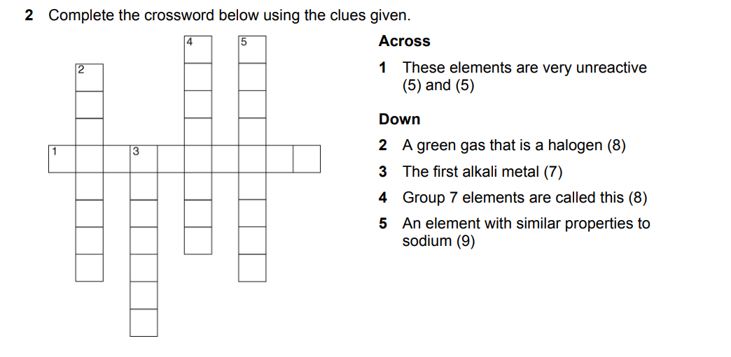

Teachers: Farah Yamak & Veronica Mkhjian

