Topic 6.3: The solar system
Getting Started
1 The Sun, planets, moons, (and asteroids and comets)
2 The Sun
3 A star emits/sends out light and a planet reflects light.
4 The Moon travels around the Earth

Activity 1: The planets
1 Jupiter
2 Mercury
3 Mercury
4 Neptune
5 Venus
6 Jupiter
7 Neptune
8 Mercury
9 Mercury
10 Neptune
11 Saturn
12 Jupiter
13 Earth
14 Jupiter and Saturn
15 Uranus and Neptune

Activity 2: Identify phases of the Moon
1 Waning
2 1: full Moon; 2: last quarter; 3: waning crescent
3 New Moon
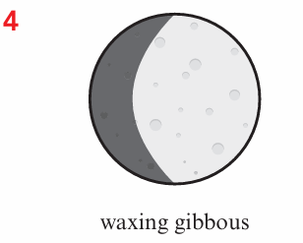
5 29.5 days
6 The Moon’s orbit around the Earth.

