Topic 6.3: The solar system
Workbook
Focus
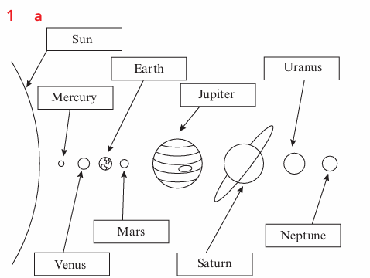
b Turning on an axis; moving in an orbit around the Sun.

2 a The movement in an orbit around the Earth.
b 29.5 or 29½ days
c Between 4 and 7

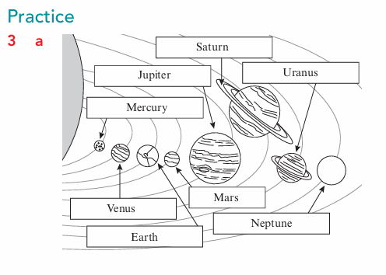
b An ‘Earth day’ is 24 hours and an ‘Earth year’ is 365¼ days or 8766 hours.
c Mars, Jupiter, Saturn, Uranus and Neptune. All these planets are further from the Sun than Earth and therefore take longer to complete their orbits around the Sun.
d Mercury, because this planet is the closest to the Sun.
e The scale is very incorrect. In reality the Sun is far larger than any of the planets. The distance between the planets and the Sun is much larger than shown on the diagram.
