

Rosary School – Marj Elhamam
Covalent & metallic bonding
Name: _________________ |  | Date: ___ /___ / 2025
Grade: 9( A,B,C ,D) |  | Chemistry summary notes

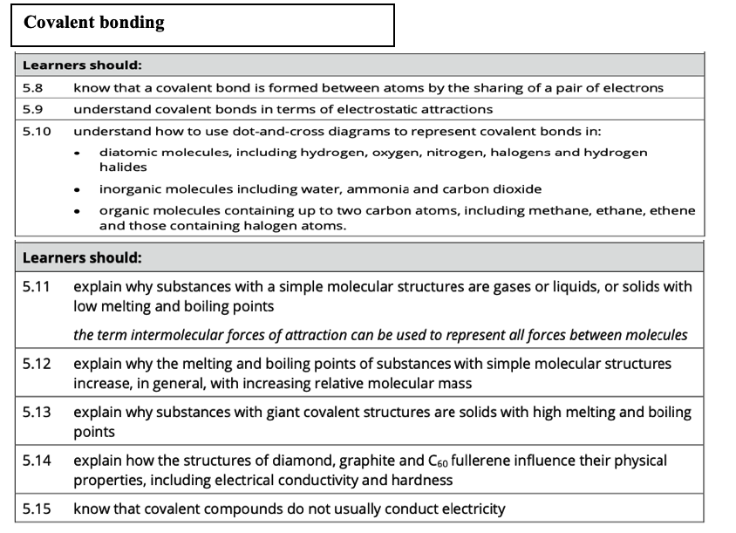
Covalent bonding:
* What is a covalent bonding?
A pair of electrons is shared between two (non-metal) atoms, which are attracted to both nuclei of the atoms in the bond.
-Each atom will gain a full outer shell of electrons.
-When two or more atoms are chemically bonded together, a molecule is formed.
- A dot and cross diagram represents the number of electrons in the outer shells of each atom in a molecule.
Question one page 96.
State whether each of the following compounds is ionic or covalent.
a) MgO b) CH₃Br c) H₂O₂
d) FeCl₂ e) NaF f) HCN

1) Hydrogen molecule H₂
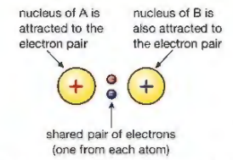


-A hydrogen atom has one electron in its shell.
-To gain a full shell, it requires one more electron. It can do this by overlapping its shell with another hydrogen atom. (shared pair attracted to nuclei of both atoms)
-One pair of electrons is shared between two atoms, therefore a single covalent bond is formed.
-Hydrogen molecules are said to be diatomic because they contain two atoms.

* Why does hydrogen form molecules?
Whenever a bond is formed, energy is released, and that makes the things involved more stable than they were before. The more bonds an atom can form, the more energy is released and the more stable the system becomes.
The H₂ molecule is much more stable than two separate hydrogen atoms.

2) Covalent bonding in a chlorine molecule (Cl₂).
A chlorine atom which is a non- metal has 7 electrons in its outer shell. Each Cl shares 1 electron so that both Cl atoms will have 8 electrons in their outer shell.
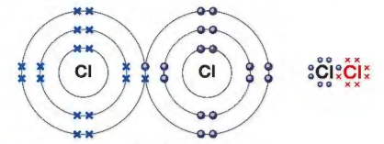
Question:
Exam tip:
Use dots to represent the electrons from one atom and crosses to represent for the other.
Draw dot- and- cross diagrams to show the covalent bonding in:
i) Br₂ ii) HCl

3) Covalent bonding in an oxygen molecule (double bond):

Oxygen has six electrons in its outer most shell, so requires two more. It can do this by overlapping its shell with another oxygen atom and sharing two pairs of electrons. This is called a double bond O=O
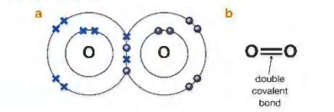
4) The triple bond in nitrogen molecule:

Nitrogen has 5 electrons in its outer most shell, therefore it requires 3 more electrons.
When bonding, each nitrogen atom shares 3 electrons.
Therefore, in a nitrogen molecule there are 3 shared pairs of bonding electrons, this forms a triple bond.

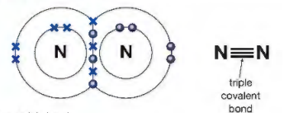

Exam style question:
Draw dot- and- cross diagrams to show the covalent bonding in:
i) NH₃ ii) CO₂

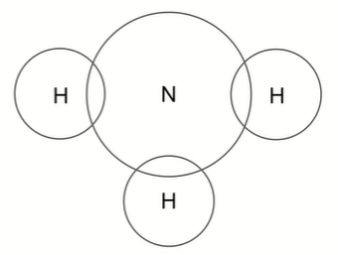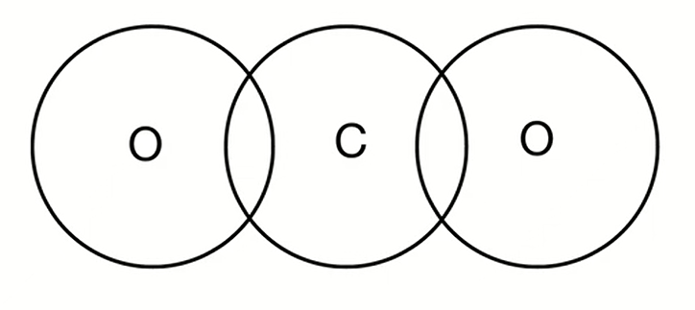

Electrostatic attractions
There is a strong electrostatic attraction between the shared pair of electrons and the nuclei of the atoms involved, since the electrons are negatively charged and the nuclei are positively charged.

- A covalent bond is represented by a short straight line between the two atoms, H-H.

- Sharing electrons in the covalent bond allows each of the 2 atoms to achieve an electron configuration similar to a noble gas, this makes each atom more stable.

5) Covalent bonding in Methane, ammonia and water:

A) Methane:
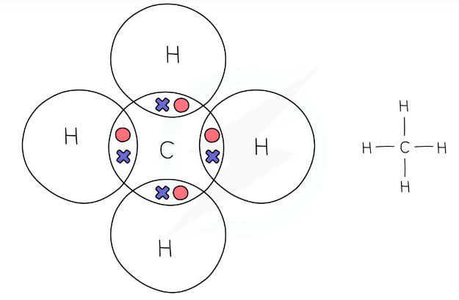

B) Draw dot-and -cross diagram to show the covalent bonding in ammonia
(NH₃) and water.
i) NH₃ ii) H₂O

6) Covalent bonding in slightly more complicated organic molecules:
A) Ethane:
Ethane has the formula of C₂H₆. There is a carbon-carbon covalent bond as well as the carbon- hydrogen bonds.
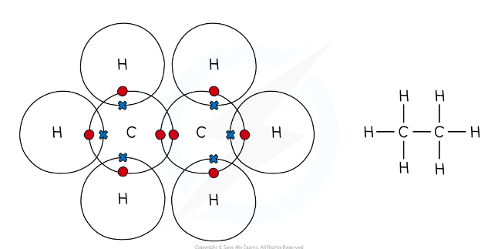
B) Ethene:
Ethene has a formula C₂H₄.
It has two hydrogen atoms attracted to each carbon atom and a double bond between the carbon atoms.

Question:
Draw dot-and -cross diagram to show the covalent bonding in ethene.

Homework:
Draw dot-and -cross diagram to show the covalent bonding in chloroethane
(CH₃CH₂Cl).

8) Organic molecules containing halogen atoms:

1) Bromomethane (CH₃Br):
The 3 H atoms and the Br atom are joined to the central C atom.
Br is in group 7, we know that it has 7 electrons in its outer shell. Therefore, we know that Br will form just one covalent bond.
When you draw a dot-and -cross diagram for CH₃Br you will only be asked to show the outer electrons.

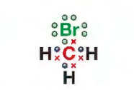

2) Chloroethene (CH₂CHCl):
Remember that C will form four covalent bonds, H will form one and Cl will form 1.
Draw the dot-and-cross diagram:

Note:
There are a few examples you may encounter where the central atom has more or fewer than 8 electrons.
1) BF₃: boron is the central atom and the Fs are the outer atoms. Each F will share 1 other electron to have 8 electrons in its outer shell.

Boron has 3 electrons in its outer shell, it is the maximum number of electrons it can share.
2) SO₂ (sulfur dioxide): The central atom is S. Each O atom has 6 electrons in its outer shell, so we will need to share the 2 other electrons to have 8 electrons in the outer shell.
So, the S atom shares 2 electrons with each of the O atoms to form double bonds.

In Sulfur (IV) oxide, sulphur originally had six electrons in its outer shell, if it shares four electrons, it has 10 electrons in its outer shell.

Homework: Q2 (b) page 96.
*Covalently bonded substances maybe simple molecular structures, or giant covalent structures.
Exam-Style-Question:
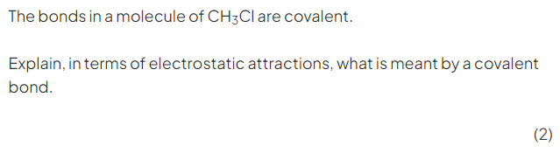

A) Simple molecular structures:

Simple molecular structures have covalent bonds joining the atoms together, but the intermolecular forces that act between neighbouring molecules.

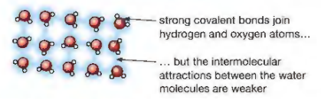

* For water:
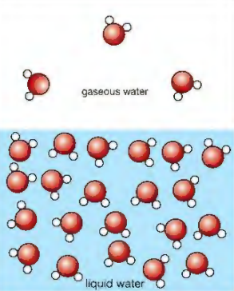
* Only the intermolecular forces are broken when water evaporates/boils.
- The intermolecular forces between molecules are much weaker than covalent bonds.
- When a substance consists of molecules with intermolecular forces of attraction between them, we say it has a simple molecular structure.
For example, CO₂, CH₄, …
- Most simple molecular structures are either gases or liquids at room temperature.
- They can be solids with low melting and boiling points but this is less common.

*Properties of simple molecular structure:
1) They have relatively low melting and boiling points because:
-They have strong covalent bonds
-There are weak intermolecular forces between the molecules.
-These forces require little energy to overcome

2) As the molecules increase in size, the melting and boiling points generally increase because the strength of these intermolecular forces increases and so more energy is needed to overcome them.

Note: the larger the molecule (Mr) the stronger the intermolecular forces:
Ethane (M_{r}= 30) has a boiling point -89°C.
Butane (M_{r}= 58) has a boiling point of -1°C.

3) Do not conduct electricity as there are no free electrons or ions to move and carry a charge.
- Most covalent compounds do not conduct at all in the solid state & are thus insulators.

4) Covalent molecular compounds tend to be insoluble in water, but they are often soluble in organic solvents.
- There are some exceptions to this: ethanol and substances such as NH₃ and HCl that react with water as they dissolve.

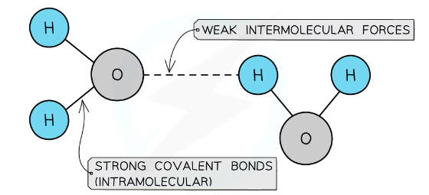
Exam tips:
1) Bonds do not break during melting and boiling.
2) We are using the term covalent molecular compounds with a simple molecular structure.
3) Intermolecular forces are not the same as bonds.

Exam style questions:
1)
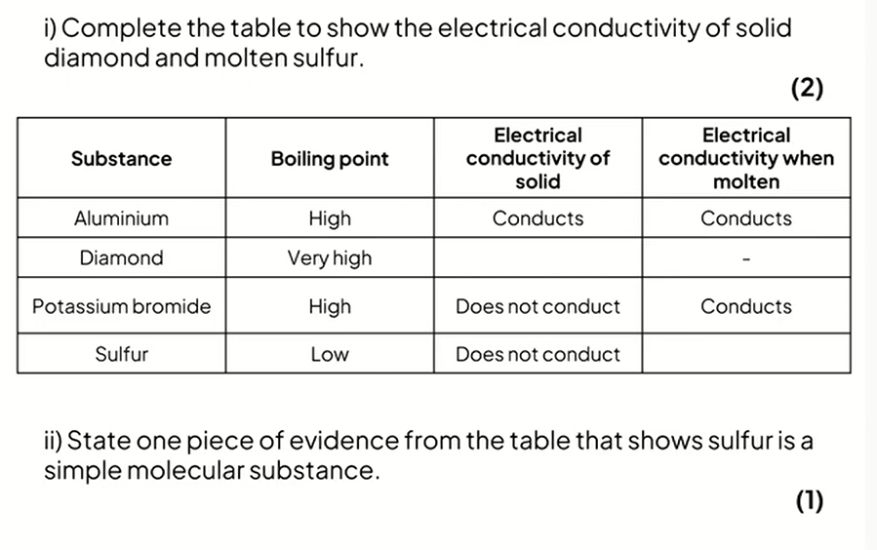
2)
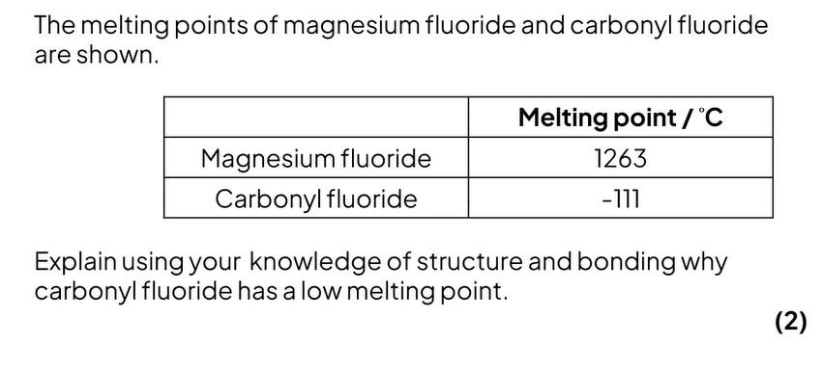

B) Giant covalent structures:

General points:
- Giant covalent structures are solids with high melting points.
- They have a huge number of non-metal atoms bonded to other non-metal atoms via strong covalent bonds, these structures can also be called giant lattices and have a fixed ratio of atoms in the overall structure.
- Two examples include diamond and graphite.
- All giant covalent structures have high melting points because:
-There are strong covalent bonds between atoms.
-These require lots of energy to overcome.

Diamond & graphite:
- Diamond and graphite are allotropes of carbon.
(Allotropes are different forms of the same element)
- Both substances contain only carbon atoms but due to the differences in bonding arrangements they are physically completely different.

Diamond:
In diamond, each carbon atom bonds with four other carbons, forming a tetrahedron structure. Each covalent bond is very strong.
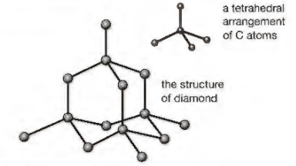
What are the physical properties of diamond?
1) Diamond is very hard because:
-A lot of energy has to be supplied to break the strong covalent bonds in the giant structure.
-Each carbon atom is covalently bonded to four other carbon atoms
The covalent bonds are very strong, and they will form a tetrahedral structure.
-Diamond being hard makes it useful for cutting tool.

2) Diamond has a high melting point because:
-It has a giant covalent structure.
-There are strong covalent bonds between atoms which need lots of energy to break the bonds.

3) Doesn't conduct electricity: all the electrons in the outer shells of the carbon atoms are tightly held in covalent bonds between the atoms, non-are free to move.
Exam Tip:
Diamond is the hardest naturally occurring mineral, but it is by no means the strongest.
Students often confuse hard with strong, thinking it is the opposites of weak.
Diamonds are hard, but brittle- that is, they can be smashed fairly easily with a hammer.

Graphite:
Each carbon atom in graphite is bonded to three others forming layers of hexagons (structure), leaving one free electron per carbon atom.

What are the physical properties of graphite?
1) Graphite is soft and slippery, because:
-Each carbon atom is bonded to three other carbon atom forming layers
-The layers are free to slide over each other because there are only weak forces between the layers, not covalent bonds.
- Graphite is used in pencils.

2) Graphite can conduct electricity and heat, because:
-Due to each carbon atom only forming three bonds, one electron from each carbon atom is delocalised.
-The delocalised electrons are free to move and carry a charge through the structure.
Graphite is similar to metals in that it has delocalised electrons

3) Graphite has a high melting point because:
-It has a giant covalent structure.
-There are strong covalent bonds between atoms which need lots of energy to break.

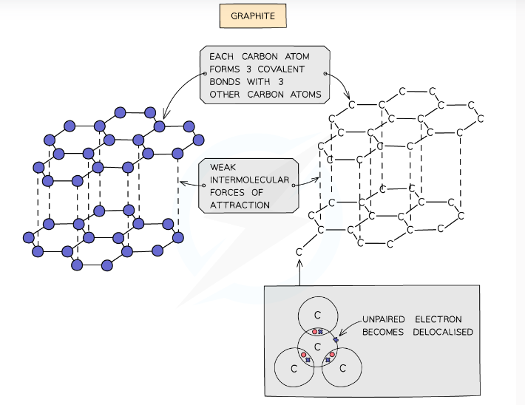
Exam style questions:
Question one:
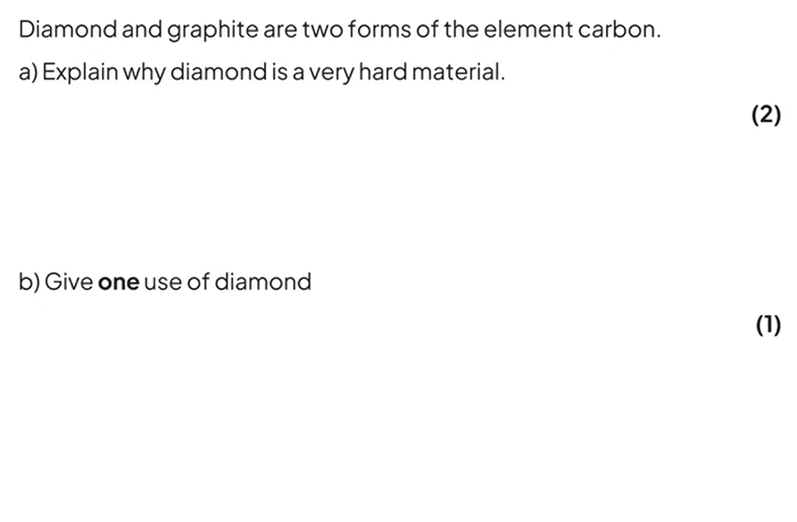

Question two:
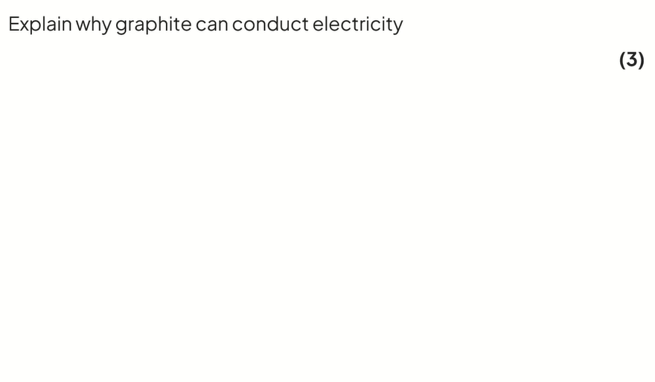
Question three:
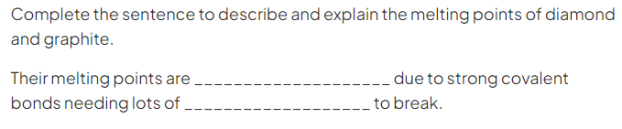

Question four:
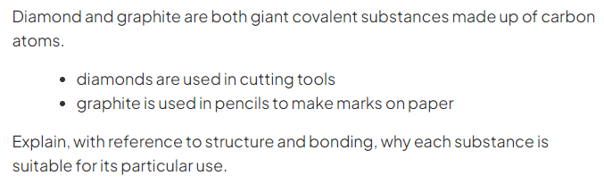
__________________________________________________________
__________________________________________________________
__________________________________________________________
__________________________________________________________
__________________________________________________________
__________________________________________________________
__________________________________________________________
__________________________________________________________
Remember: Explaining the melting point for any giant covalent structure is always the same:
- They have giant covalent structures
- There are many strong covalent bonds
- These need lots of energy to break

* C₆₀ fullerene:
-Another allotrope of carbon is C₆₀ fullerene.
- * C₆₀ fullerene consists of molecules that form hollow tubes or spheres and has a simple molecular structure.
- In solid or liquid C₆₀ fullerene there are molecules with weak intermolecular forces between them.

Uses:
1) Transport for medicines around the body.
2) Trapping other molecules by forming around the target molecule and capturing it, making them useful for targeted drug delivery systems, the medicine can fit inside the C₆₀ fullerene as it will not react with the blood or medicine and they are non-toxic.
3) Some fullerenes are excellent lubricants and are starting to be used in many industrial processes.

What are the physical properties of C₆₀ fullerene?
1) It has lower melting and boiling points than diamond and graphite.
C₆₀ fullerene has a simple molecular structure. Only weak intermolecular forces of attraction must be broken, so less energy is required to overcome the forces to separate the molecules.

2) It is not as hard as diamond.
It does not take as much energy to break the intermolecular forces of attraction in C₆₀ fullerene compared to breaking the strong covalent bonds in diamond.
3) It does not conduct electricity.
Although all the carbon atoms in C₆₀ fullerene only form three bonds, the fourth electron on each atom can only move around within each C₆₀ molecule. The electrons cannot jump from molecule to molecule.

Exam style question:
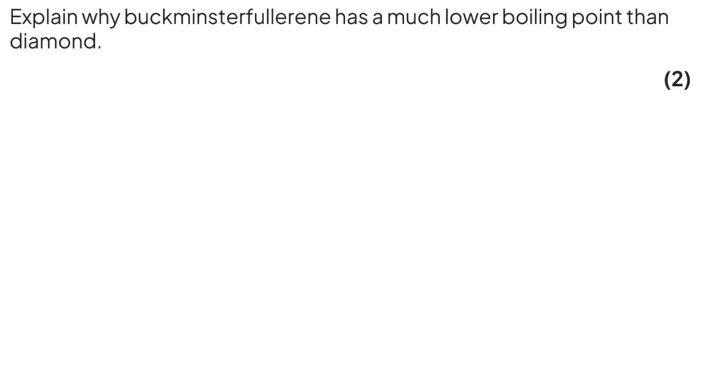
Homework: Q5and Q 7 page 97.
Metallic bonding:

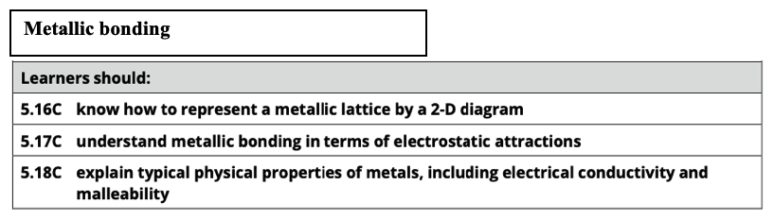
Metallic bonding:
- Metals consist of giant structures of atoms arranged in a giant metallic lattice (regular pattern) of positive ions in a sea of delocalized electrons.
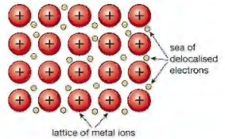
Exam tip:
Learn how to draw this structure.

Metals have giant structures, it means that there are no individual molecules and ALL the positive ions in the lattice attract ALL the delocalized electrons.

Within the metal lattice, the atoms lose their outer electrons and become positive ions.
The outer electrons no longer belong to any specific metal atom and are said to be delocalized. This means they can move freely between the positive metal ions and act like a "sea of electrons".

- Metallic bonding is the electrostatic forces of attraction between each + ion and delocalized electrons. This holds the structure together.
- This type of bonding occurs in metals and metal alloys.

What are the properties of metals?
1) Most metals have high melting and boiling points as there are strong electrostatic forces of attraction between positive metal ions and the negative delocalized electrons within the giant metal lattice structure. This needs lots of energy to be broken.

2) Metals conduct electricity when solid or molten: because the delocalized
electrons are free to move randomly through the structure.

3) Most metals are malleable (this means they can be hammered into shape) and ductile (they can be drawn into wires). This is because positive ions are arranged in layers which can slide over each other when force is applied.

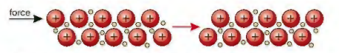

Exam style question:

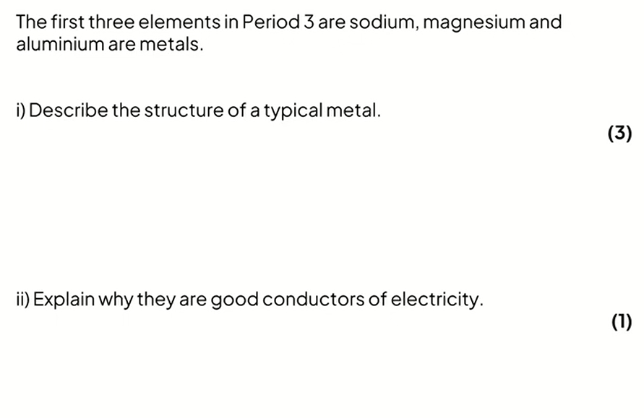
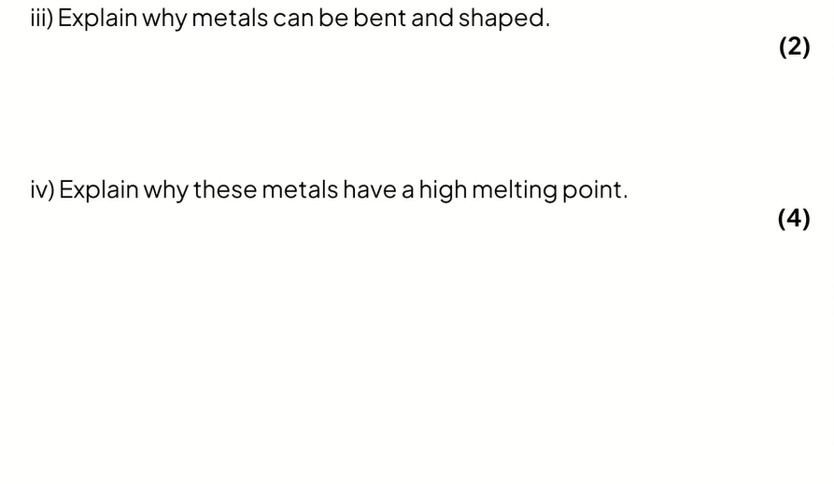

Sodium and magnesium metallic differences:
- In sodium, metallic bonding is quite weak, because there is 1 delocalized electron for each Na+ ion.
- In magnesium, metallic bonding is stronger as there is 2 delocalized electrons, therefore greater forces of attraction between positive ion and delocalized electrons, which results a higher melting point (more energy is required to overcome forces of attraction).
The more delocalized electrons, the stronger the metallic bonding.

Key points:
-We discussed ionic compounds and how they conduct electricity when molten or in aqueous solution because the ions are free to move.
-Ionic substances do not conduct electricity when solid because the ions are not free to move.
-Metals conduct electricity when solid or molten, because the delocalized electrons are free to move.
It is important not to confuse this:
* ionic substances: ions move.
* metals: electrons move.

Homework: Q1 main book page 100.

