

Rosary School – Marj Elhamam
Covalent and metallic bonding
Name: _________________ |  | Date: ___ /___ / 2025
Grade: 9( A,B,C ,D) |  | Subject :Chemistry  Past paper questions

Question one:
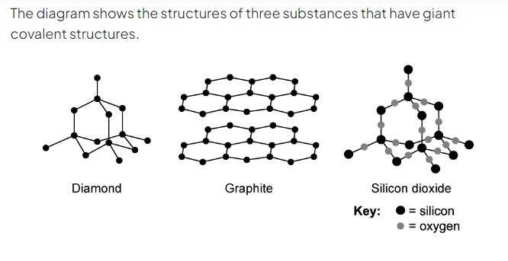
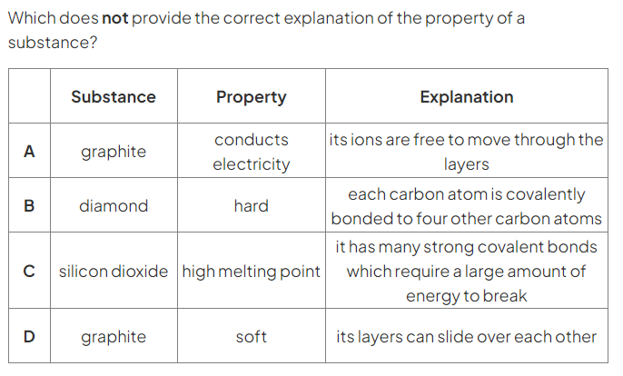
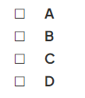
(3)
Question two:
A)
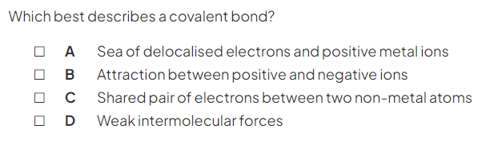
(1)
B)
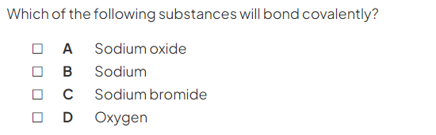 (1)
C)
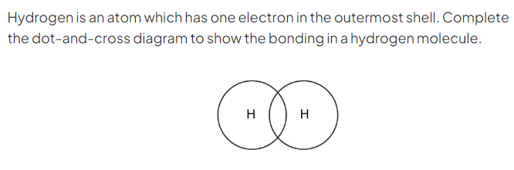(1)

Question three:
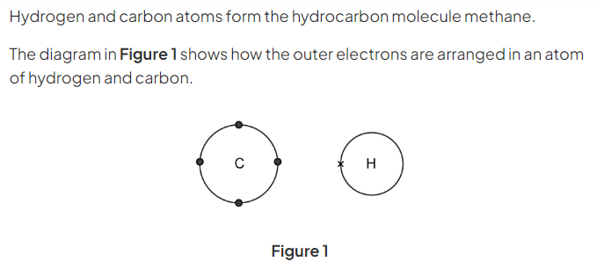
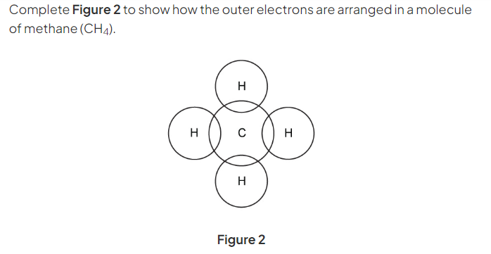
(2)
B)
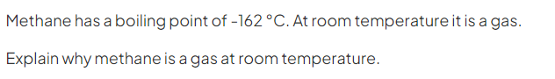(3)
________________________________________________________________
________________________________________________________________________________________________________________________________

Question four:
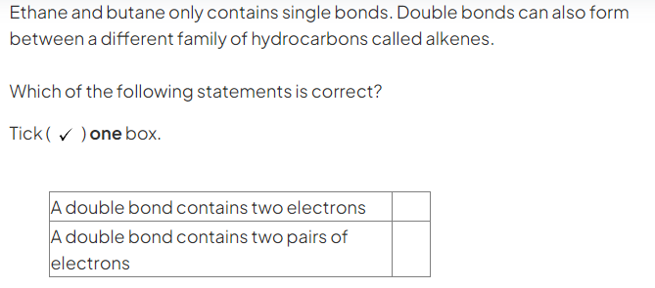(1)
Question five:
a)
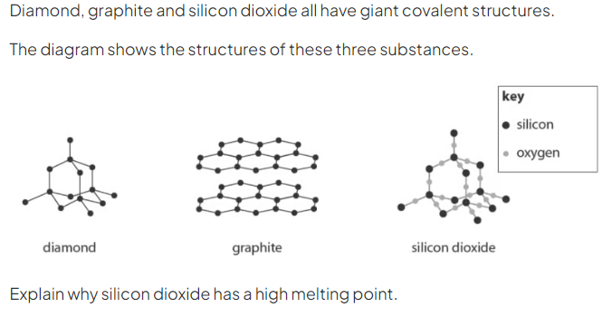______________________________________________________________
______________________________________________________________
(2)
b)
_____________________________________________________________
_____________________________________________________________
(2)
C)
___________________________________________________________
___________________________________________________________
(2)
Question six:
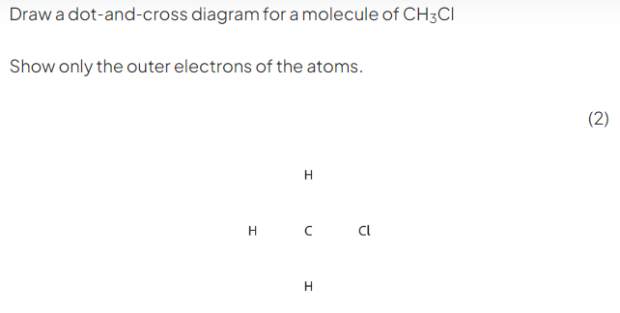

Question seven:
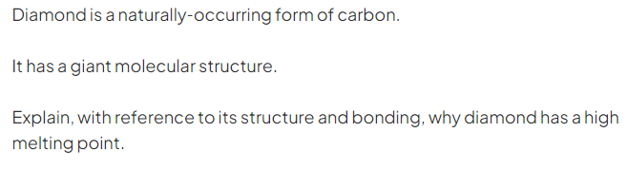
________________________________________________________________
________________________________________________________________
________________________________________________________________
(3)
Question eight:
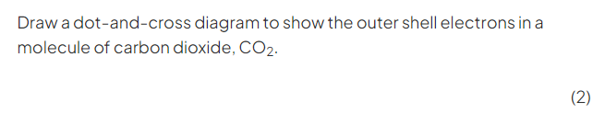

Question nine:
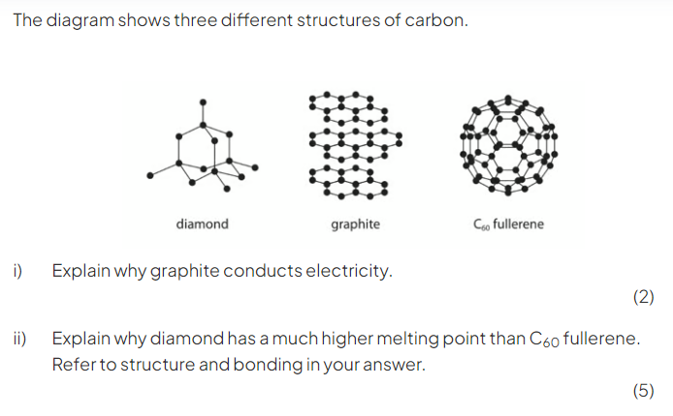
________________________________________________________________
________________________________________________________________
________________________________________________________________
________________________________________________________________
________________________________________________________________
________________________________________________________________

Question ten:
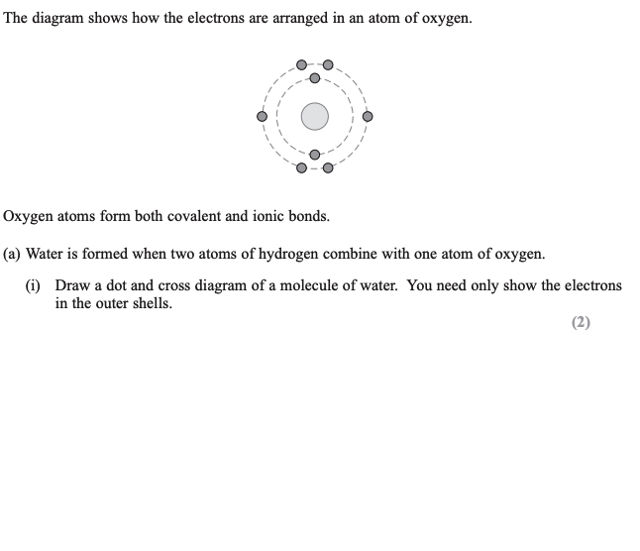
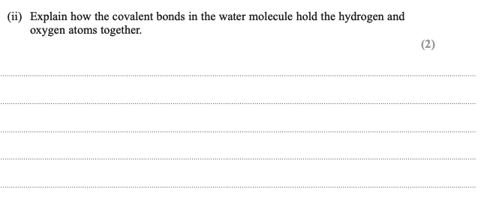

Question eleven:
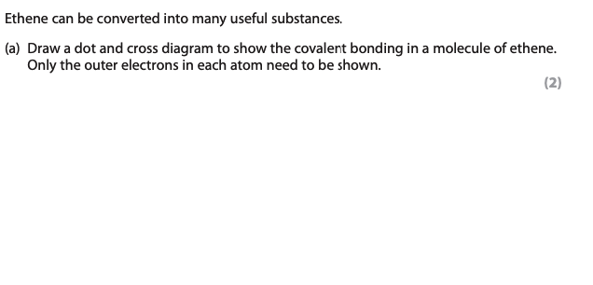

Metallic bonding:
Question one:
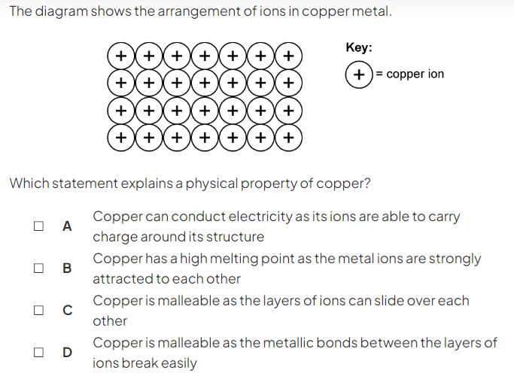(1)

Question two:
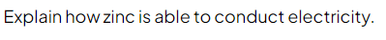
______________________________________________________________
______________________________________________________________
(2)
Question three:
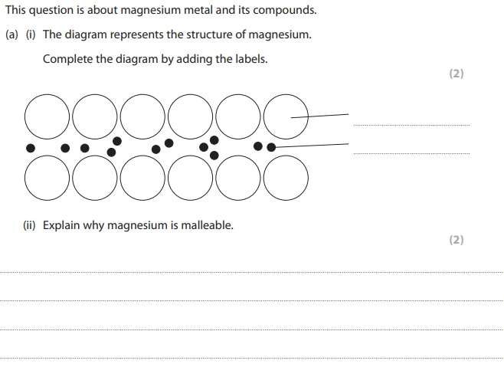

Revision questions:
Question one:
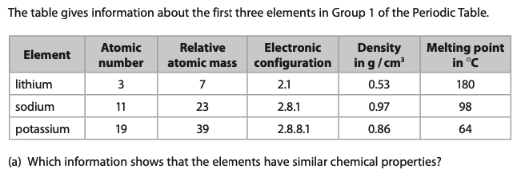
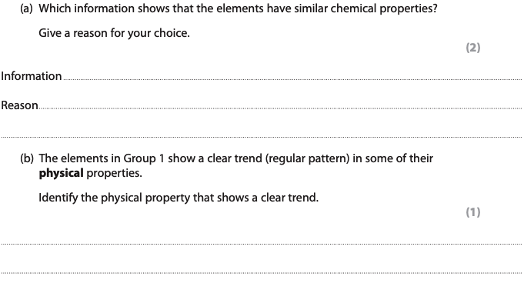
Question two:
