

Rosary School – Marj Elhamam

Name: _________________ |  | Date: __ /__ / 2025
Grade: 9( A,B,C ,D) |  | Chemistry summary notes  4XCH1

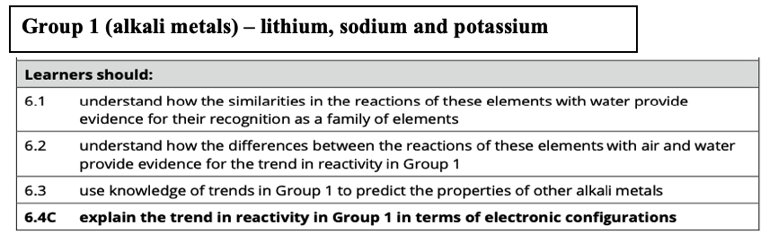
Unit 2: Alkali metals
- The Group 1 metals are lithium, sodium, potassium, rubidium, caesium and francium and they are found in the first column on the left side of the Periodic Table.
- Group 1 metals are known as the alkali metals.
- They all have 1 outer electron.
- The group 1 metals get more reactive as you look down the group.
- The alkali metals share similar characteristic chemical properties because they each have one electron in their outermost shell. (They all have the same number of electrons in the outer shell).
- Group 1 –physical properties:
- They are all soft metals which can easily be cut with a knife, becoming softer as you move down the group.
- They have relatively low densities and low melting and boiling points (relative to other metals/ metals in different groups).
- The melting point and boiling point decrease down the group due to decreasing attractive forces between outer electrons and positive ions and the density increases going down the group.
- They are shiny and silver when freshly cut.
Exam tip:
- Make sure you name them alkali metals not alkaline metals.
- Be careful to state how the trend changes by referencing the group.

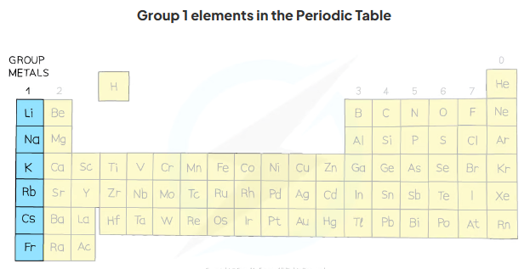

Chemical properties of the group 1 metals:
- They react quickly with oxygen in air to form an oxide, so they are stored under oil to stop them from reacting.
- They all react with water to form a hydroxide with the formula MOH (e.g. LiOH, NaOH), and hydrogen.
- They form ionic compounds which contain an M⁺ ion (e.g. Na⁺, K⁺)

Note: To stop Cs, and Fr from reacting they are sealed in glass tubes to avoid contact with oxygen.

Reaction with water
The general pattern shown is:
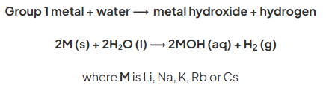
- The hydroxides formed all have the same general formula and are colourless, aqueous solutions.
*Trends in Group 1
The reactions of the alkali metals with water get more vigorous as you descend the group.
Examiner tip:
Remember the group 1 metals all produce alkaline solutions (>pH 7) when they react with water. Lithium will produce a solution of lithium hydroxide; sodium will produce a solution of sodium hydroxide and so on.
Make sure you can give the reaction equations with the correct state symbols to show what is happening during the reactions!
Summary of the reactions of the first three alkali metals with water:
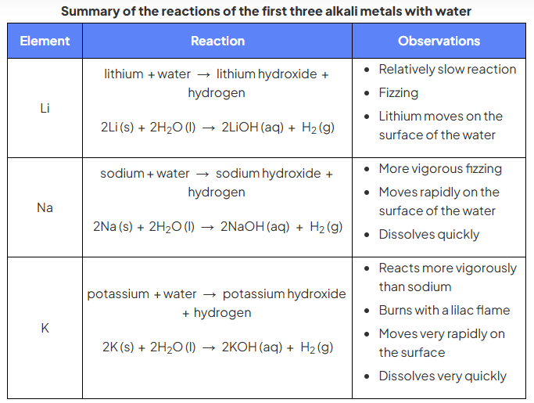
The main observations that are made when:
1) sodium reacts with water:
* The sodium floats because it is less dense than water.
* The sodium melts into a ball because its melting point is low and a lot of heat is produced.
* There is fizzing due to the formation of hydrogen gas.
*The sodium moves around on the surface of the water because hydrogen gas isn’t given off symmetrically around the Sodium ball, therefore Sodium is pushed around the surface of water.
* The piece of Sodium gets smaller and eventually disappears because it is used up in the reaction.
2)lithium reacts with water:
*There is fizzing.
*Lithium doesn't melt, instead it floats.
*Lithium moves on the surface of water more slowly.
*Lithium takes longer time to disappear/to get smaller than sodium.
3) potassium reacts with water:
* Potassium catches fire.
* Potassium moves around very rapidly on the surface of water and at the end of the reaction Potassium will explode, and cause spitting around.
*Potassium dissolves very quickly
* Testing the solution: universal indicator is added to the water. The water turns purple/blue indicating an alkaline solution has been formed.
Rubidium, and caesium reaction with water:
* They react more violently than reaction of potassium with water and the reaction can be explosive.

Examiner tip:
You could be asked to make predictions about how rubidium would be expected to react with water, knowing that it lies below potassium in group1.
Words like ‘explosively’ and ‘violently’ would be good ones to
Choose when describing the reaction.

Exam-Style-Questions
Question one:
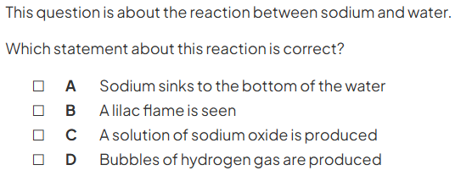
Question two:
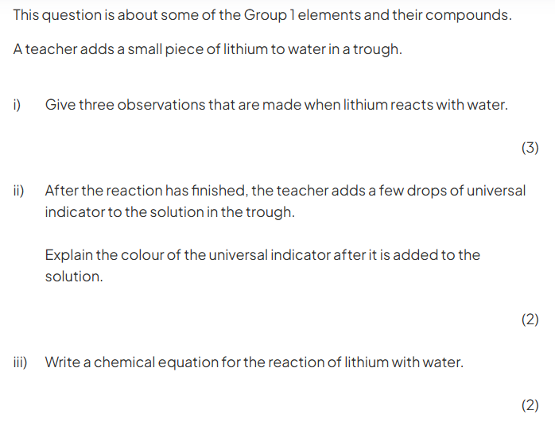

Predicting the properties of francium:
As we move down a group in the Periodic Table the properties of the elements change gradually. So, if we know the properties of most of the elements in a group, we should be able to predict the properties of elements we don't know.
We can predict that francium:
- ________________________________________________________
________________________________________________________
- ________________________________________________________
________________________________________________________
- ________________________________________________________
________________________________________________________
- ________________________________________________________
________________________________________________________

Exam tip:
If you are asked to compare potassium with sodium use phrases such as:
-fizzes more vigorously.
-moves around more quickly.
-disappears more quickly.

-disappears more quickly.

Example exam questions:
Question one:
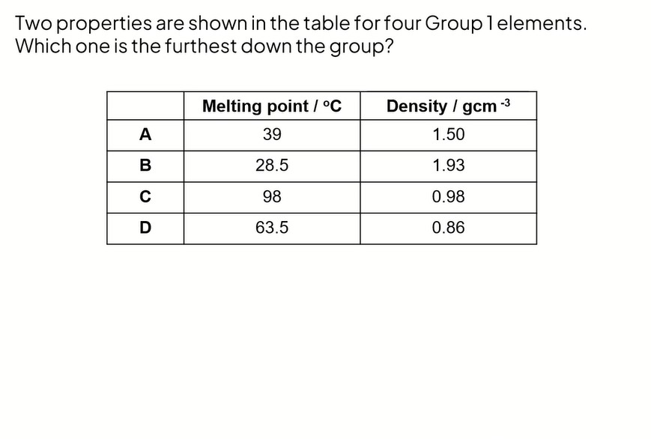

Question two:

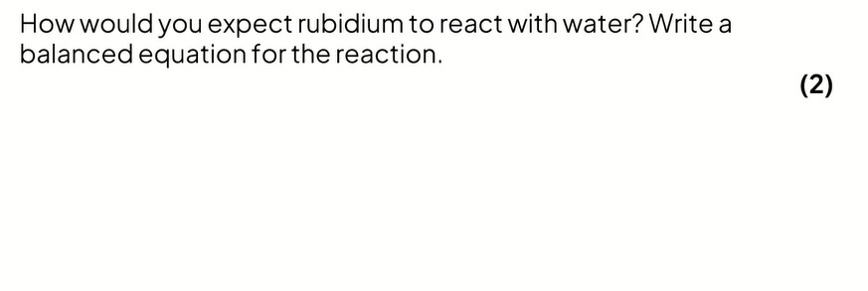

Reactions of the alkali metals with oxygen
- The alkali metals react with oxygen in the air forming metal oxides, which is why the alkali metals tarnish when exposed to the air, (therefore they are stored in oil).
- The metal oxide produced is a dull coating which covers the surface of the metal.
*The metal tarnish more rapidly as you go down the group.
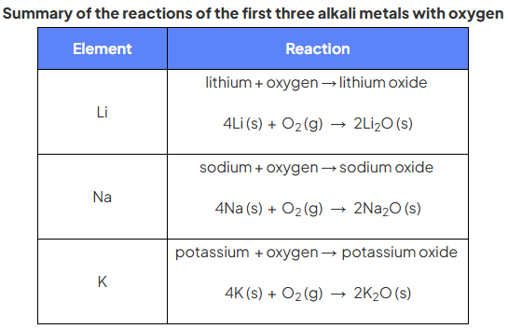

Notes:
* Lithium tarnishes more slowly than sodium.
* Potassium tarnished more quickly than sodium.
* If we heat each of the metals in air using a Bunsen burner. The have the following observations:
-Lithium burns with a red flame to form lithium oxide.
-Sodium burns with a yellow flame to form sodium oxide.
-Potassium burns with a lilac flame to form potassium oxide.

Electronic configuration of Group 1 elements
- The reactivity of the Group 1 metals increases as you go down the group
- When a Group 1 element reacts its atoms only need to lose electron, and forming metal ions in solution. For example:
Na (s) Na⁺ (aq) + e⁻
The next shell down automatically becomes the outermost shell and since it is already full, a Group 1 ion obtains noble gas configuration.
Explaining the increase in reactivity:
As we move down the group, the atoms have more shells of electrons and get bigger: a sodium atom is bigger than a lithium atom and a potassium atom is bigger than a sodium atom. As the atoms get bigger, the outer electron, which is the one lost in the reaction, is further from the nucleus. Because it is further from the nucleus it is less strongly attracted by the nucleus and therefore more easily lost.
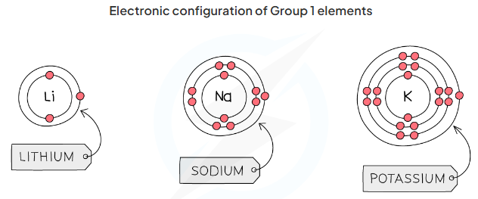

Summarizing the main features of the group 1 elements:
Group 1 elements:
- are metals.
- are soft with melting points and densities which are very low for metals.
- have to be stored out of contact with air or water.
- react rapidly with air to form coatings of the metal oxide.
- react with water to produce an alkaline solution of the metal hydroxide and hydrogen gas.
- increase in reactivity as you go down the group.
- form compounds in which the metal has a 1+ ion.
- have mainly white/colourless compounds which dissolve to produce colourless solutions.

Example exam question:
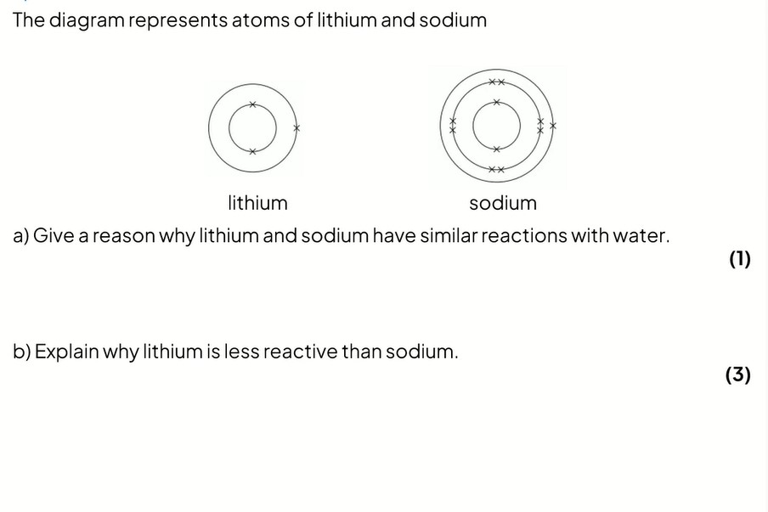

Homework: Q2,3 and 4 page 129.

