

Rosary School – Marj Elhamam
Unit Two: Chapter 4
Name: _________________ |  | Date: ___ / ___ / 2025
Grade: 9 (A, B, C, D) |  | Biology summary notes

Food and digestion
Objectives:
2.7 Identify the chemical elements present in carbohydrates, proteins and lipids (fats and oils)
2.8 Describe the structure of carbohydrates, proteins and lipids as large molecules made up from smaller basic units: starch and glycogen from simple sugars, protein from amino acids, and lipid from fatty acids and glycerol
2.9 Practical: investigate food samples for the presence of glucose, starch, protein and fat
2.24 Understand that a balanced diet should include appropriate proportions of carbohydrate, protein, lipid, vitamins, minerals, water and dietary fibre
2.25 Identify the sources and describe the functions of carbohydrate, protein, lipid (fats and oils), vitamins A, C and D, the mineral ions calcium and iron, water and dietary fibre as components of the diet
2.26 Understand how energy requirements vary with activity levels, age and pregnancy
2.27 Describe the structure and function of the human alimentary canal, including the mouth, oesophagus, stomach, small intestine (duodenum and ileum), large intestine (colon and rectum) and pancreas
2.28 Understand how food is moved through the gut by peristalsis
2.29 Understand the role of digestive enzymes, including the digestion of starch to glucose by amylase and maltase, the digestion of proteins to amino acids by proteases and the digestion of lipids to fatty acids and glycerol by lipases
2.30 Understand that bile is produced by the liver and stored in the gall bladder
2.31 Understand the role of bile in neutralising stomach acid and emulsifying lipids
2.32 Understand how the small intestine is adapted for absorption, including the structure of a villus
2.33B practical: investigate the energy content in a food sample

We need food for three main reasons:
- to supply us with a ‘fuel’ for energy
- to provide materials for growth and repair of tissues
- to help fight disease and keep our bodies healthy.
The food that we eat is called diet.
A balanced diet:
A diet that provides enough of all of the food groups in the correct proportions.
- There are seven main food groups. These are:
carbohydrates – proteins – lipids – dietary fibre – vitamins – minerals and water.

Carbohydrates
- Function: Main source for supplying body cells with energy.
- Sources: bread, cereals, pasta, rice, and potatoes.
- Made up of the elements carbon, hydrogen, and oxygen.
- Most of the carbohydrates in our body comes from starch.
Starch:
1.Large, insoluble molecule 2. Polymer of glucose.
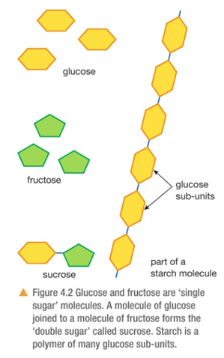
- Three main types of carbohydrates are:

- Monosaccharides: glucose and fructose (fruit sugar), galactose.

- Disaccharides: are made of two monosaccharides joined together, examples: sucrose, lactose, and maltose.

- Polysaccharides: polymers of sugars, such as starch, glycogen, and cellulose.

Lipids: (Fat and oils)
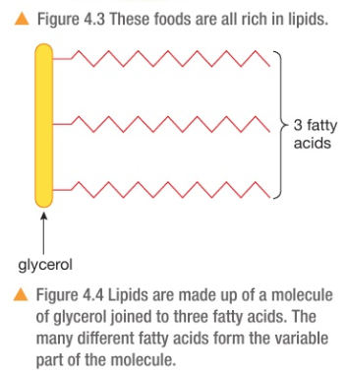
- Function: energy storage and insulation (reducing heat loss through the surface of the body) and help to protect organs from mechanical damage such as the heart and kidneys.
- Animal lipids are solid at room temperature (Fat)
- Plant lipids are liquid at room temperature (oil)
- Sources: oil, butter, meat, cheese, eggs, and milk.
- It consists of the elements carbon, hydrogen, and oxygen.
- The building blocks for lipids are glycerol and 3 fatty acids.
- There are many different fatty acid molecules, which give us the many different kinds of lipid found in food.

Proteins:
- Function: growth and repair of tissues.
- Sources: meat, fish, cheese, eggs, beans, peas, and nuts.
- Made up of the elements: carbon, hydrogen, oxygen, nitrogen, and sometimes sulfur.
- The building blocks for proteins are amino acids.
- Change in the order of the amino acids, changes the chemical structure of the protein, leading the different proteins being produced.
- Enzymes, collagen, keratin in skin and nails, haemoglobin and hormones are made of protein.
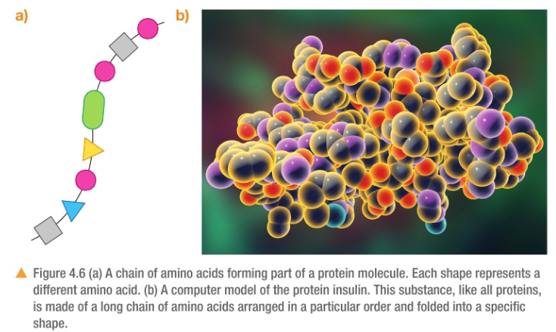

Exam Tip:
Study the main function and sources of each.

Exam Style Question
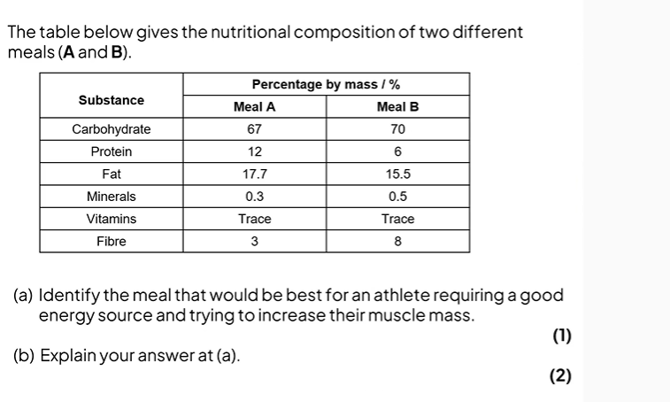

Minerals and Vitamins:
Needed in small quantities to maintain health.
Some examples of minerals:
- Calcium:
- Function: making teeth, bones and is involved in the clotting of blood.
- Sources: dairy products, fish, bread, vegetables.
- Deficiency: Rickets (The bones become deformed).

- Iron:
- Function: is needed to make haemoglobin in red blood cells which help carry oxygen.
- Sources: red meat, liver, eggs, some vegetables (spinach).
- Deficiency: anaemia (tired and lack energy).

Some examples of vitamins:
- Vitamin A:
- Function: making a chemical in the retina; also protects the surface of the eye.
- Sources: fish liver oils, liver, butter, margarine, carrots.
- Deficiency: night blindness, damaged cornea of the eye.

- Vitamin C:
- Function: sticks together cells lining surfaces such as the mouth (forms an essential part of the collagen protein, which makes up the skin, hair, gums and bones).
- Sources: fresh fruit and vegetables.
- Deficiency: scurvy (where wounds fail to heel, and bleeding occurs in various places in the body especially in the gums).

- Vitamin D:
- Function: helps bones absorb calcium and phosphate, and is required for strong bones and teeth).
- Sources: fish liver oils, also made in the skin from sunlight.
- Deficiency: rickets, poor teeth.
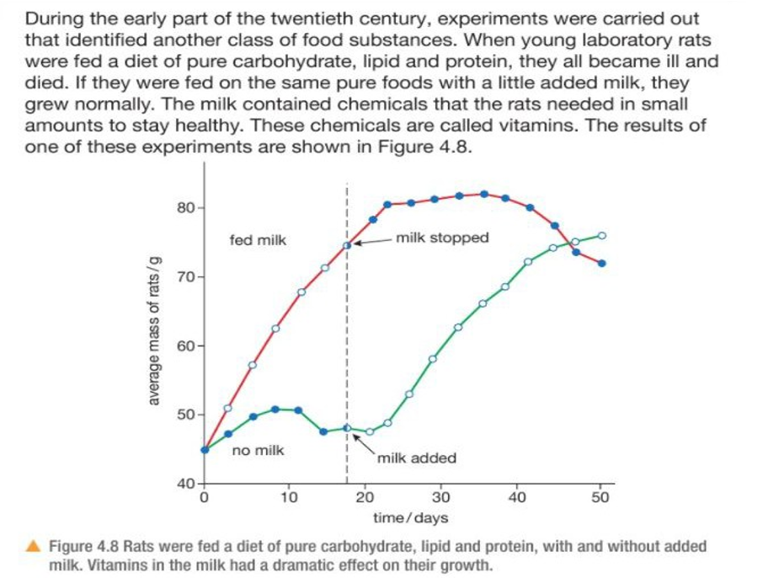

Water:
- Function: needed for chemical reactions to take place in the body.
- Sources: water, juice, milk, fruit and vegetables.
- Deficiency: dehydration.

Dietary Fibre:
- Function: provide bulk (roughage) for the intestine to push food through it.
- Sources: vegetables, whole grains.
- Deficiency: constipation, colitis (inflammation of colon), bowl cancer.

Food Test
Activity 3: Study from book p. 58
Exam Style Question

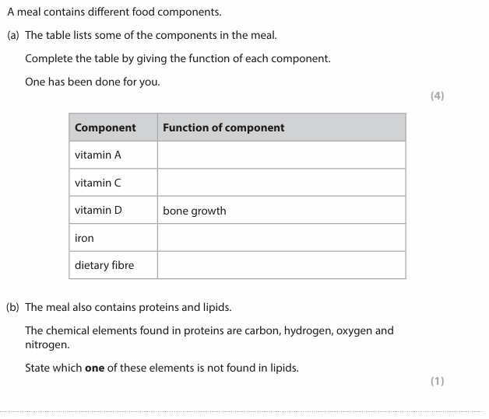

Energy From Food
-We need energy in order to:
1. keep warm.
2. keep your heart beating.
3. allow messages to be sent through your nerves and for other body function.

Variation in Energy Requirements
- The nutritional requirements for individuals will vary throughout their lifetime
- An individual will still require the same key food groups, but in different quantities depending on a number of factors such as age, height, sex, activity levels, pregnancy and breastfeeding
  - The amount of energy that young people need increases towards adulthood as this energy is needed for growth Children need a higher proportion of protein in their diet than adults as this is required for growth. Energy needs of adults decrease as they age.
  - The more active, the more energy required for movement as muscles are contracting more and respiring faster.

  - During pregnancy, energy requirements increase as energy is needed to support the growth of the developing fetus, as well as the larger mass that the mother needs to carry around. Extra calcium and iron are also needed in the diet to help build the bones, teeth, and blood of the fetus
  - For breastfeeding mothers, energy requirements increase and extra calcium is still needed to make high-quality breast milk
  - Male average energy requirements tend to exceed that of females due to them having a larger proportion of muscle compared to fat.
- Food scientists measure the amount of energy in a sample of food by burning it in a calorimeter. The calorimeter is filled with oxygen, to make sure that the food will burn easily.
A heating filament carrying an electrical current ignites the food. The energy given out by burning food is measured by using it to heat up water flowing through a coil in the calorimeter.

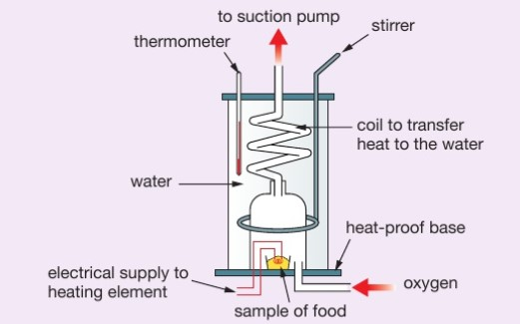

A food Calorimeter

Activity 4: Study from course book pages 60 and 61
Homework: Q6 & Q10 page 69

Digestion:
- Is the chemical and mechanical breakdown of food. It converts large insoluble molecules into small soluble molecules, which can be absorbed into the blood and delivered to cells in the body.

- Digestion is speed up by the enzymes, although most enzymes stay inside cells, the digestive enzymes are made by the tissues and glands in the gut and pass out of cells.
Peristalsis:
- Waves of muscular contraction that push food along the alimentary canal.
- Peristalsis is controlled by circular and longitudinal muscles, contraction of each will have a different effect on the alimentary canal.
Step One: Circular muscles contract.
The lumen narrows behind the food.
Step Two: Contraction of longitudinal muscles ahead of food.
The alimentary canal shortens in front of food.
Step Three: Circular muscle layer contract to push the food forward.
- Mucus produced to continually lubricate the food and reduce function.
-Dietary fibre provides the roughage required for the muscles to push against during peristalsis.

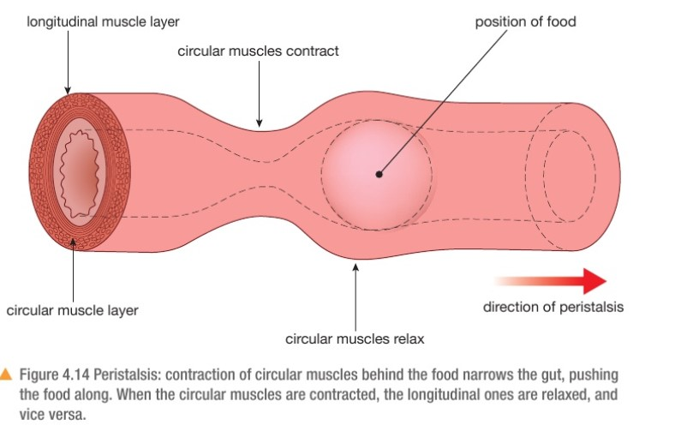

Exam Tips:
1. These muscles work together to push food forward.
2. Mucus & fibres will facilitate the process of peristalsis.

Exam Style Question
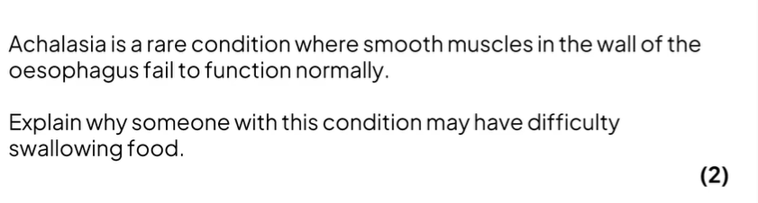

The Digestive System
-The human digestive system is made up of the organs that form the alimentary canal.
-The alimentary canal is the passage through which food flows through the body, starting at the mouth and ending at the anus.
-The mouth, stomach and the first part of the small intestine (called the duodenum) all break down the food using enzymes, either made in the gut wall itself, or by glands such pancreas.
-Digestion continues in the last part of the small intestine (called the ileum) and it is here that the digested food is absorbed.
-The last part of the gut, the large intestine, is mainly concerned with absorbing water out of the remains and storing faeces.
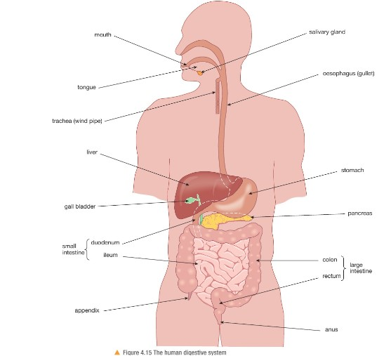

The role of digestive enzymes
There are three types of digestive enzymes:
1. Carbohydrases: are enzymes that break down carbohydrates to simple sugars such as glucose.
2. Proteases: are enzymes that break down proteins into amino acids.
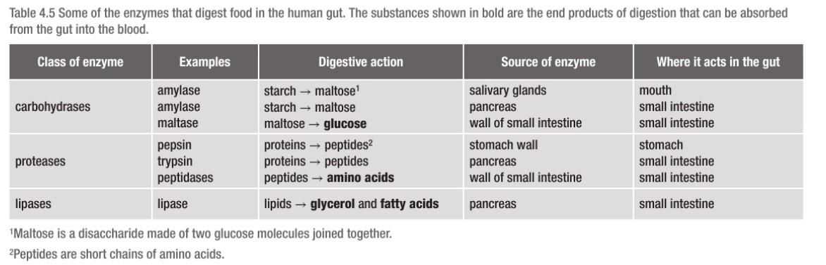
3. Lipase: are enzymes that break down lipids to glycerol and fatty acids.

Exam Tips:
1. Remember that enzymes remain unchanged and are reused.
2. Maltose is made up of two glucose molecules.
3. Amino acids are the building blocks of proteins.

Exam Style Question
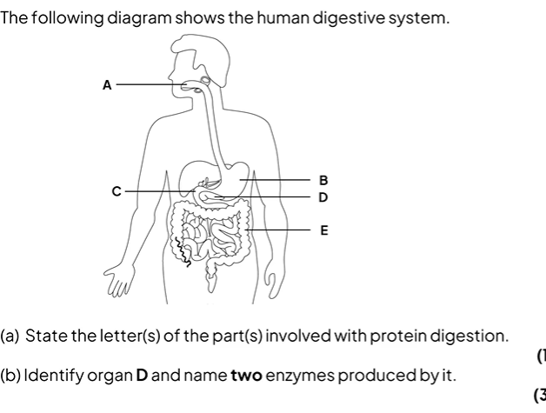

Alimentary Canal: Structure and function
1. Mouth:
- Digestion begins in the mouth.
- Teeth chew food to break it into smaller pieces (mechanical digestion) to increase the surface area for enzyme to work
- Saliva helps moisten the food and contains the enzyme amylase, which starts the breakdown of starch into maltose (chemical digestion).

2. Oesophagus:
- The tube that connects the mouth to the stomach.
- No digestion.
3. Stomach:
- Initial digestion of protein takes place.
-Stomach wall secretes hydrochloric acid to kill bacteria in food and provide the optimum pH (2) for protease enzyme (pepsin) to work.
- The semi-digested food is held back in the stomach by a ring of muscle at the outlet of the stomach called sphincter muscle, when it relaxes it releases the food into the duodenum.

- Small intestine:
A-In the duodenum
1. Several digestive enzymes are added to the food which are made by the pancreas (produces all 3 types of enzymes: amylase, protease & lipase) and digest starch, protein and lipids.
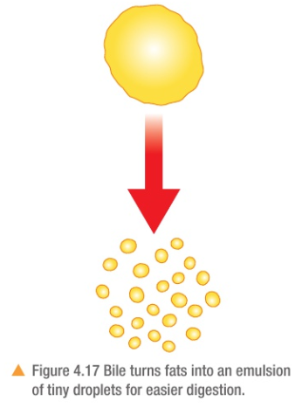
2. The liver make a digestive juice called bile (green liquid that is stored in the gall bladder with no enzyme).
- Function of the bile: It turns any large lipid into an emulsion of tiny droplets. This increases the surface area of the lipid so that lipase enzymes can break it down more easily.
Bile and pancreatic juice have another function. They are both alkaline to neutralize the acidity of the food coming from the stomach to set the optimum pH for enzymes.

B-In the ileum:
1. Is where the absorption of water and digested food molecules take place.
2. The ileum is long and lined with villi to increase the surface area over which absorption can take place.

Adaptations of the small intestine:
-Absorption: is the movement of small digested food molecules from the digestive system into the blood (glucose and amino acids) and lymph (fatty acids and glycerol).
- absorption of small soluble molecules occurs through diffusion and sometimes active transport.
- The small intestine is adapted for absorption as:
1. It is very long.
2. It has a highly folded surface with millions of villi
These adaptations massively increase the surface area of the small intestine allowing absorption to take faster and more efficiently.
Structure of a villus:
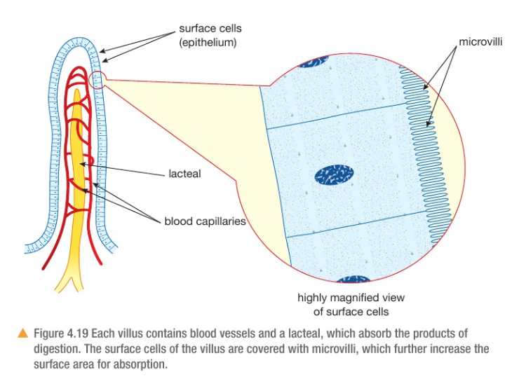

-They are tiny, finger like projections.
-Villi have several specific adaptations which allow for the rapid absorption of substances, such as
1. Large surface area: Microvilli on the surface oof the villus further increases the surface available for the absorption.
2. A short diffusion distance: the wall of a villus is only one cell thick called an epithelium making it easier for the products of digestion to diffuse through and enter the blood. The epithelium cells contain many mitochondria, which supply the energy needed for active transport of some substances.
3. A steep concentration gradient:
a. The villi are well supplied with a network of blood capillaries that transport glucose and amino acids away from the small intestine in the blood.
b. a lacteal (lymph vessel) runs through the centre of the villus to transport fatty acids and glycerol away from the small intestine in the lymph.
c. Enzymes produced in the walls of the villi assist with chemical digestion.
d. The movement of the villi (peristalsis) helps to move food along and mix it with the enzymes present.

Note: the blood vessels from the ileum join up to form a large blood vessel called the hepatic portal vein, which leads to the liver. The liver acts rather like a food processing factory, breaking some molecules down, and building up and storing others. For example, glucose from carbohydrate digestion is converted into glycogen and stored in the liver. Later, the glycogen can be converted back into glucose when the body needs it.

Assimilation: is the movement of the digested food molecules into the cells of the body where they are used to build new parts of cells.

Exam Style Question
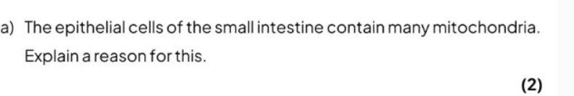

Homework : Q5 p.67

The large intestine:
The function of the first part of the large intestine, called the colon, is to absorb most of the remaining water, leaving a semi-solid waste material called faeces. This is stored in the rectum, until expelled out the body through the anus.

Notes:
1.Water is absorbed (by osmosis) primarily in the small intestine, but also in the large intestine.
2. Food taken into the body goes through several different stages during its passage through the alimentary canal.
1. Ingestion.
2. Mechanical digestion
3. Chemical digestion.
4. absorption.
5. Assimilation
6. Egestion (is the passing out of the food that has not digested or absorbed as faeces through the anus).

