

Rosary School – Marj Elhamam
Chapter4: Food and digestion
Past paper questions
Name: _______________ |  | Date: ___ / ___ / 2025
Grade: 9 (A, B, C, D) |  | Subject: Biology IG
Question One
The diagram shows part of the gut of a rabbit.
The rabbit is a primary consumer and eats mainly grass and other vegetable material.
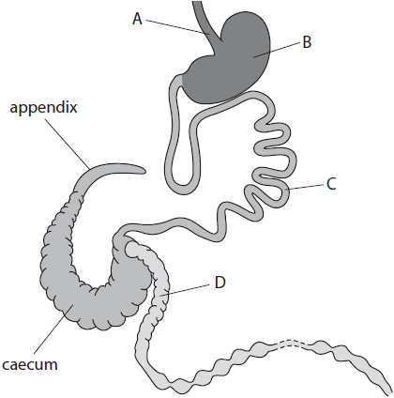
(a) Name the parts labelled A, B, C and D.
(4)
A ......................................................................................................................
B ......................................................................................................................
C ......................................................................................................................
D ......................................................................................................................
(b) The gut of a rabbit has a large caecum and appendix. These contain bacteria that are able to produce the enzyme cellulase.
Explain how these bacteria help the rabbits with their diet of plant material.
(3)
.............................................................................................................................................
.............................................................................................................................................
.............................................................................................................................................
.............................................................................................................................................
.............................................................................................................................................
.............................................................................................................................................
(c) The human gut has a caecum and appendix but they are much smaller than those in the rabbit.
(i) Suggest why the human gut only has a small caecum and appendix.
(1)
.............................................................................................................................................
.............................................................................................................................................
.............................................................................................................................................
(ii) In humans the appendix also acts as a store of useful bacteria. Scientists have discovered that patients who have had their appendix removed are more likely to develop infections of the colon.
Explain how having no appendix may increase the likelihood of bacterial infections of the colon.
(2)
.............................................................................................................................................
.............................................................................................................................................
.............................................................................................................................................
.............................................................................................................................................
Question Two:
Cow's milk contains a mixture of nutrients, including protein, fat, sugar, vitamins, and minerals.
(a) (i) The main sugar in milk is a carbohydrate called lactose.
Which chemical elements are present in carbohydrates?
(1)
A carbon and hydrogen only
B carbon, hydrogen, and oxygen only
C carbon, hydrogen, and nitrogen only
D carbon, hydrogen, nitrogen, and oxygen
(ii) Describe how to test a sample of milk for protein.
(2)
.............................................................................................................................................
.............................................................................................................................................
.............................................................................................................................................
.............................................................................................................................................
(b) Some people drink a milk alternative produced from plants, such as soy and rice, instead of milk produced by animals.
The table shows nutritional information for different milk products.
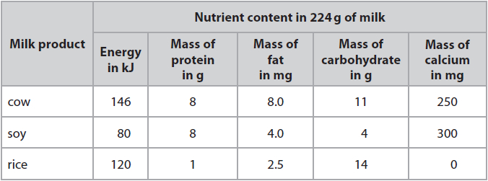
(i) The recommended daily amount of calcium for a child is 1400 mg.
Calculate the mass of cow's milk that would contain 1400 mg of calcium.
(2)
mass = ........................................................... g

(ii) Discuss whether soy milk or rice milk is a suitable replacement for cow's milk in the diet of children.
(5)
.............................................................................................................................................
.............................................................................................................................................
.............................................................................................................................................
.............................................................................................................................................
.............................................................................................................................................
.............................................................................................................................................
.............................................................................................................................................
.............................................................................................................................................
.............................................................................................................................................
.............................................................................................................................................
.............................................................................................................................................
.............................................................................................................................................

Question Three:
(a) The diagram shows the human alimentary canal with structures labelled X, Y and Z.
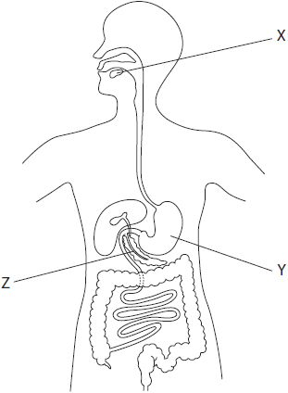
(i) Which of these structures produce amylase?
(1)
A X only
B X and Y
C X and Z
D Y and Z
(ii) Table 1 gives the names of some enzymes, the molecules they digest, and the products formed.
Complete Table 1 by giving the missing information.
(3)
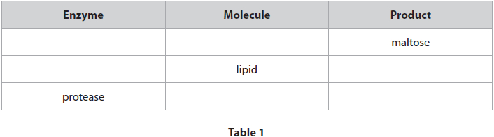

(b) Table 2 shows the recommended daily amounts (RDA) of some dietary components for a person.
Table 2 also shows the actual amounts of these dietary components in a person's diet in one day.
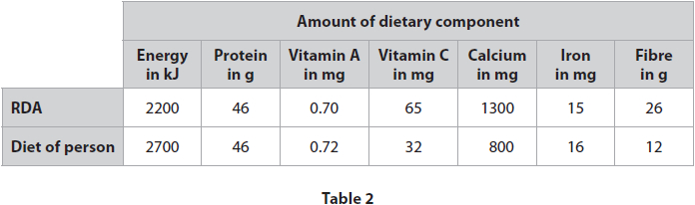
(i) One 100 g serving of lentils provides 25 g of protein.
Calculate the mass of lentils that contains 46 g of protein.
(2)
mass of lentils = ........................................................... g

(ii) Discuss the possible long-term effects of this person eating the same diet every day.
(5)
.............................................................................................................................................
.............................................................................................................................................
.............................................................................................................................................
.............................................................................................................................................
.............................................................................................................................................
.............................................................................................................................................
.............................................................................................................................................
.............................................................................................................................................
.............................................................................................................................................
.............................................................................................................................................
(iii) Suggest two reasons why the RDA for energy may not be the actual amount required by this person.
(2)
1 ..........................................................................................................................................
.............................................................................................................................................
2 ..........................................................................................................................................
.............................................................................................................................................
Question Four
Bread contains starch.
(a) Describe how you would test a piece of bread to show it contains starch.
(2)
........................................................................................................................
........................................................................................................................
........................................................................................................................
......................................................................................................................
(b) The diagram shows the mycelium of an organism growing on a piece of bread.
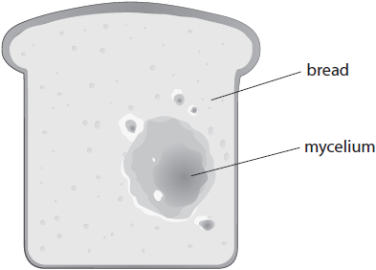
(i) Which type of organism is shown growing on the bread?
(1)
A bacterium
B fungus
C protoctist
D virus
(ii) Which enzyme is released by the organism to digest starch?
(1)
A amylase
B ligase
C lipase
D protease

Question 5:
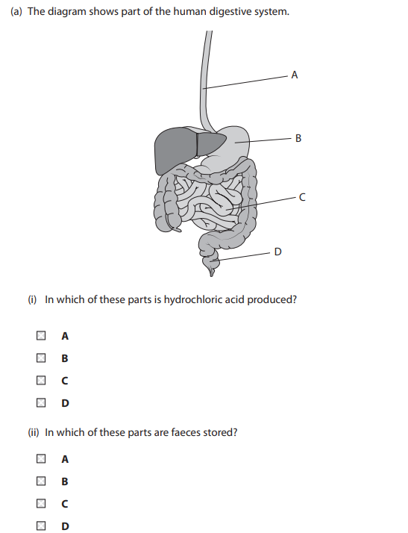
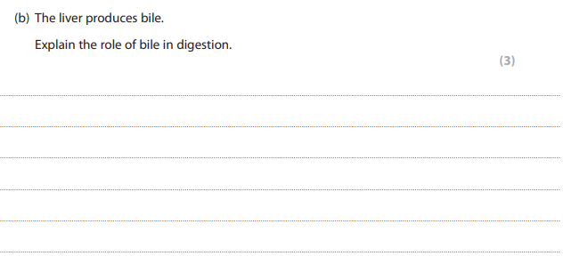
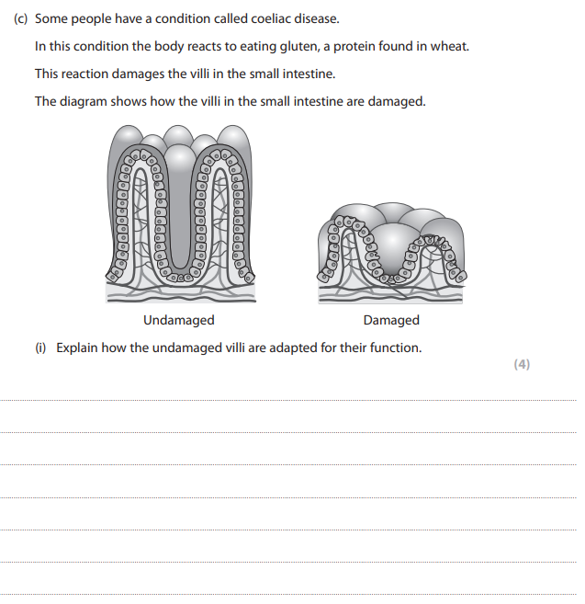
Question 6:
