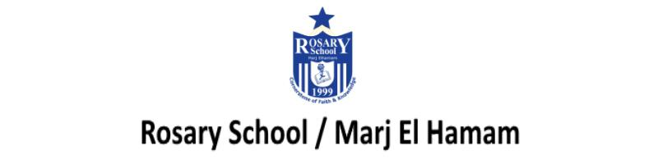

9Ga Ions ( course book answers pages 90-91)
Question one:
negative

Question two:
The negative charge of the electrons is balanced by an equal and opposite positive charge from the nucleus

Question three:
positive

Question five:
The electrons are able to move freely in the same direction , transferring energy to form an electrical current.

Question six:
S^{2–}

Question seven:
- positive or Mg²⁺
- lost

Question eight:
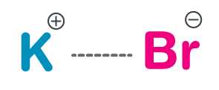
Question nine:
The ions cannot move in their solid state.

Question ten:
The sodium and chloride/salt ions in the sea water will carry an electrical current through the water, which may injure the swimmer.

9Ga Ions
Workbook answers pages 64 / 65

Question one:
nucleus; negative; positively; atom; loses

Question two:
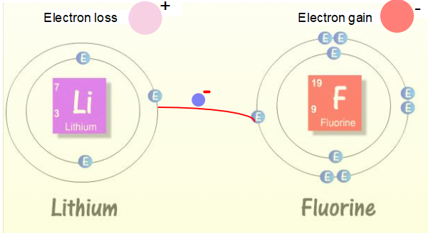

Question three:
The negative charge of the electrons is balanced by an equal and opposite positive charge from the nucleus.
Question four:
- 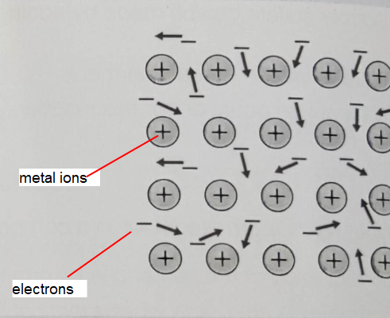
- i (Electrons are able to move) freely (and randomly) in all directions.
ii (The electrons are shared) between the metal ions.
iii (The structure is held together due to attraction) between negative electrons and positive metal ions.

Question five:
When a voltage is applied, the electrons in a metal move in the same direction, transferring energy and forming an electric current.

Question six:
ionic (bond)

Question seven:
B, C

Question eight:
- In a solid, the ions are held in place and cannot move. When molten or in solution, the ions can move to carry the current.

Question nine:
- sodium chloride
- Br− , bromide
- Sulfide , S²⁻
- 2−

Question ten:
- argon, Ar
- sulfur, S
- helium, He

