

Rosary School – Marj Elhamam
Study sheet 1
Name: _________________ |  | Date: / / 2025
Grade: 7 (A,B,C,D,E) |  | Subject : Biology
8B Plants and their reproduction

Learning Objectives
1) Describe the key characteristics of the five kingdoms of organisms and use this to assign organisms to their kingdoms (animals, plants, fungi, protoctists, prokaryotes).
2) Describe how organisms are classified into smaller and smaller groups based on their characteristics.
3) Explain how plants and animals are classified into the major groups (flowering plants, conifers, ferns, mosses, vertebrates, invertebrates, mammals, reptiles, fish, amphibians, birds, arthropods, molluscs, insects, arachnids).
4) Identify the genus and species names from a scientific name.
5) Explain why preserving biodiversity is important (useful products, organism interactions, enriches our lives, disaster recovery).
6) Correctly use the terms asexual reproduction and sexual reproduction.
7) Identify and give examples of inherited variation.
8) Describe how the fusing of gametes (sex cells) and their nuclei during fertilisation form a fertilised egg cell (zygote).
9) Explain how inherited variation is caused (does not include genes).
10) Explain the difference in outcomes of asexual and sexual reproduction in plants.
11) Identify and describe the functions of the main structures in a flower (including identification of which are male and which are female).
12) Describe what happens in pollination and use flower structure and pollen shape to identify wind-pollinated and insect-pollinated flowers.
13) Describe how the structures of a flower are adapted to their functions.
14) Describe how plants avoid self-pollination and ensure cross-pollination, and explain the reasons for this.
15) Describe the events that occur after pollination, leading to fertilisation and embryo formation.
16) Identify different structures within a seed.
17) Describe some ways in which seeds are dispersed (using fleshy fruits, wind, animals, water, explosions).
18) Explain the functions of the different parts of a seed.
19) Explain the importance of seed dispersal, and evaluate different methods of seed dispersal.
20) Describe a plant’s life cycle using a diagram.
21) Describe respiration, including its word equation (aerobic only).
22) Describe photosynthesis, including its word equation.
23) Describe what happens to the different parts of a seed during germination.
24) Explain the importance of pollination for the production of foods.
25) Describe examples of interdependence and explain how changes in a population or community in an ecosystem affect other populations.

8Ba Classification and biodiversity: (page 22+23)
Organisms are classified into kingdoms based on their characteristics, which are subdivided into smaller and smaller groups.
Refer to Photo B page 20 the last two groups are genus and species, which together give each species its scientific name.
Example: the scientific name of sunflowers Helianthus annuus.
genus: Helianthus species: annuus
Questions:
- What is the scientific name for a common sunflower?
Helianthus annuus

2-What do you notice about how scientific names are written?
Both words are in italics and the first word (genus) has a capital but the second word (species) does not. (Note: instead of writing a scientific name in italics, you can underline it instead.)

The Five Kingdoms
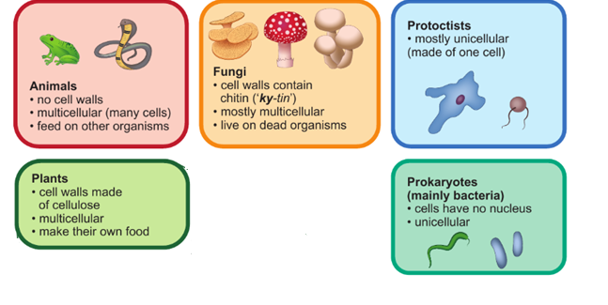
Plant Kingdom:
Plants have green leaves, have cell walls made of cellulose and can photosynthesise. This kingdom has four main groups:
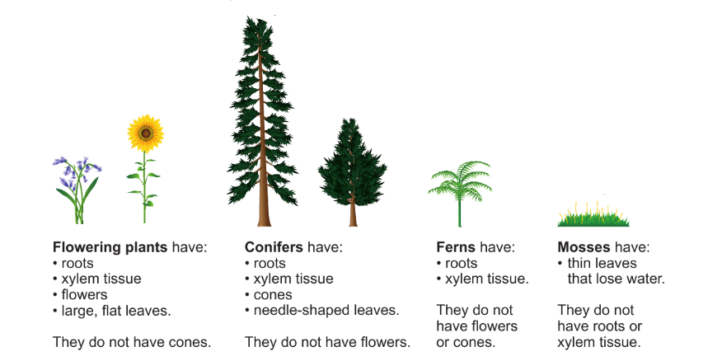

Animal kingdom:
Some main groups in the animal kingdom are:
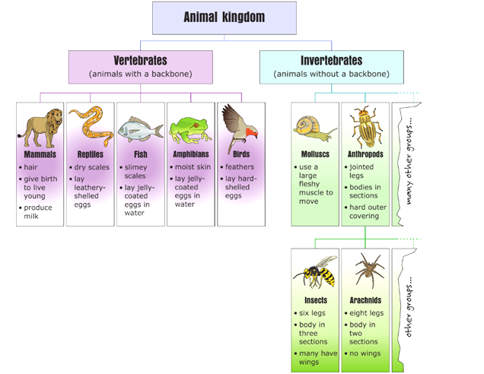

Question:
In the diagram above, which characteristics of birds are the same as reptiles, and which are different?
Birds and reptiles both have backbones/are both vertebrates, they are both animals, they both lay eggs. Birds and reptiles are different because birds have feathers but reptiles have dry scales, and the eggs that they lay have different shells.
Biodiversity: Number of different species in an area is called biodiversity.
We need preserve biodiversity because:
- organisms depend on one another (interdependent).
- useful products.
- more biodiverse areas recover faster if disaster strikes.

Question:
Which of these habitats do you think has the greatest biodiversity: tropical rainforest,
Arctic, desert? Explain your reasoning.
tropical rainforest, many more species live there
Workbook page 16 & 17

8Bb Types of reproduction: (page 26+27)
- Asexual reproduction in plants
Some plants can reproduce through asexual reproduction. This type of reproduction does not require gametes, as one parent plant can form a new plant. This means that the offspring will be identical to the parent. Examples include:
- runners in strawberries
- tubers in potatoes
- bulbs in onions and garlic
Gardeners use asexual reproduction to produce identical new plants quickly and cheaply. Often, they cut off a leaf or side stem from a plant and put it in moist soil. This is called taking a cutting. The cuttings grow roots and form new plants.
Asexual reproduction produces offspring that are all exactly the same as the parent. Asexual reproduction does not produce inherited variation but does allow plants to spread much faster than by using sexual reproduction
Questions:
- Tony has seven tubers from one plant in his garden, called Cyclamen persicum. When he plants the tubers, why can he be sure that they will all grow into plants that look the same?
The tubers are produced by asexual reproduction and come from only one plant. The new plants will all have the characteristics of the
parent plant.

- a- How is taking a cutting an example of asexual reproduction?
a plant is being grown from part of the parent plant/a new plant is produced using only one parent
b- Suggest one advantage of taking cuttings compared with collecting seeds from plants and growing them.
it is quicker, you can be sure what the new plants are going to look like

- Sexual reproduction in plants
Reproduction produces new living things (offspring). Sexual reproduction needs two parents to produce sex cells or gametes. The gametes fuse to produce a fertilised egg cell or zygote. The zygote uses cell division to grow into an embryo, which can grow into an adult and become a parent (completing its life cycle).
The offspring from sexual reproduction contain characteristics from both parents. The differences in these characteristics are inherited variation.
Questions:
- From photo A, describe one characteristic the plumcot has inherited from:
- apricots: shape, size b- Plums: skin and flesh colour
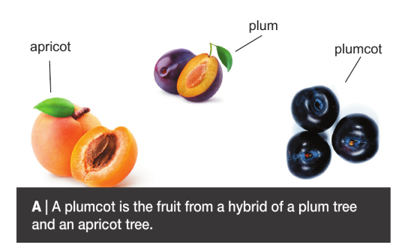
- What inherited variation is seen in photo B?
Flower colour
Workbook page 19.

8Bc Pollination: (page 28+29)
Flowering plants use flowers for sexual reproduction. Most flowers contain both male and female reproductive organs.
Male gamete in plants = pollen
Female gamete in plants = ovule.
Parts of a flower:
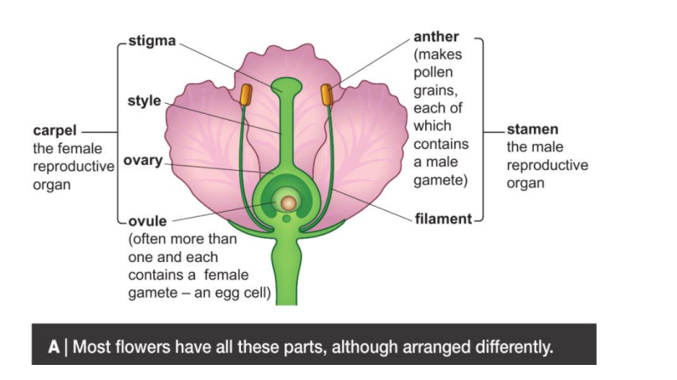
Question:
- Suggest two parts that you would find in an egg cell.
Nucleus, cytoplasm, cell surface membrane, mitochondria, cell wall
The pollen grains made in the anther need to be carried to the stigma of another flower.

Pollination: The transfer of pollen from an anther to a stigma.
* Pollination is carried out by:
1. animals (insects). 2. wind. 3. water

Flowers have different structures depending on how they are pollinated.
- Insect-pollinated flowers:
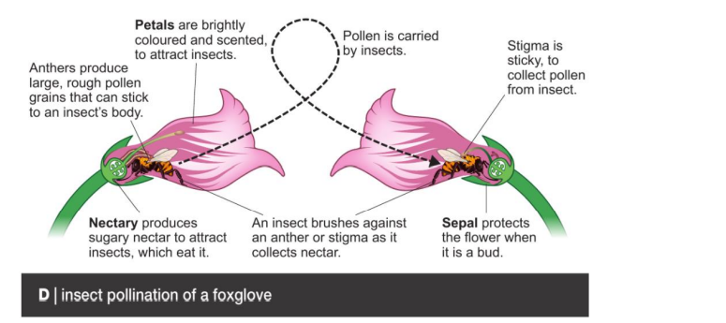
Plants that use animal pollinators have flowers with petals. They attract the animals (mainly insects) with scent, colours and nectar to eat.
Characteristics of insect-pollinated flowers:
- Petals: large brightly coloured.
- Anther position: within flower
- Stigma structure: sticky
- Scent: present
- Pollen grains large, rough and have spikes on them to stick to insect

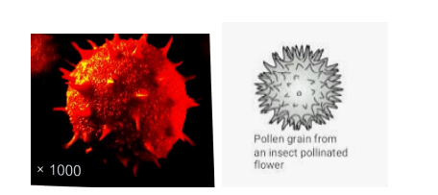

Questions:
- What is the function of the stigma?
to trap pollen grains
- How is it adapted to this function in insect-pollinated plants?
It is sticky
2)Wind-pollinated flowers:
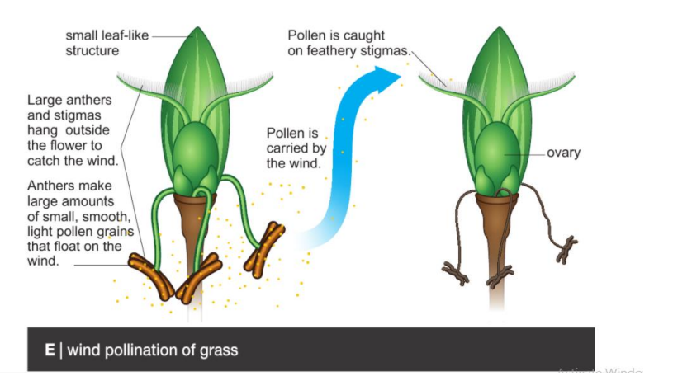
Characteristics of wind-pollinated flowers:
- Petals: none or very small.
- Anther position: hanging outside flower
- Stigma structure: feathery
- Scent: none
- Pollen grains: light, small and smooth so that they are easily carried by the wind
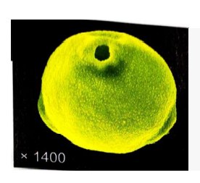
G H
Question:
Look at photos G and H. Which shows pollen from an insect-pollinated plant?
Explain your reasoning.
Photo H because the pollen grains are bigger and have spikes on them to stick to insects.
**What is the difference between cross- pollination and self - pollination?
Cross- pollination: when pollen is transferred from one plant to a different plant of the same species.0
Self-pollination: when pollen is transferred from a flower on a plant to a stigma in the same flower or to another flower on the same plant.
Workbook page 20, 21

8Bd Fertilisation and dispersal: (page 32+33
Once on the stigma, a pollen grain grows a pollen tube, which enters the ovule containing an egg cell. The nucleus from the male gamete inside the pollen grain joins with the nucleus inside the egg cell to form a zygote. This is called fertilisation. The zygote grows into an embryo and the ovule becomes a seed, containing the embryo and a food store.
Fertilisation: Fusing of a male gamete with a female gamete.
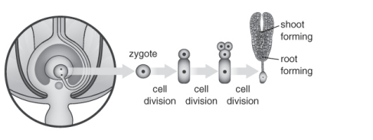
Questions:
- a- Describe how the nuclei from an egg cell and the male gamete reach one another, after pollination.
a A pollen grain grows a pollen tube down to the ovule, in which the egg cell is found. The male gamete is carried in the pollen tube to the egg cell in the ovule.
b-What is formed after the nuclei have fused?fertilised egg cell (zygote)
c-What is the name of this process? fertilisation
- How many cells will one cell become after cell division has happened three times?
Eight cells

Seeds and fruits:
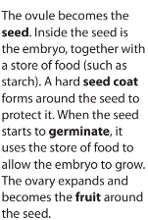

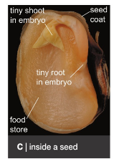

Seed Dispersal:
A part of the flower forms a fruit. This is used for seed dispersal, which stops the new plants competing with the parent plants for water, nutrients, light and space.
*Seed dispersal: The spreading of seeds away from a parent plant.
Methods of seed dispersal:
● Some fruits are eaten by animals and the seeds come out in their faeces (e.g. apples).
● Some fruits are carried on the fur of animals (e.g. burdock).
● Some fruits are carried by the wind (e.g. dandelion).
● Some fruits explode, scattering the seeds (e.g. lupins).
Questions:
- a- How do tomatoes spread tomato seeds?
The fruits are eaten and when the seeds are
egested from the animal they will be in a different place.
b- What protects the seeds?
Seed coat
c-Why do the seeds need protection?
to stop the seeds being digested in the digestive system
- Why is it important for dandelion seeds to be spread away from the parent plants?
so that the new plants are not in competition with the parents and so that the plant species can spread to new areas
Workbook page 23

8Be Germination and growth: (page 34+35)
When conditions are right, seeds germinate. The resources needed are water, oxygen and warmth (WOW). Water allows chemical reactions to start, which break down the food store and allows cells in the embryo to swell up. Oxygen is needed for respiration, to release energy from the food store. Warmth is needed to speed up the chemical reactions.
Germination: when a seed starts to grow.

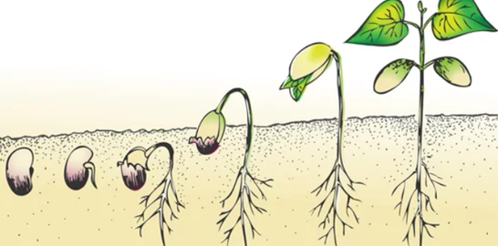

The root grows first then the shoot. Finally, new leaves open and photosynthesis can start in the chloroplasts. The glucose from photosynthesis is turned into starch to be stored. The mass of material produced is biomass. Photosynthesis can be summarized as a word equation:
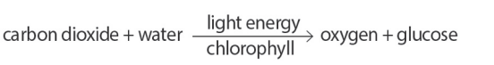
A growing plant needs light, air, water, warmth and nutrients called mineral salts (LAWWN). The energy for growth comes from respiration, a process in which oxygen is used to release energy from glucose. It happens in the mitochondria of cells and can be summarised as:

Questions:
- Describe the stages of germination. Include at least three stages.
the seed absorbs water, the root emerges, the shoot emerges, the first leaves open
- a- What are the raw materials needed for respiration?
oxygen, glucose
b- What are the products of respiration?
carbon dioxide, water, energy
- Suggest why some plants make many fruits.
to ensure that at least some fruits survive and carry the seeds away from the parent
- Explain how an embryo grows.
The cells in the embryo use cell division. The energy for this process comes from respiration.The glucose for respiration comes from the food store in the seed.
- Why does the mass of a seed decrease during germination?
The food store is being used up.
- a-What gases from the air does a plant need?
oxygen, carbon dioxide

b-why does it need them?
oxygen (for respiration), carbon dioxide (for photosynthesis)
Life cycle of a flowering plant:
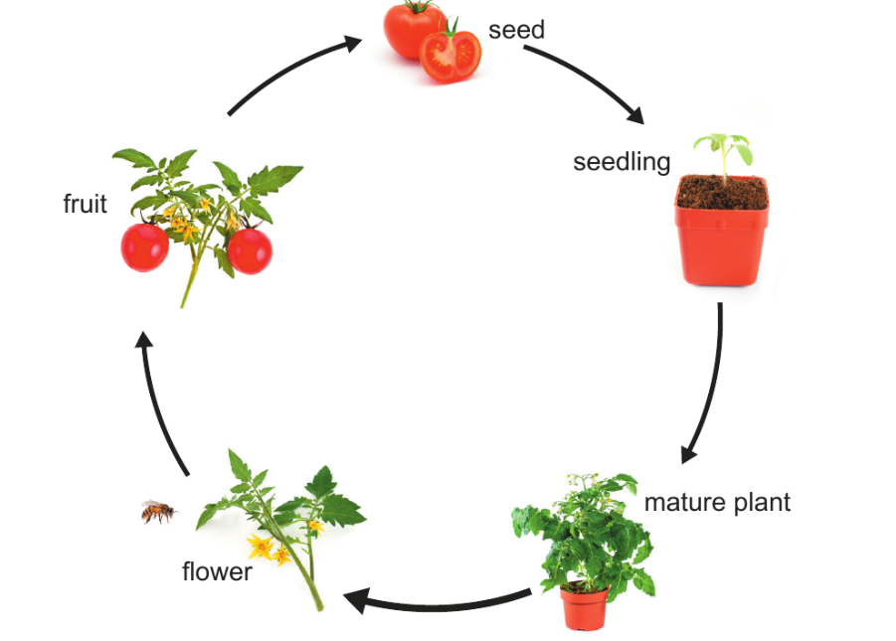
Interdependence
Many plants depend on insects for pollination and the insects depend on the plants for food, such as nectar. We say that they are interdependent.
Humans also depend on the insects and the plants, because many plants do not form seeds and fruits for us to eat if they are not pollinated.
Plants and animals rely on one another in other ways. Many animals use plants for shelter. The seedlings from seed dispersed through being eaten by animals also gain from a supply of mineral salts from the animals’ droppings.
Questions:
- How are animals and plants interdependent for the gases they need?
Plants release oxygen from photosynthesis, which animals depend on for respiration. Animals produce carbon dioxide when they breathe out, which plants depend on for photosynthesis.
- Number of honeybees have been decreasing recently. Explain how this might affect humans.
There are fewer pollinators and so some plants may not produce as much fruit or seeds as they used to

Workbook page 25

