

Rosary School – Marj Elhamam
Study sheet (1)
9B Plant growth
Name: _________________ |  | Date: ___/____ / 2025
Grade: 8(A,B,C,D )

Objectives:
9Ba Reactions in plants
1. Model aerobic respiration and photosynthesis using word equations.
2. Explain the functions of light and chlorophyll in photosynthesis (in terms of energy transfer).
3. Recall the factors that affect the rate of photosynthesis.
4. Explain how the rate of photosynthesis can be controlled by a limiting factor, including using the equation to identify possible limiting factors.
5. Recall and interpret the balanced symbol equations for photosynthesis and aerobic respiration.
9Bb Plant adaptations
1. Describe the adaptations of leaves and plant cells for photosynthesis and gas exchange.
2. Describe how water and mineral salts are absorbed and moved around a plant, and how water is lost.
3. Recall some of the main nutrients required by plants and what they are needed for (nitrogen from nitrates and magnesium).
4. Explain how wilting occurs.
5. Explain how the features of leaves and plant cells are adaptations for photosynthesis.
6. Explain how roots and stems are adapted for their function.
9Bc Plant products
1. Describe the synthesis of proteins from amino acid monomers, including the importance of nitrates.
2. Describe the synthesis of starch
3. Describe how starch is used as a food storage material, and the test for starch.
4. Recall that plants use glucose produced by photosynthesis to make new substances, often using mineral salts.
5. Explain the need for the different resources by a seed as it germinates.
5. Recall some functions of different proteins.

9Bd Growing crops
1. Describe why and how cross-breeding and selective breeding are done, and state why they are done.
2. Explain how attack of plants by pests and pathogens can have an impact on food supply and human populations.
3. Explain how food production for humans can be increased using different plant varieties and pest management strategies (including insecticides and herbicides).
9Be Farming problems
1. Use food webs to predict the effects of changes in biological factors (including human activity).
2. Explain why preserving habitats is important, and suggest ideas on how to achieve this through more sustainable development.
3. Model the recycling of carbon in an ecosystem using the carbon cycle.
4. Make predictions about how changes in abiotic (physical) and biotic (biological) factors will affect carbon supply in an ecosystem.
5. Make predictions about how changes in physical and biological factors will interact with adaptations and affect survival (e.g. effects of disease on monoculture).
6. Explain the effects of phosphates, nitrates and persistent pesticides on ecosystems.
9Ba Reactions in plants
What chemical reactions happen in plants?
- Photosynthesis:
Photosynthesis is a series of chemical reactions that we can summaries using a:
- word equation:
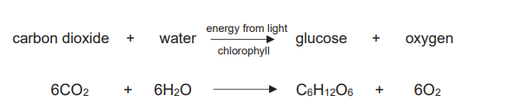

- symbol equation:
Energy and chlorophyll are needed for it to happen. The energy is transferred by light (usually from the Sun) and becomes stored in glucose.
- Aerobic respiration:
Plant cells release the energy stored in glucose using aerobic respiration.
Word equation:
Symbol equation:
The energy released from glucose is transferred to molecules of ATP, which store energy for a cell until it is needed. All living cells need energy and so all living cells respire.
Note: Aerobic respiration happens all the time, but photosynthesis can only happen when there is light.
Questions:
- Where in a plant cell does photosynthesis occur?
chloroplast
- Why do plants in a field only photosynthesise during the day?
They cannot photosynthesise if there is no light(e.g. when it is night).
- The faster Canadian pondweed photosynthesises, the more oxygen bubbles it produces. Explain how three different limiting factors can prevent the number of bubbles increasing.
amount of light because photosynthesis needs energy transferred by light; water
because photosynthesis needs water as a raw material; carbon dioxide concentration because
photosynthesis needs carbon dioxide as a raw material; temperature because enzymes for
photosynthesis work more slowly if it is colder; amount of chlorophyll/number of chloroplasts
– more chlorophyll/chloroplasts = more photosynthesis.
- Which letter (A-D) do you think
represents a time of 23:00? D
- Which line shows the oxygen concentration, X or Y? Y
- Explain why line X goes up between letters B and D.
When it starts getting darker photosynthesis gets slower and so less carbon dioxide is taken out of the water, but respiration is still occurring and releasing carbon dioxide into the water. So, the amount of carbon dioxide increases
at this time.
- What is the test for carbon dioxide?
It turns limewater milky.
- Graph C shows the levels of oxygen and carbon dioxide in the water around a pondweed plant.
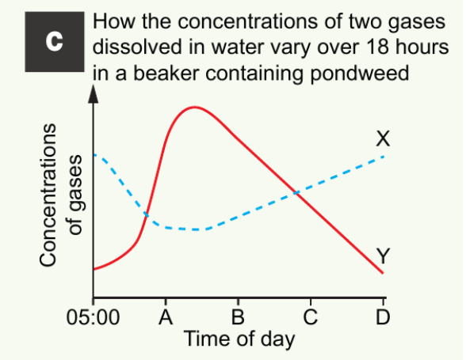
Workbook page 16

9Bb Plant adaptation: How are plants adapted for getting what they need?
- Getting water
Water is taken out of the soil by the roots. Roots are adapted to their function by being branched and spread out to help them to absorb water from a large volume of soil. They also have root hair cells, which have a large surface area to help them absorb water quickly. The water flows up xylem vessels (made of hollow cells) to the leaf.
- Xylem vessels: the tubes that carry water & dissolved mineral salts to the leaves.
- Phloem vessels: the tubes that carry the sugar solution.
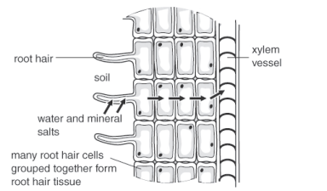
Water is also needed because mineral salts are dissolved in it, for instance:
- plants need nitrates to make proteins
- magnesium salts are needed to make chlorophyll.
- potassium is needed for plant root cells to absorb water properly.
Water also stops plants wilting by filling up their cells, and it can keep their leaves cool.
Question: Describe the route that water takes from the soil to a leaf.
absorbed by root hair cells, travels through other cells to xylem vessels, flows up xylem vessels in the stem and into a leaf

Getting carbon dioxide
Air, containing carbon dioxide, diffuses into leaves through stomata. Leaves are thin so that the carbon dioxide does not need to go far before reaching the cells that need it.
- Increasing the amount of carbon dioxide around a plant can often speed up photosynthesis.
Diffusion and gas exchange is faster at higher temperatures and when there is a greater difference between the concentration of a gas inside and outside of a leaf.
Question: Why do you think stomata close at night?
to prevent loss of water
- Getting light
Many leaves are wide so that they have a large surface area to trap as much light as possible. They are also arranged so that they do not shade one another. Most photosynthesis happens in the palisade cells, which are found near the upper surface of leaves. Palisade cells are packed with chloroplasts. Chloroplasts contain chlorophyll, a green chemical that absorbs energy transferred by light and uses it to power photosynthesis.
- Increasing the amount of light can often speed up photosynthesis.
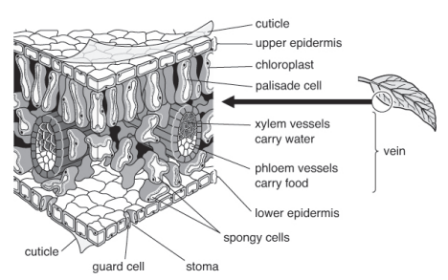
Questions:
- What cells control gas exchange?
Guard cells
- Describe how a leaf is adapted to allow palisade cells to get all the resources they need.
It is broad (to allow a large surface area to collect energy), it is flat (so that gases do not
have far to travel to reach photosynthesizing cells), veins/xylem vessels carry water (for
photosynthesis); for adaptation,

Workbook page 17 & 18
9Bc Plant products: Why do plants make lipids, carbohydrates and proteins?
Uses of glucose
Glucose is a type of sugar. It is used for three things:
- respiration to release energy
- making other substances that act as stores of energy (e.g. starch), which can be turned back into glucose for respiration when needed
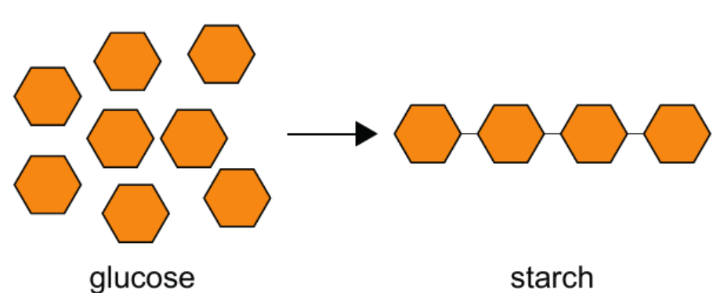

- making new materials for growth.
Examples:
- Cellulose: Which is used to make plant cell walls.
- Lipids (fats and oils): Which is used to make cell membranes and energy stores in seeds.
- Proteins: Which are chains of amino acids, to make amino acids a plant needs nitrate salts. All enzymes are proteins which are needed for photosynthesis and respiration.
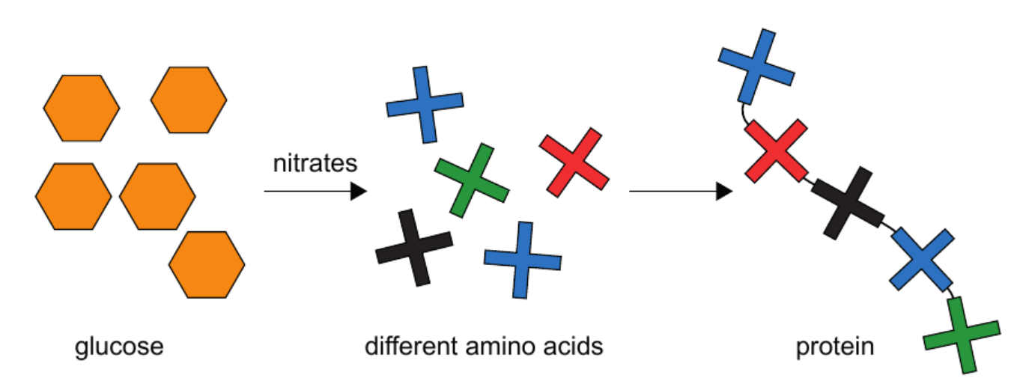

Question: When is starch broken down in chloroplasts, during the day or night? Explain your reasoning.
during the night because the process only starts when photosynthesis stops

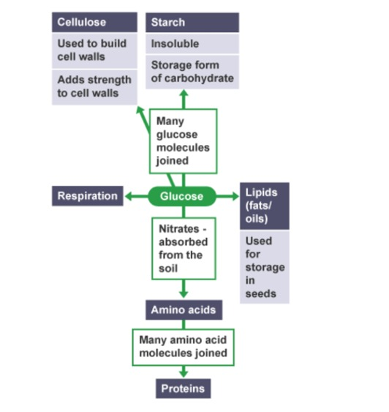
Note:
New substances made by a plant are carried around the plant in phloem vessels.

Question: Why do plants not grow well if there is a lack of nitrates in the soil?
They need nitrates to make proteins. All enzymes are proteins and so processes such as photosynthesis and respiration cannot occur properly without a good supply of nitrates.
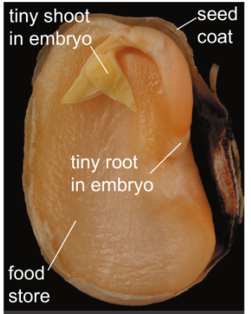
Seed:
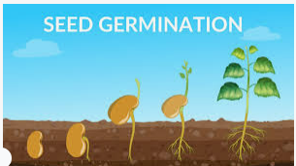

When conditions are right, seeds germinate. The resources needed are water, oxygen and warmth. (WOW)
Germination: when a seed starts to grow.

Stages of germination:
- The seed absorbs water 2- The root emerges 3-The shoot emerges, the first leaves open.
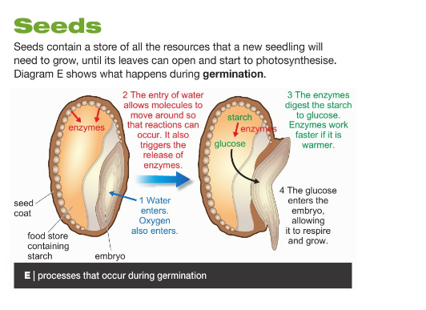
Workbook page 19

9Bd Growing Crops: How do farmers make sure their crops grow well?
Farmers want to get as much useful product (yield) from their crops and land as possible.
- Hedgerows are removed to create more space for big machines, as machines can plant and harvest crops faster than humans.
- Greenhouses can also be used to make sure that plants have the best conditions for growth and to protect crops from changes in abiotic factors (temperature, wind, rain).

Pesticides
Pesticides kill pests (organisms that damage crops). Insecticides kill insect pests. Fungicides kill fungi that cause plant diseases.
Herbicides kill weeds, which compete with the crop plants for water, light, and mineral salts. The size of the crop and its yield are reduced by competition from weed growth.
Selective breeding is the process of selecting (choosing) specific plants or animals with desirable characteristics and breeding them to create offspring with those same desired characteristics.
Steps for Selective Breeding in Plants
To selectively breed plants, choose desirable characteristics, such as:
Bigger fruits (e.g watermelons), Sweeter taste (e.g strawberries), Disease resistance (e.g wheat), Bright-colored flowers (e.g roses), Drought tolerance (e.g maize)
- Select Parent Plants:
Find healthy plants that already show these desirable characteristics.
- Cross-Pollinate and Grow the Seeds:
Manually transfer pollen from one parent plant to the flower of another.
Collect seeds from the pollinated flowers and plant them.
- Select the Best Offspring:
Choose the plants that have the best combination of characteristics.
- Repeat the Process:
Continue cross-breeding the best offspring for several generations to stabilize the desired characteristics.

Example:
A breeder wants to produce a variety of apple plant that is both sweet and resistant to pests.
- Select two apple plants — one with sweet taste and another with pest resistance.
- Cross-pollinate by transferring pollen from the sweet apple to the flowers of the pest-resistant apple
- Grow the seeds.
- From the offspring, select apple plants that inherit sweet and pest - resistance.
- Repeat the process for several generations.
Over many generations, this method produces a new variety of apple that is both sweet and pest resistance.
Questions:
- Describe the effect of too little phosphate.
The plants do not grow very tall.
- a- Write down two other mineral salts that plants need.
b-Why do plants need these?
potassium (needed to absorb water properly),
nitrogen/nitrates (needed to make proteins),
magnesium (needed to make chlorophyll)

- a- Why would the apples in photo D not be sold in shops?

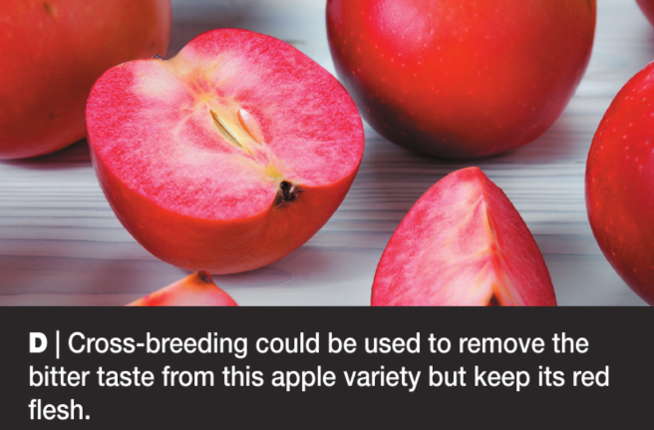
It tastes bitter.

b-What could be done to make a red-fleshed apple that could be sold?
cross-breed with apples that taste nice (and
this is exactly what is being done)

- Look at photo C. Suggest two reasons why the 1950s variety of wheat is not grown today.
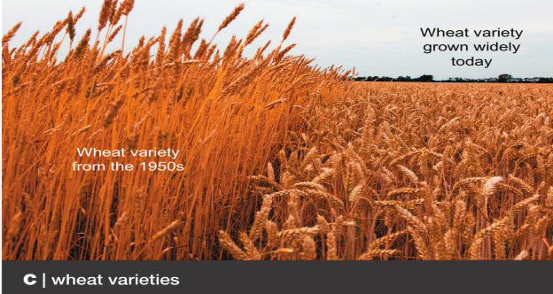

The old variety does not produce as many grains as the new one and so is a less useful crop that would make less money. The old variety is not as resistant to rust and so will be more likely to be harmed by the disease and produce less yield. Other answers are possible, such as the older variety has a thinner stem (and so more likely to be wind damaged) and the ear is held more upright (so more likely to trap water and so provide good conditions for fungal growth).

Workbook page 20, 21

9Be Farming problems: What problems can farming cause?
( this lesson is not included in the final assessment)
Fertilisers
Fertilisers can wash into rivers and lakes. The very rich supply of nutrients (eutrophication) causes fast growth of algae and plants, which block out light, causing a lot of them to die.
As decomposer bacteria break down the dead material, they use up the oxygen in the water, causing fish to die.

Pesticides
Insecticides can kill helpful insects that eat pests or pollinate plants. Some insecticides are persistent (do not break down in the environment). Predators in the food chain may eat many animals containing small amounts of insecticide meaning that the top predator gets a large amount of the substance, which may harm it.

Varieties
Farmers often plant the same variety of crop. Since all the plants are identical, if one gets a disease then all the others will. A new disease can wipe out the whole crop.
Planting a single crop variety over a large area reduces biodiversity. The food webs become smaller, and if a disaster hits the area it takes much longer to recover than if the area was very biodiverse.
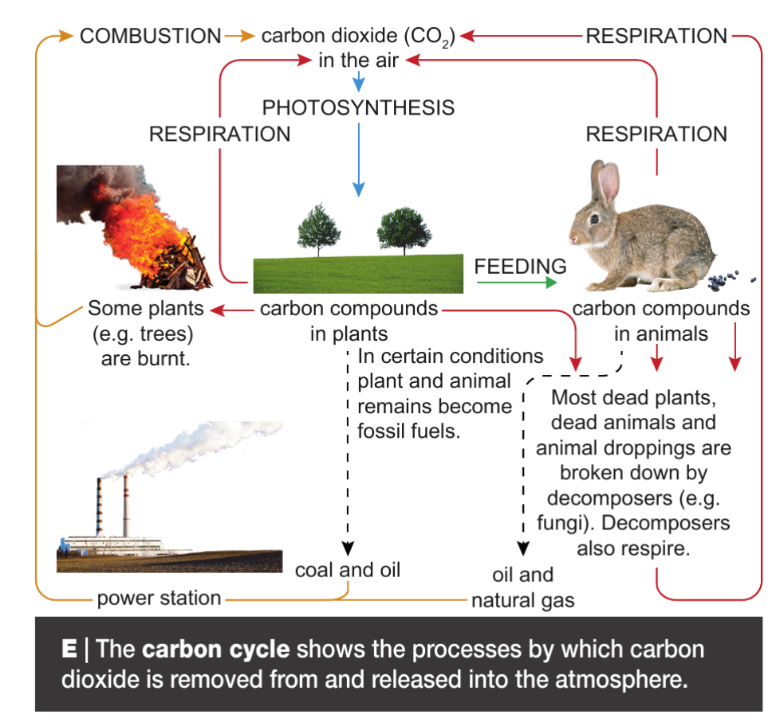
Questions:
- a- Draw out a food web of the following: Sparrowhawks eat sparrows and dormice. Wheat is eaten by caterpillars and aphids. Caterpillars feed on hazel trees, as do dormice. Sparrows feed on aphids and caterpillars.

b-This food web is from a hedge next to wheat field. What would happen to the populations of the organisms if a farmer sprayed the wheat with:
- a general insecticide
________________________________________________________________________________________________________________________________________________________________________________________________________________________________________________________________________________________

- a selective herbicide?
________________________________________________________________________________________________________________________________________________________________________________________________________________________________________________________________________________________________

- In 19th century Ireland, most people survived by growing and eating one variety of potato (called lumper). Between 1845 and 1852 more than a million people starved. Suggest why.
________________________________________________________________________________________________________________________________________________

- Explain two ways in which a farmer could grow crops more sustainably.
________________________________________________________________________________________________________________________________________________________________________________________________________________________________________________________________________________________________________________________________________________________________________
- Complete the table to show the advantages and disadvantages of clearing land, insecticides, herbicides, and fertilisers.
Farming process | Advantages | Disadvantages
Clearing land

Insecticide use

Herbicide use

Fertilizer use

Workbook page 23, 24

