

Rosary School – Marj Elhamam

Name: _________________ |  | Date: ____ /____ / 2025
Grade: 7 (A,B,C,D,E) |  | Subject : Phyhsics

Worksheet 2
The Oscilloscope
- An oscilloscope is an instrument that shows a picture of a sound on screen.
- An oscilloscope can be connected to a microphone to show sound waves. The oscilloscope trace is like a line graph.
- The trace is the line that appears on the screen that represents the sound wave.
- On a sound wave trace, the amplitude is the maximum distance from 0.
- The frequency is the number of complete waves (one up and down) that pass a point each second.
- In trace B, one wave takes 0.2 seconds. In each second 5 waves pass and so the frequency is 5 Hz.
Workbook page 139 Q.3
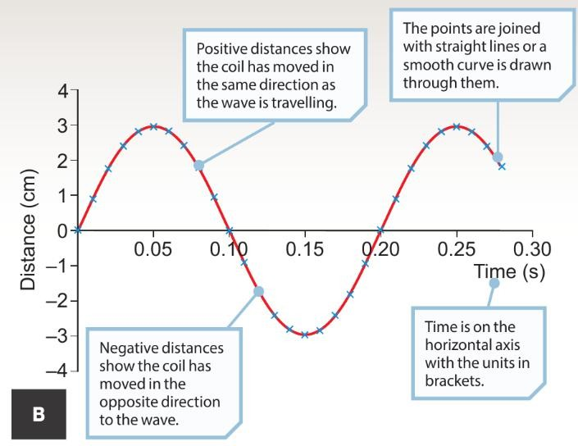
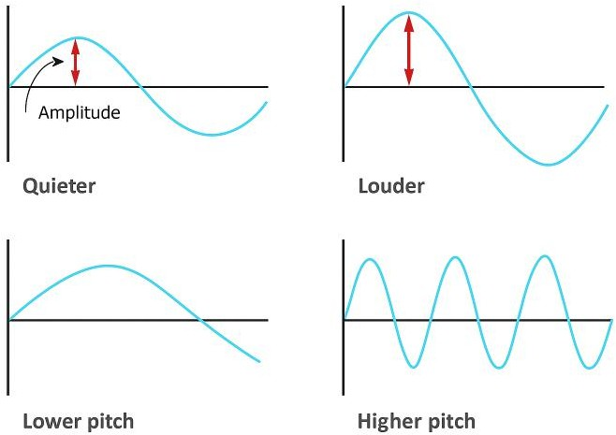

Question 1:
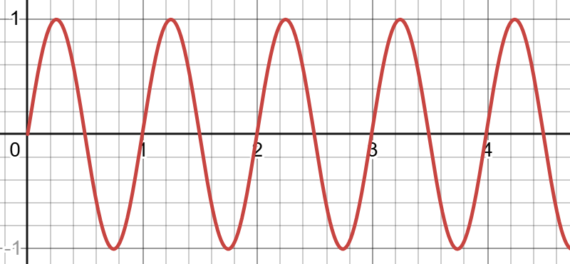
Determine the Amplitude and Frequency of the wave below.
Frequency:
Amplitude: _______________________________

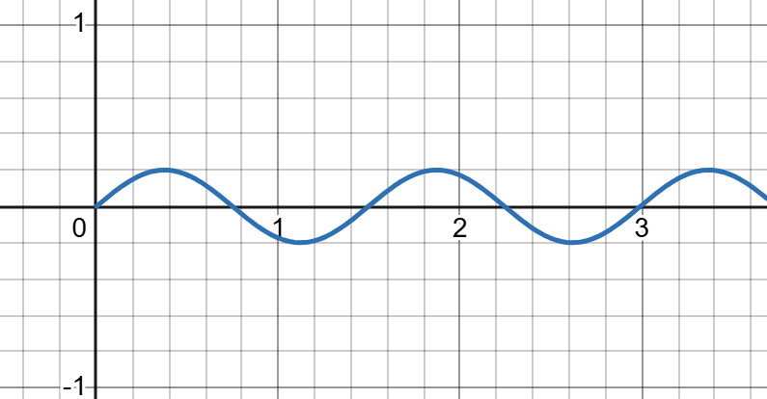
Question 2:
Circle the correct word between the brackets.
Compared to the wave in Question 1, the wave in the diagram is (Louder/Softer) and has (Higher/Lower) pitch.

Question 3:
The ring tone on a mobile phone can be changed.
The figure shows the sound trace made by four sound waves on an oscilloscope screen.
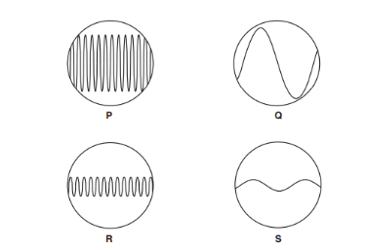

Explain which sound trace from a ring tone (P, Q, R or S) will have a quietest
sound with the lowest pitch.
________________________________________________________________________________
________________________________________________________________________________
________________________________________________________________________________

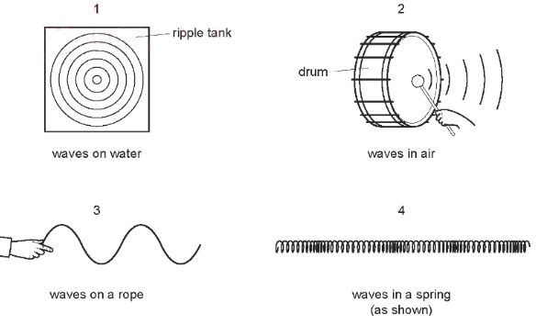
Question 4:
The diagrams show examples of wave motion.

Which are longitudinal waves? _____________________________________.

Question 5:
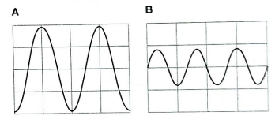
We can use graphs to represent the movement of air particles in a sound wave. The diagram represent two different sound waves.

- Which graph shows:
- Particles moving only a little way as the wave passes. __________________.
- The wave with the greater number of waves per second. ________________.
- Complete the following sentences by crossing out the incorrect word.
Wave A has the (highest/ lowest) frequency. It will make a (higher / lower) note than wave B.
Wave A has the (largest / smallest) amplitude. It will be (louder/ quitter) than wave B.

Question 6:
The diagram below shows a plastic ball floating on the surface of a lake and attached by a long rope to a weight on the bottom of the lake. A water wave on the surface of the lake causes the ball to move vertically up and down.
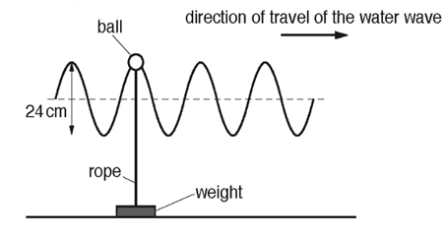

- Determine the amplitude of the wave. ______________________cm.

- Explain how the motion of the ball shows that the water wave is transverse.
__________________________________________________________________________________________________________________________________________________________

Question 7:
Ultrasound waves are used to produce images.
This is an ultrasound image for a fetus surrounded by fluid.
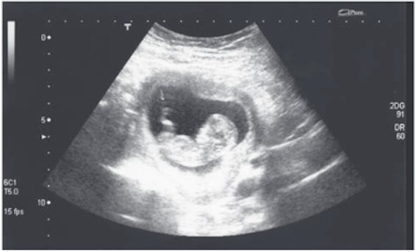
- The ultrasound wave is caused by waves bounce off the fetus.
This is an example of waves that are.
absorbed

reflected
refracted
transmitted
- Describe two other uses of ultrasounds.
i) _______________________________________________________________________
ii) _______________________________________________________________________

Question 8:
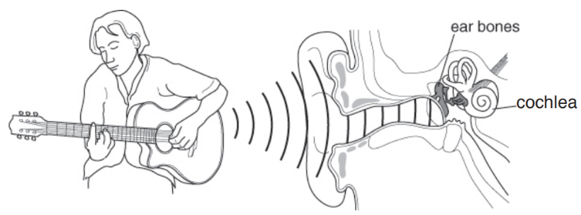
The diagram shows someone playing a guitar and shows part of an ear. The eardrum vibrates when sound waves reach it.

- Give the function of:
- the ear bones: __________________________________________________________.
- the cochlea: ____________________________________________________________.
- What happens to the eardrum if the sound reaching the ear gets louder?
- the eardrum vibrates faster b. the eardrum vibrates slower
c. the eardrum vibrates further d. the eardrum vibrates less

