

Rosary School – MarjElhamam
Science Worksheet (5)
Name: _________________ |  | Date: / 11 / 2025
Grade: 5 (A, B, C, D, E)

Question 1:
Hashem has dropped a coin in the swimming pool.
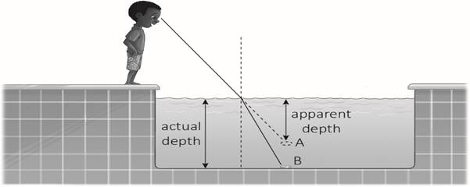

a) What does the light do when it travels from the water to the air?
__________________________________________________________________

b) Explain why the light does this. ____________________________________________________________________________________________________________________________________
c) The coin is at B. Why does Hashem think he sees the coin at point A?
________________________________________________________________

Questions 2:
A day on Jupiter lasts 10 hours. A day on Earth lasts 24 hours. Explain why Jupiter has a shorter day than Earth.
________________________________________________________________________________________________________________________________

Question 3:
The table shows the time it takes four planets A, B, C, and D to orbit the Sun.
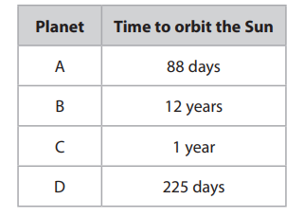

List the four planets in the order of their distance from the sun
nearest to the sun ………………..
………………..
………………..
furthest from the sun …………………

Question 4:
Why is the print bigger when you read it through a magnifying glass?
________________________________________________________________________________________________________________________________________________________________________________________________________________________________________________________________________

Question 5:
Yuri uses a toy car to make a model. He uses the model to explain a property of a ray of light.
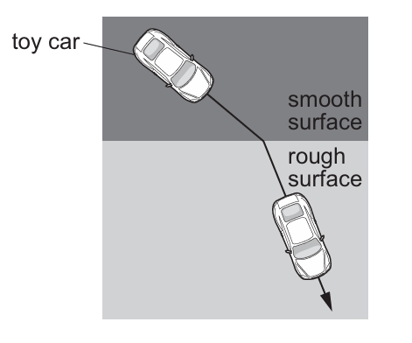
- Describe two things that happen to the car as it travels from the smooth surface to the rough surface.
- ____________________________________________________________
- ____________________________________________________________

- Circle the property of a light ray shown by this model.

Opaque reflection refraction transparent

- The smooth surface in the model represents air.
Air is a medium that a light ray passes through. Write down the name of another medium that a light ray passes through
_______________________________________________________________

Question 6:
Lily draws a diagram to show the position of the Earth in the month of June.
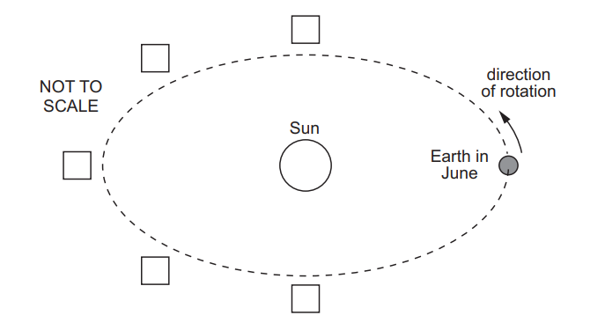
Put number 6 in the correct box to show where the Earth will be 6 months later.
Put number 9 in the correct box to show where the Earth will be 9 months later.

Teachers:
Marah Naber & Daniella Petro

