

Rosary School – MarjElhamam
Science Worksheet (5)
Name: _________________ |  | Date: / 11 / 2025
Grade: 5 (A, B, C, D, E)

Question 1:
Hashem has dropped a coin in the swimming pool.
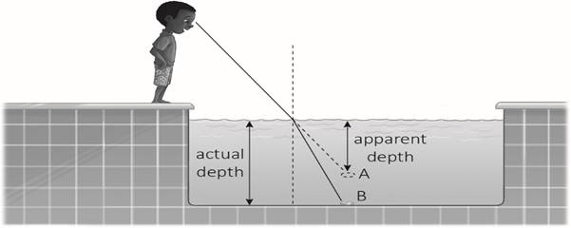

a) What does the light do when it travels from the water to the air?
It bends or refracts

b) Explain why the light does this.
Because the speed of the light changes when the medium changes.
c) The coin is at B. Why does Hashem think he sees the coin at point A?
Its an optical illusion.

Questions 2:
A day on Jupiter lasts 10 hours. A day on Earth lasts 24 hours. Explain why Jupiter has a shorter day than Earth.
It takes Jupiter less time to orbit around its axis.
Question 3:
The table shows the time it takes four planets A, B, C, and D to orbit the Sun.
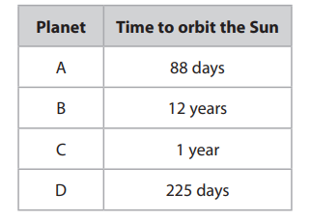

List the four planets in the order of their distance from the sun
nearest to the sun Planet A
Planet D
Planet C
furthest from the sun Planet B

Question 4:
Why is the print bigger when you read it through a magnifying glass?
Light rays pass from the print through the lens and bend inwards and converge at a point just beyond the lens. This point where the rays converge is the focus and we see the enlarged print.
Question 5:
Yuri uses a toy car to make a model. He uses the model to explain a property of a ray of light.
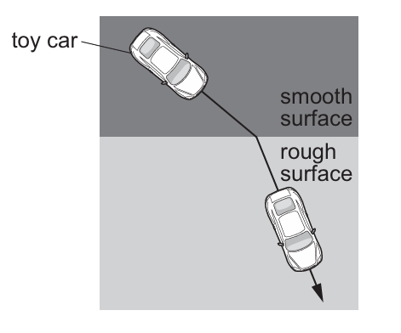
- Describe two things that happen to the car as it travels from the smooth surface to the rough surface.
- Changes direction.
- Slow down
- Circle the property of a light ray shown by this model.

Opaque reflection refraction transparent

- The smooth surface in the model represents air.
Air is a medium that a light ray passes through. Write down the name of another medium that a light ray passes through
Glass, water, or clear plastic

Question 6:
Lily draws a diagram to show the position of the Earth in the month of June.
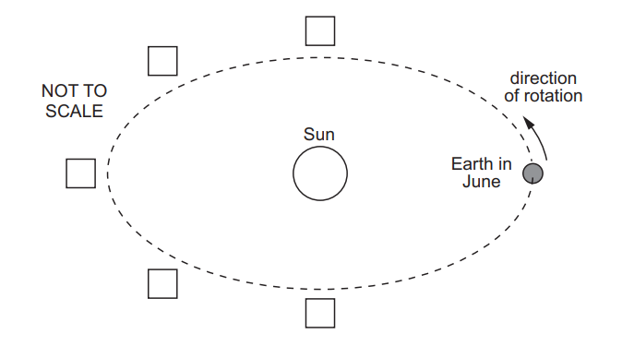
9
6
Put number 6 in the correct box to show where the Earth will be 6 months later.
Put number 9 in the correct box to show where the Earth will be 9 months later.

Teachers:
Marah Naber & Daniella Petro

