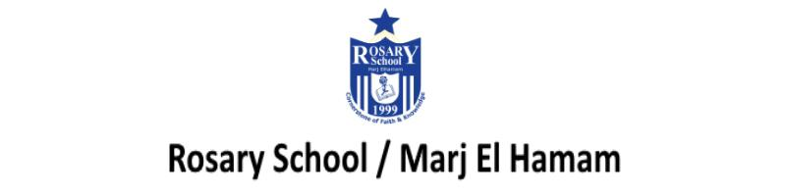

8Fe Chemical trends
Course book pages 99

Question five:
photo B: sodium + oxygen → sodium oxide
photo C: phosphorus + oxygen → phosphorus oxide
photo D: sulfur + oxygen → sulfur dioxide

Question six:
sodium oxide + water → sodium hydroxide + hydrochloric acid → sodium chloride + water

Question seven:
From left to right across the periodic table the oxides become more acidic,
form solutions with lower pH and become less alkaline.

Question eight:
- Add a universal indicator and check the pH against the colour chart.
- Element X and element Y are on the left side of the periodic table.
( on student’s book we changed the question, if one of the unknown elements has a pH of 5 the answer would change to → on the right side)

Question nine:
- It would burn brightly.
- Fluorine would be more reactive than chlorine as reactivity increases up the group of halogens.

8Fe Chemical trends
Workbook pages 72-73
Question one:
- more
- i rubidium hydroxide AND hydrogen (gas)
ii violent fizzing, fire/flame, explosion
- They form hydroxides with water, which are alkaline.

Question three:
- silvery metal – alkaline solution
gas – acidic solution
- i on the left/because it formed an alkali.
ii on the right /because it formed an acidic solution.

Question three:
- B
- acid + base ---> salt and water

Question three:
- sodium chloride
potassium nitrate
copper sulfate
- zinc oxide + hydrochloric acid ---> zinc chloride + water

Question five:
- A
- D

Question six:
- It would burn brightly.
- Fluorine would be more reactive than chlorine as reactivity increases up the group of halogens.

