

Rosary School – Marj Elhamam
Lab report (2)
Name: _________________ |  | Date: / 11 / 2025
Grade: 7 (A, B,C,D,E) |  | Subject: Chemistry

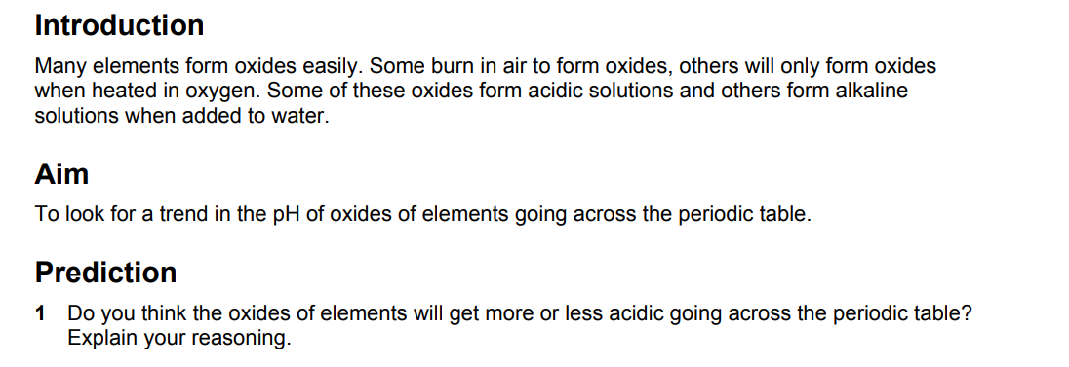
__________________________________________________________________
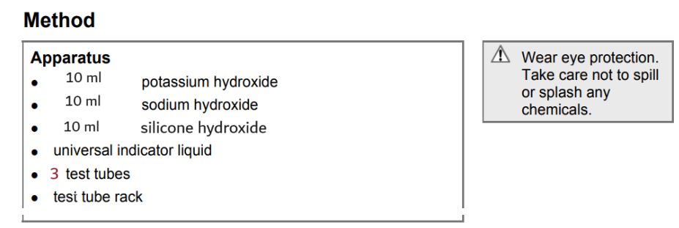
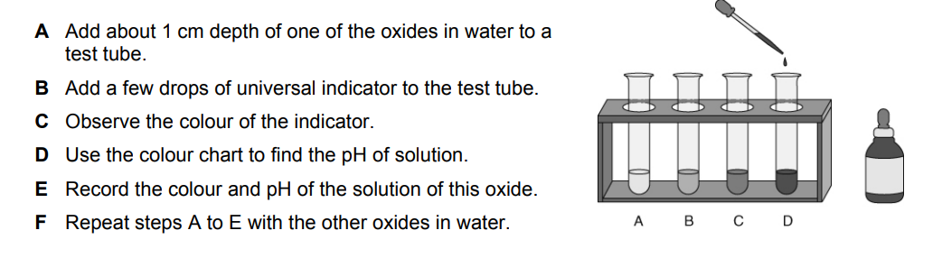

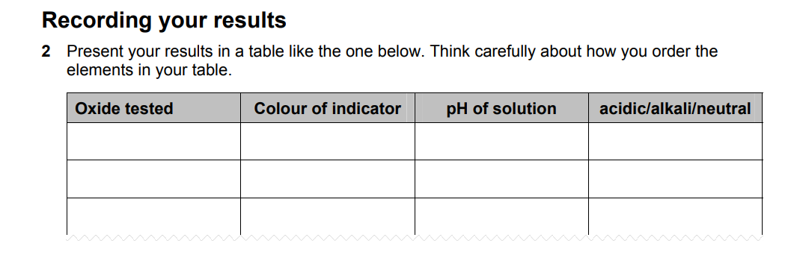
Conclusions:
2- Write word equations for the formation of the oxides of potassium , sodium and silicone __________________________________________________________________
__________________________________________________________________
__________________________________________________________________
3- how does the indicator colour tell you if a solution is acidic, alkaline or neutral?
__________________________________________________________________
__________________________________________________________________.
4- what are the ranges of pH values for
i) acids ________________________
ii) alkalis ___________________________
iii) neutral solutions ________________________
5) Describe any general trend in the chemical properties of the oxides across the periodic table from left to right.
____________________________________________________________
6) What conclusions can be made about the difference between the chemical properties of metal oxides and non-metal oxides?
____________________________________________________________
7) The oxides of chlorine and fluorine are difficult to produce. If they could be made, estimate the pH of solutions of these oxides, and explain your answer.
____________________________________________________________

