
Rosary School / Marj El Hamam
Name : _____________________ Date : / / 2025
Subject :Science Grade: 6 ( )
Study Sheet (2)
7K Forces

Lesson | Learning Objectives
7Ka Different forces | - Describe what a force is.  - Recall the names of simple forces and state what is meant by contact and non-contact forces.  - Recall the effects of forces on an object.  - Classify forces as contact and non-contact and identify situations and places where different forces are likely to be found.  - Represent sizes and directions of forces using arrows.  - Explain the difference between mass and weight and recall the units for measuring these.  - Compare the way in which force meters and balances that compare masses work.
7Kc Friction | - Describe how friction forces affect movement.  - Describe some ways in which friction can be changed.  - Identify simple situations in which friction is helpful or not helpful.  - Recall some effects of frictional forces.  - Explain some ways in which friction can be changed.  - Suggest how and why friction has been reduced or increased in unfamiliar situations.  - Draw lines of best fit on scatter graphs.
7Kd Pressure | - State what is meant by pressure and recall its units.  - Describe how the pressure depends on force and area.  - Describe the effects of high or low pressure in simple situations.  - Recall some common units for measuring pressures.  - Use the formula relating force, pressure and area.  - Explain applications of pressure in different situations.
7Ke Balanced and unbalanced | - State what is meant by: balanced forces, unbalanced forces.  - Explain the effects of balanced and unbalanced forces in simple situations.  - Explain why a vehicle needs a force from the engine to keep moving at a constant speed.  - Describe how new evidence changed scientific ideas.  - Explain the effects of balanced and unbalanced forces in unfamiliar situations
7Kb Springs | -Recall the effects of forces on an object.  - Explain how a force has caused certain effects on an object.  - State what is meant by extension, compress, stretch, elastic, plastic.  - Describe how the extension of a spring depends on the force applied. Explain how a force meter works and how to use one.  - Explain what is meant by elastic limit, limit of proportionality.  - Students analyse new situations involving springs.

7Ka Different forces:
- Forces are pushes or pulls.
-Forces can affect on an object by:
1) changing the shape or size of an object.
2) changing the speed things are moving (make them move faster or slower).
3) changing the direction of a moving object.
*Types of forces:
1) Contact forces: only act when two objects or materials are touching before the force can affect.
Examples of contact forces are:
● friction: is a force caused by two things rubbing together.
● air resistance (kind of friction)
● water resistance (kind of friction)
● upthrust. Upwards forces from water or air are called upthrust.
(The force that makes things float).
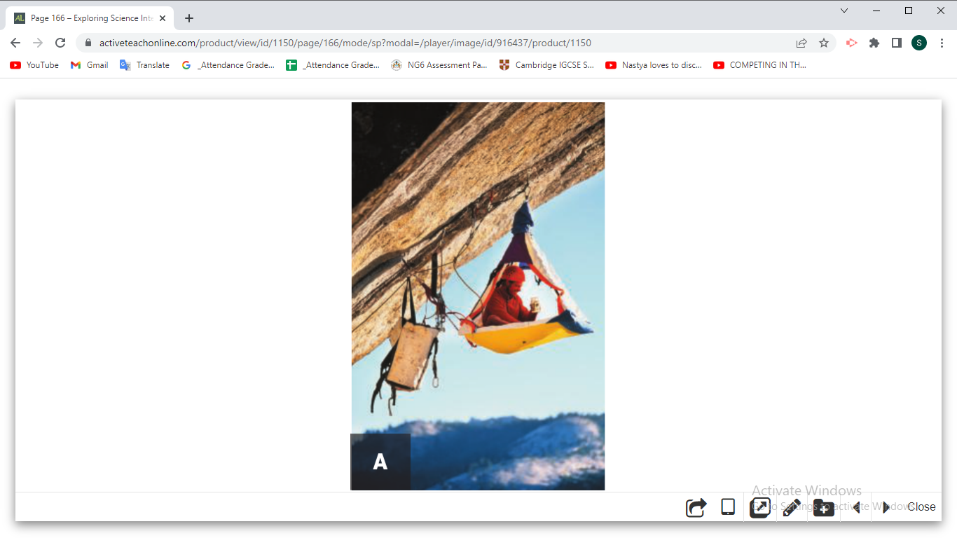
2) Non-contact forces: forces that can affect an object from a distance (without touching)
Examples of non-contact forces:
● gravity: A force that pulls objects downwards.

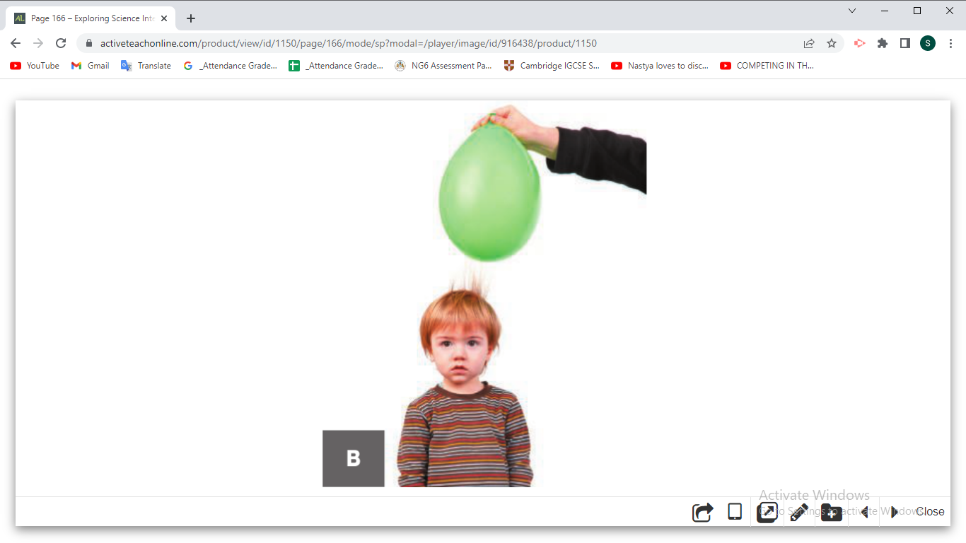
● static electricity: A force that can attract or repel things. It is caused when certain materials rub together.

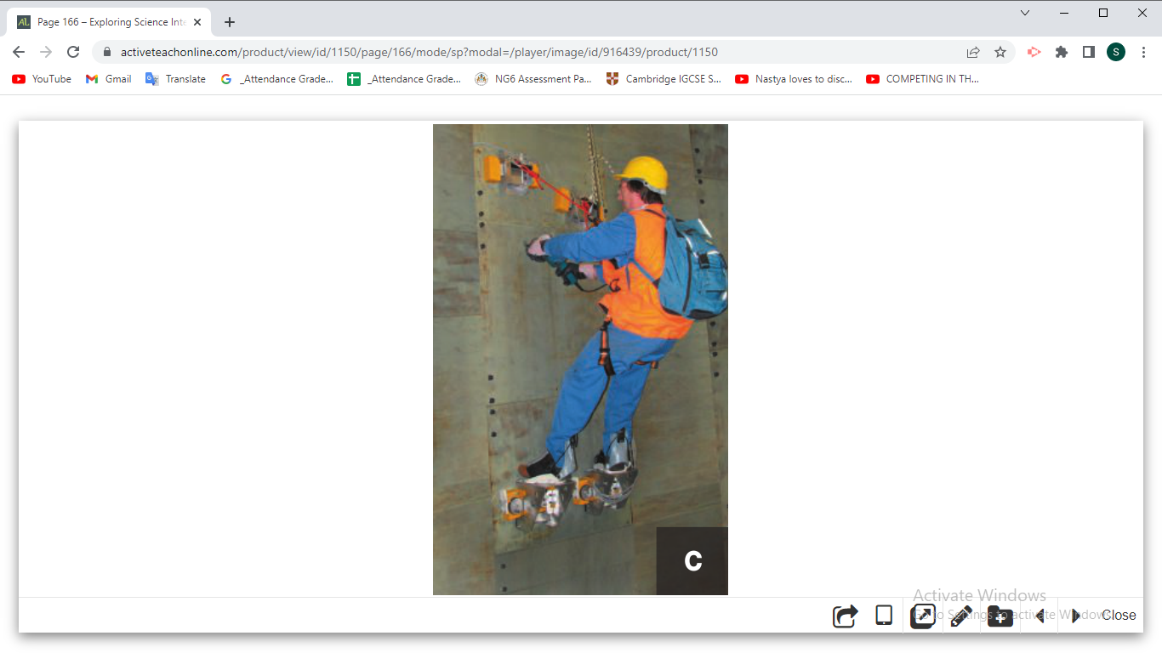
● magnetism: A force that attracts objects made of iron or other magnetic materials.

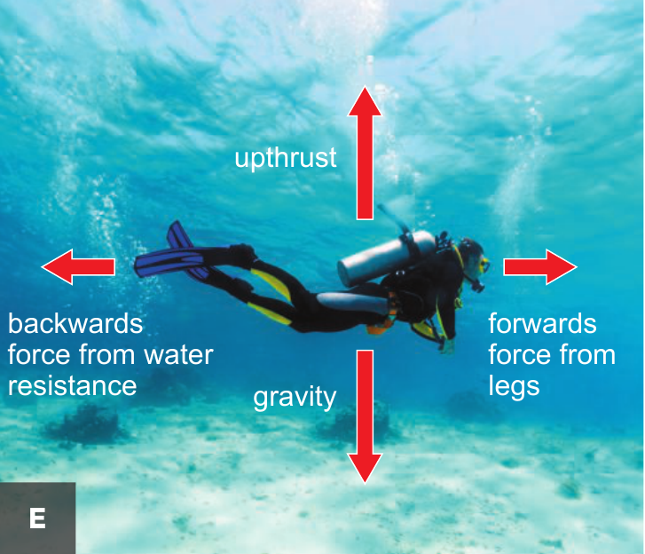
The unit for measuring force is the newton (N).

-Notes:
- The direction in which the force is acting is important so we use arrows to show forces.
- The direction of the arrow shows the direction of the force; a bigger arrow shows a bigger force.
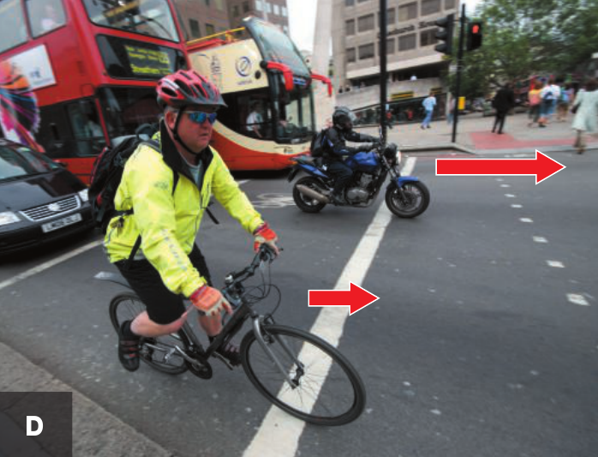
Question:
Look at photo D.
- Which bike has the biggest force on it?
___________________________________
- How do you know this from the photo?
_______________________________________________________________
- What will happen to the two bikes as a result of these forces?
_______________________________________________________________

Weight and mass
- Mass is the amount of matter that makes up an object.
The units for measuring mass are kilograms (kg) and grams (g).
- Weight is the force of gravity pulling on you. The newton (N) is the scientific unit used to measure forces, and so it is also used as the unit for weight.
Wherever you take an object, its mass will not change but its weight depends on the force of gravity. An object on the Moon would have a smaller weight than on Earth, because the Moon’s gravity is not as strong as Earth’s.

Notes: Weight = mass (kg) ×10 (N/Kg) Mass = weight(N) ÷ 10 (N/kg)
convert g to Kg by dividing by 1000
Example: What is the weight of a 40 kg child on Earth?
Weight = mass ×10
= 40 × 10
= 400 N
Questions:
- A car has a weight of 10000 N. What is the mass of the car on Earth?
_________________________________________________________________
_________________________________________________________________

2) Why would you weigh less on the Moon than you do on the Earth?
_________________________________________________________________
_________________________________________________________________
3) Workbook page124 + 125

7Kc Friction:
Friction is a contact force (between two touching objects)
Friction can:
● slow things down ● produce heat
● wear things away ● cause a noise
Friction can be increased by using rough surfaces, or by using materials such as rubber that have a lot of friction.
Friction is helpful in:
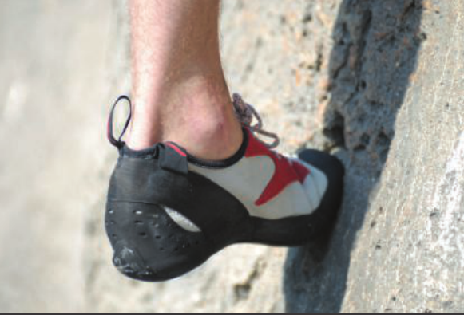
- The tyres of a Formula One racing car as they stop the car from sliding off the road as it speeds round sharp corners.

- Rock climbing shoes are made from special rubber that increases friction to give a good grip.

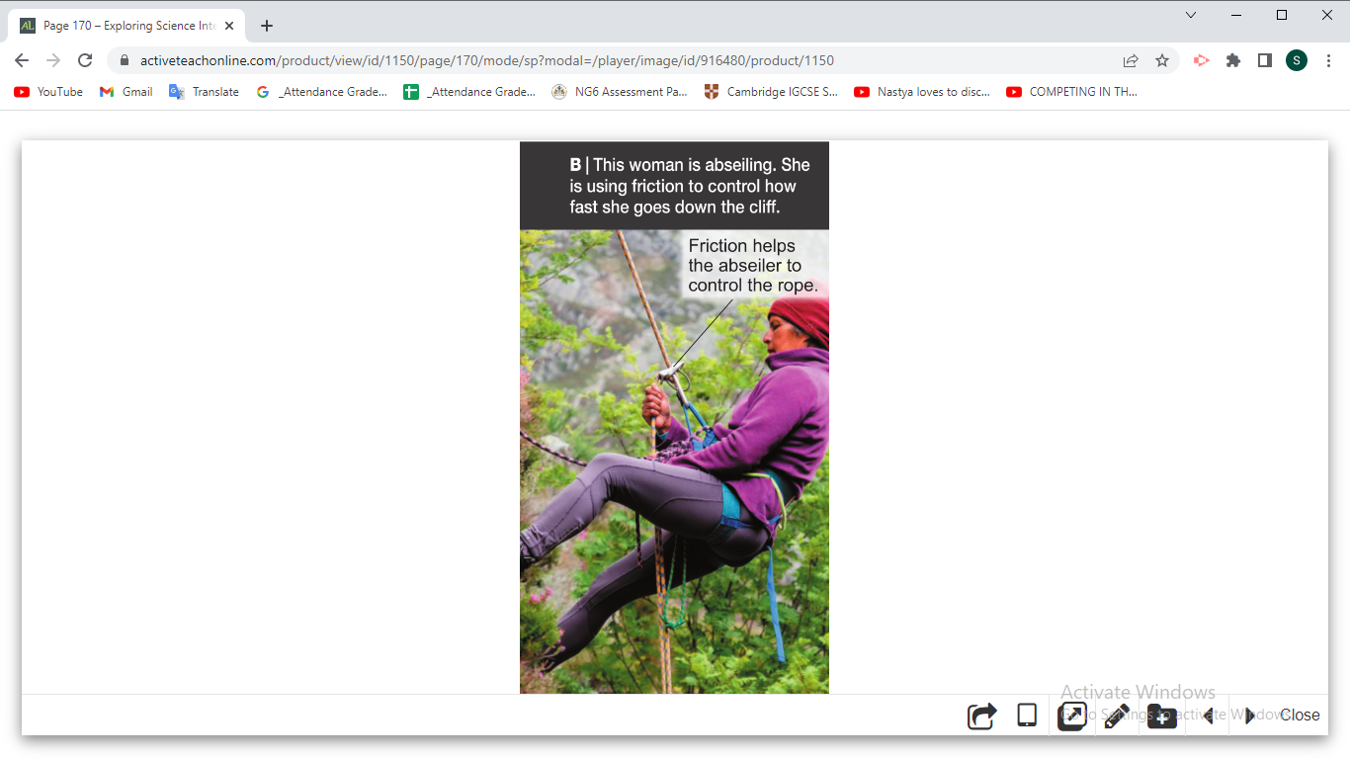

- Abseiling helps the abseilers control how fast they go down the cliff.

Friction can be reduced by using smooth surfaces, or by lubrication. Oil and grease are examples of lubricants, and help things to move past each other easily.
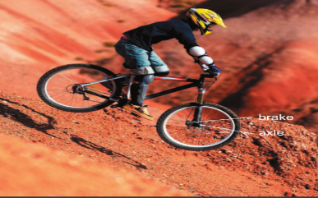
Friction is not helpful in:

- The brake pads on a bicycle eventually wear away, and so do car tyres.
- Parts of your clothes get thinner as friction wears them away.
- If a car engine runs without any oil, the large amount of friction between the moving parts causes it to overheat and stop working.
- Rusty door hinges squeak and make a door difficult to open.
*Note:
Friction due to gases (air resistant) and liquids (water resistant) can also cause things to slow down. And it can be reduced by having smooth surfaces and smooth shapes.
Questions
1) The tread on bicycle and car tyres is designed to allow water to escape from under the tyre on wet roads. Explain why this is important.
__________________________________________________________________________________________________________________________________________
- a- Why do car owners have to replace their car tyres regularly?
__________________________________________________________________________________________________________________________________________
b- Suggest why racing car tyres do not last as long the tyres on normal cars?
_______________________________________________________________________________________________________________________________________________________________________________________________________________

- Workbook page 127.

7Kd Pressure:
Pressure is the amount of force pushing on a certain area.
- The size of the pressure depends on the size of the force and the size of the area it is pushed on.
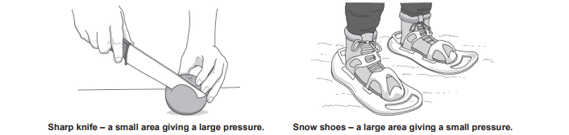
      - For a certain area, the bigger the force, the bigger the pressure. For a certain force, the bigger the area, the smaller the pressure.

Note: Explain pressure situations by relating the force, the area, and the pressure produced.
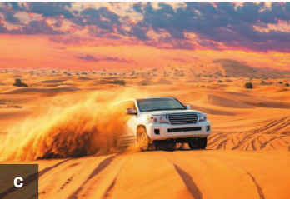
Questions:
- Look at the vehicle in photo C.
Should a car like this have a wide or narrow tyres? Explain your answer.
________________________________________________________________________________________________________________________________

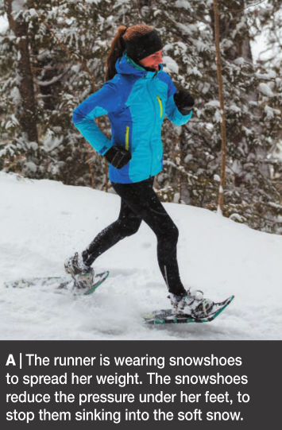
- The person on photo A puts on a large pair of snow snowshoes. Explain how the pressure under her feet will change.
_________________________________________________________________
__________________________________________________________________
__________________________________________________________________
__________________________________________________________________
__________________________________________________________________

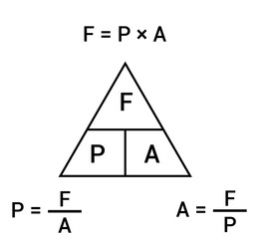
      - We use this formula to calculate pressure:

Pressure= force÷ area
Force is measured in newtons (N) and area is measured in square meters (m²).
So the unit of pressure is (N/m²) which is also called a pascal (Pa). 1Pa =1 N/m²

Example: 50 N
a) Calculate the pressure produced by the force.
4 cm

5 cm

b) Calculate the pressure in Pa.

Questions
- Calculate the force necessary to produce a pressure of 80 N/m² when acting on a surface of 5 m².

- Calculate the area on which a force of 500 N is acting to produce a pressure of 25 N/m².

- Workbook page 128

*Homework: Coursebook Q5 p. 173
7Ke Balance and unbalanced:
- Balanced forces: forces on an object that are the same size but work in opposite directions.

If forces are balanced:

1- a stationary object stays stationary.
(Forces are equal in size and opposite in direction)

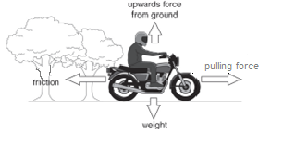

2- a moving object continues to move at the same speed and in the same direction.
(steady /constant speed)

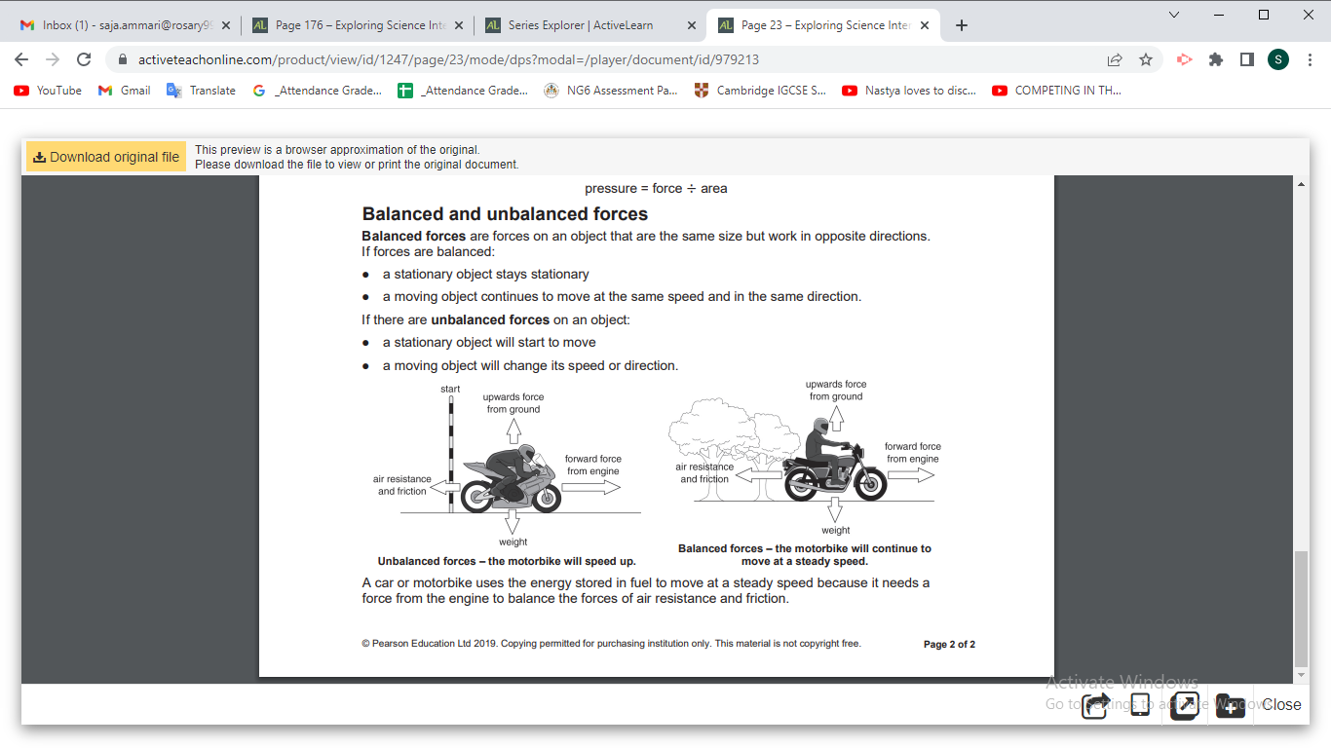

- Unbalanced forces: forces on an object are not the same size (one force is stronger than the other) but work in opposite directions.

If forces are unbalanced:
1- a stationary object will start to move.

The motorbike will move to the right in the direction of the bigger force

2- a moving object will change its speed or direction.

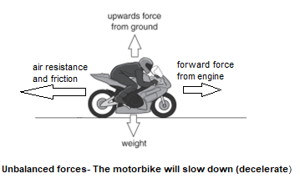

The forward force is bigger. The backward forces are bigger.
- How force meter works?
When you stretch a spring it gets harder and harder to pull it because the spring pulls back.

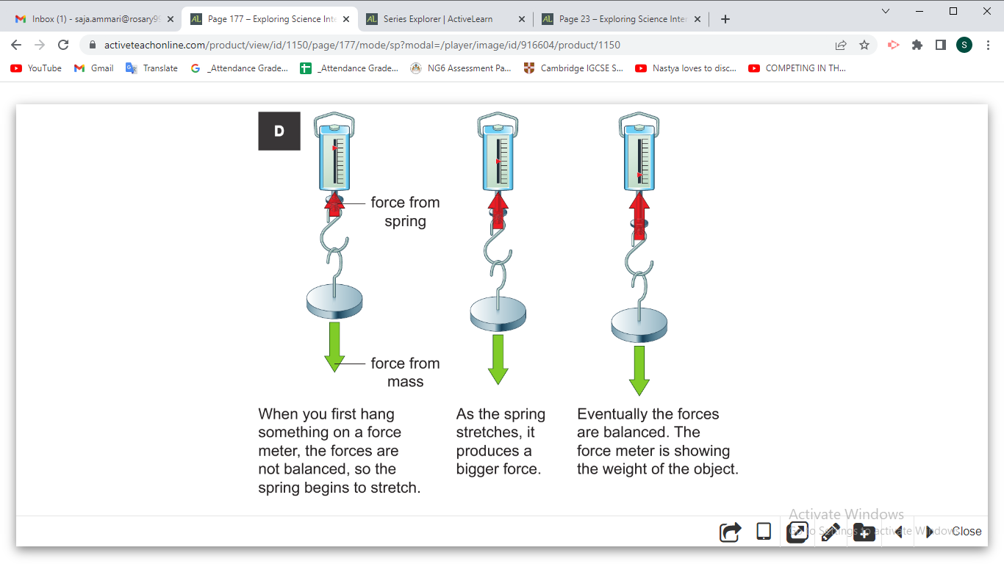

Questions

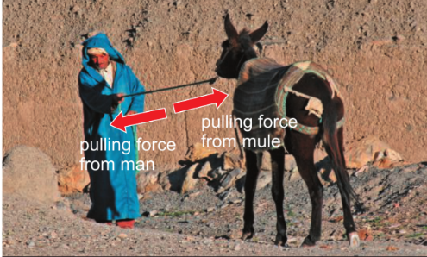
- Look the photo.
- Why isn’t the rope moving?
_______________________________________
_______________________________________
What will happen if the mule pulls harder?
______________________________________________________________

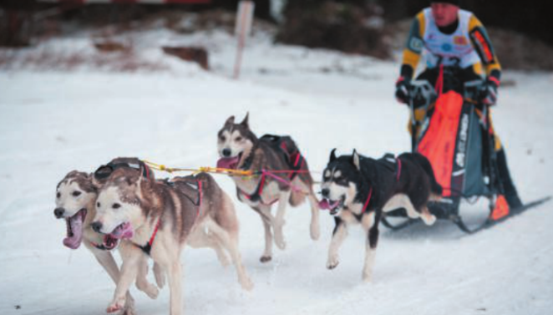
- Look at the photo below.

What will happen when the dogs get tired and cannot pull as strongly?
______________________________________________________________________________________________________________________________________

- Look at the photo below.
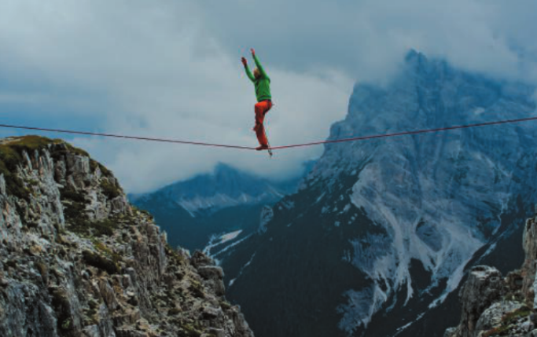

- Why is the man not moving?
________________________________________________________________
- How will the forces be different if a lighter man uses the tightrope?
________________________________________________________________________________________________________________________________
- Workbook pages 131+132

7Kb Springs:
- Materials and objects can be stretched (made longer) or compressed (made shorter).
- The amount of stretch or compress depends on
- the type of the material
- the size of the force.
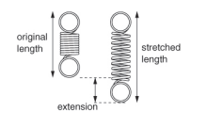
- Elastic materials (like a spring) will stretch with a force and then return to their original shape when the force is removed.
- The extension of a spring is the difference between its original length and its stretched length.
(Extension = stretched length – original length)

Example:
A weight hanged in a spring that has an original length of 16 cm.
The spring stretched to be 21 cm. Calculate the extension of this spring.

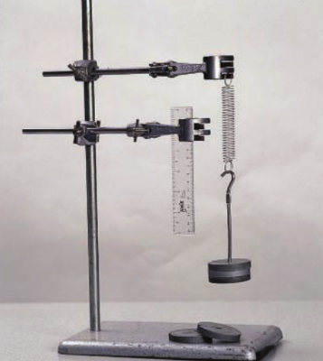
The apparatus below is being used to investigate the extention of a spring.
Question : Explain how you would use this apparatus to find out how much the spring stretches with different forces on it. __________________________________________________
__________________________________________________
__________________________________________________
__________________________________________________
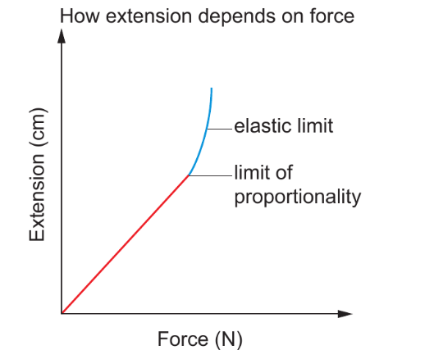

The graph shows that extension is proportional to the force up to a certain point, called the limit of proportionality. This means that for every 1N increase in the force, the spring stretches by the same amount.

*Hook’s law: The extension of some elastic materials is proportional to the force to a certain limit called limit of proportionality.

Example:
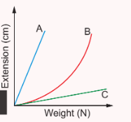
The graph below shows how far different materials stretch when a weight is hung on them.
- Which material stretches the most for certain weight? _________________.

- Which material(s) could be used for making a force meter? Explain your reasoning.
____________________________________________________________________________________________________________________________
- Explain which material would be best for making a force meter to measure small weights?
__________________________________________________________________________________________________________________________________________________________________________________________

If the spring is stretched too far, the extension stops being proportional to the force. If it is stretched even further, it goes beyond its elastic limit. The spring will no longer return to its original length when the force is removed.

- Materials that do not return to their original shape when a force is removed are plastic materials.

Questions:
- A spring stretches 2 cm when a 10N weight hangs on it. How far will it stretch with a weight of 20N? ______________.

- a-What is the difference between an elastic and plastic material?
______________________________________________________________________________________________________________________________________________________________________________________________________________
b-Name one plastic material. _________________________.

- Workbook page 126.

Achievement test questions:
Question 1:
- The diagram shows the forces acting on a car as it travels along a road.
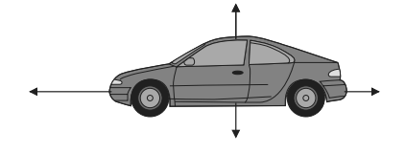
Which one of these describes how the car is moving?
A it is accelerating backwards
B it is accelerating forwards
C it is decelerating
D it is moving at a steady speed

- A car has a mass of 1200kg.
What is the weight of the car on Earth?
A 120N
B 1200kg
C 1200N
D 12000N

Question 2:
A student investigates how the extension of a spring is affected by force.
She uses the apparatus shown in the diagram.
The diagram shows the extension produced by a 3N force.
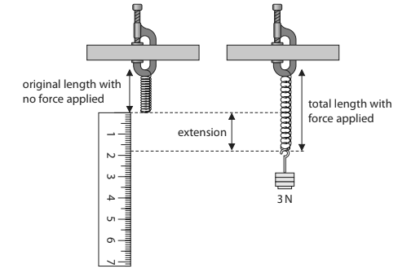
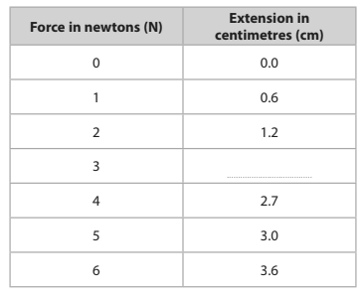
- Use the information in the diagram to complete her table of results.

(b) (i) Plot the results from the table on the grid below.
Use suitable scales for the vertical and horizontal axes.

(ii) Join the points with a line of best fit.

(iii) Circle any anomalous results on your graph.

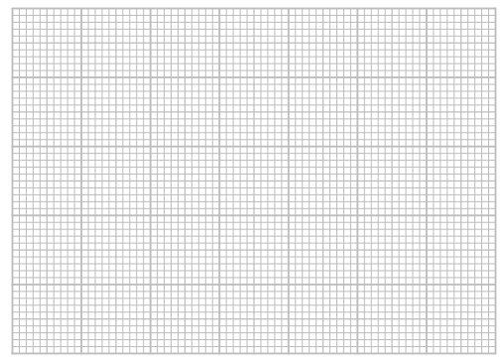
force in newtons (N)

- Tick two conclusions that can be drawn from this investigation.
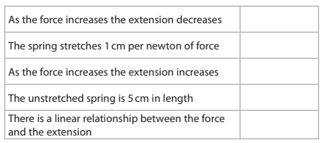

- State how the student could make her results more reliable.
________________________________________________________________________________________________________________________________________________

Question 3:
A young child pushes a cart with a forward force of 10 N. This is shown in the
diagram.
The cart does not move because of friction acting on the cart.
The cart has a mass of 2 kg.
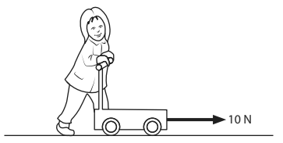
Draw one straight line from each force to its correct size and direction.

