

Rosary School – Marj Elhamam
Second Semester 2025/2026
Worksheet 6
Name: _________________ |  | Date: / 12 / 2025
Grade: 5th (A,B,C,D,E) |  | Subject: Science
*Notes: 1) Weight = mass gravitational field strength
2) 1 Kg mass = 10 N weight
Question 1:
The mass of an astronaut is 80 kg on the Moon. What is the mass of the astronaut on the Earth?
___________________________________________________________________
Question 2:
An object has a mass of 50 kg. The gravitational field strength on Earth is 10 N. The gravitational field strength on a distant planet is 4 N.
- What is the weight of the object on Earth?
__________________________________________________________________________________________________________________________

- What is its weight on the distant planet?
__________________________________________________________________________________________________________________________
Question 3:
- When an astronaut stands on weighing scales on Earth, the scales read 65 kgs, the astronaut travels to planet Y which has half the gravitational force of the Earth.
What is the weight of the astronaut on planet Y?
______________________________________________________________________________________________________________________________________
- When an astronaut stands on weighing scales on Earth, the scales read 80kgs. The astronaut travels to planet X which has double the gravitational force of the Earth.
1. What is the astronaut’s mass on Earth?
___________________________________________________________________
2. What is the astronaut’s weight on planet X?
______________________________________________________________________________________________________________________________________

Question 4:
Two blocks of metal X and Y hang from forcemeter, as shown in the diagrams.
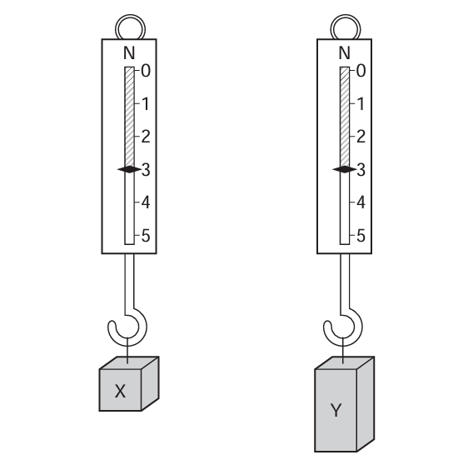
- What is the reading of each forcemeter?
X ______________________ Y_______________________
- There are risks with this investigation.
Write down one risk and one way to reduce this risk.
Risk: _________________________________________________________________
Way to reduce this risk: _________________________________________________________________

