

Rosary School – Marj Elhamam
Name: _________________ |  | Date: __ /___/ 2025
Grade: 9( A,B,C ,D) |  | Past paper questions

Alkali metals

Question one:
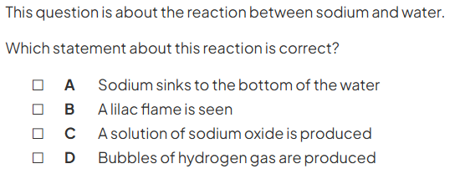
(1)
Question two:
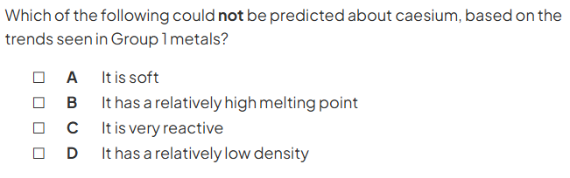
(1)
Question three:
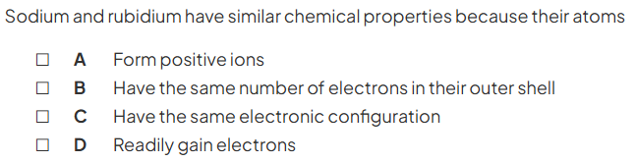
(1)

Question four:
a)
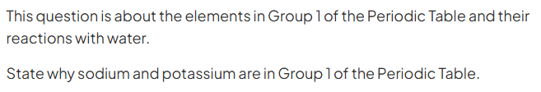(1)

B)
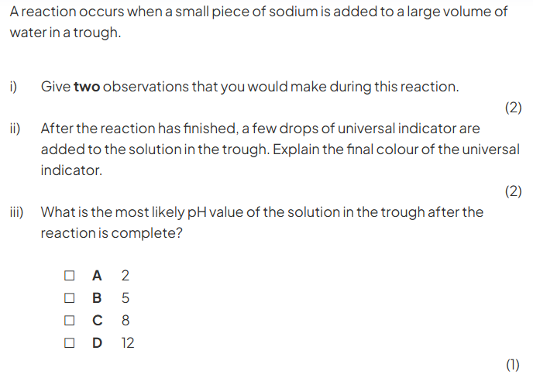

C)
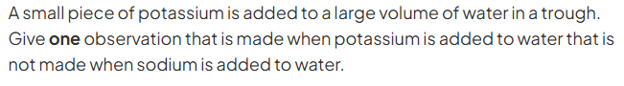
(1)

Question five:
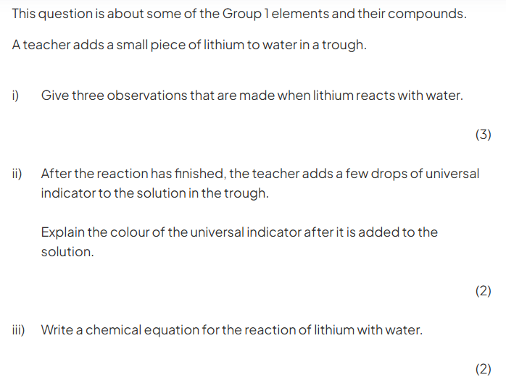
Question six:
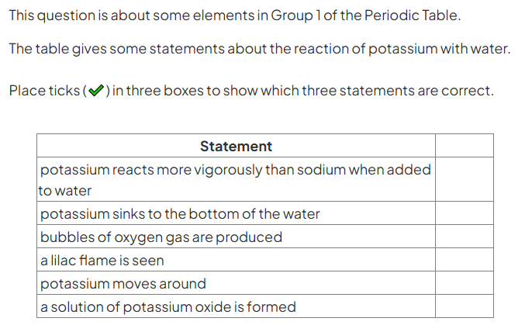
(3)

Question seven:
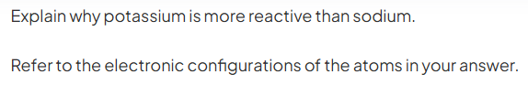
(3)

Question eight:
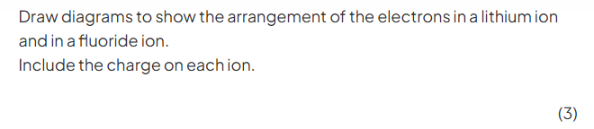
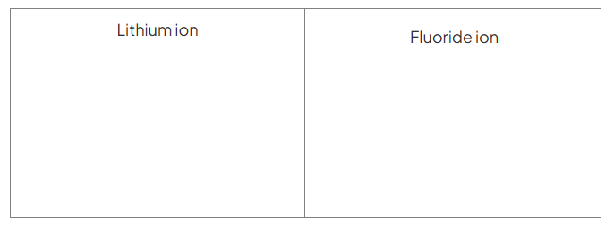Question nine:
The relative sizes of the atoms of five alkali metals are shown below. Use the diagrams to help explain the order of reactivity of the alkali metals.
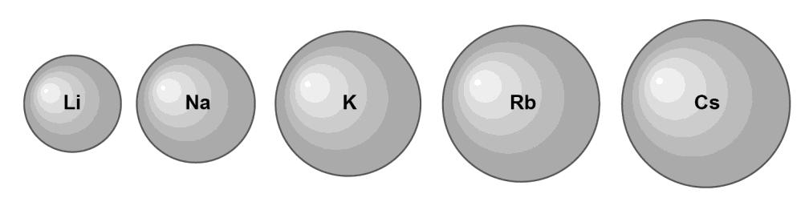________________________________________________________________________________________________________________________________________________________________________________________________________________________________________________________________________________________________________________________________
(3)
Question ten:
Write the balanced symbol equation with stating symbols for the reaction between potassium and water.
______ + ______ _______ + ______ (3)

Question eleven:
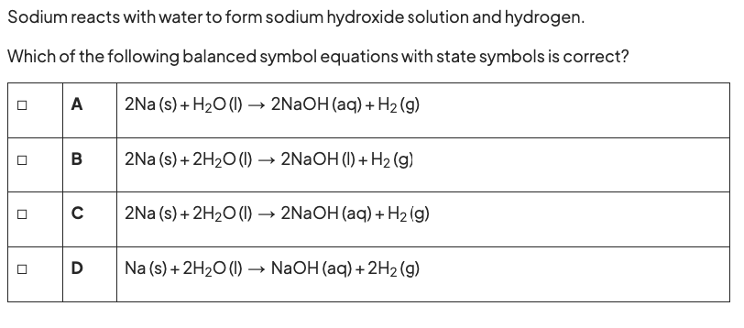

Question twelve:
Lithium, potassium and rubidium are alkali metals.
Describe what you would see when a small piece of rubidium is dropped on to water.
_______________________________________________________________
_______________________________________________________________
____________________________________________________________ (2)

