

Rosary School – Marj Elhamam
Second Semester 2025/2026
Worksheet 6
Name: _________________ |  | Date: / 12 / 2025
Grade: 5th (A,B,C,D,E) |  | Subject: Science
*Notes: 1) Weight = mass gravitational field strength
2) 1 Kg mass = 10 N weight
Question 1:
The mass of an astronaut is 80 kg on the Moon. What is the mass of the astronaut on the Earth?
80 kg
Question 2:
An object has a mass of 50 kg. The gravitational field strength on Earth is 10 N. The gravitational field strength on a distant planet is 4 N.
- What is the weight of the object on Earth?
Weight = mass X gravitational field strength
= 50 kg X 10 N = 500 N
- What is its weight on the distant planet?
Weight = mass X gravitational field strength
= 50 kg X 4 N = 200 N
Question 3:
- When an astronaut stands on weighing scales on Earth, the scales read 65 kgs, the astronaut travels to planet Y which has half the gravitational force of the Earth.
What is the weight of the astronaut on planet Y?
We can solve this question in two ways:
- Weight = mass X gravitational field strength
= 65 kg X 10 N = 650 N ( this is the weight on Earth)
Since Planet Y has half the gravitational force of the Earth, then the weight on planet Y = 650 N ÷ 2 = 325 N

- Weight = mass X gravitational field strength
= 65 kg X 5 N (the Earth’s gravitational force is 10 N, half of it is 5 N)
= 325 N

- When an astronaut stands on weighing scales on Earth, the scales read 80kgs. The astronaut travels to planet X which has double the gravitational force of the Earth.
1. What is the astronaut’s mass on Earth?
80 kg
2. What is the astronaut’s weight on planet X?
We can solve this question in two ways:
- Weight = mass X gravitational field strength
= 80 kg X 10 N = 800 N (this is the weight on Earth)
Since Planet X has double the gravitational force of the Earth, then the weight on planet X = 800 N X 2 = 1600 N

- Weight = mass X gravitational field strength
= 80 kg X 20 N (the Earth’s gravitational force is 10 N, double it is 20 N)
= 1600 N

Question 4:
Two blocks of metal X and Y hang from forcemeter, as shown in the diagrams.
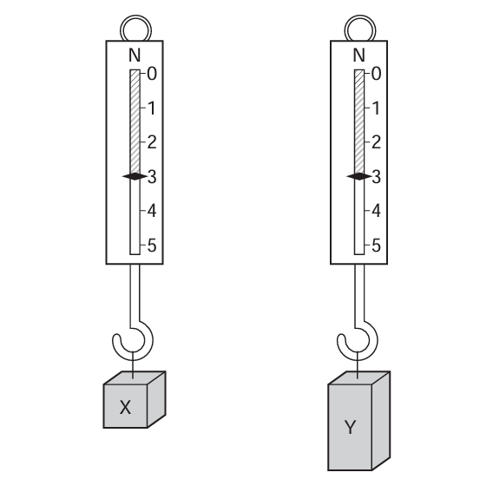
- What is the reading of each forcemeter?
X: 3 N Y: 3 N
- There are risks with this investigation.
Write down one risk and one way to reduce this risk.
Risk:
Falling off the hook
Way to reduce this risk:
Secure the blocks

