Topic 5.1: Mass and weight
Focus p60
1 a A balance or scale
b Grams (g) and kilograms (kg)
c Forcemeter
d Newtons (N)
2 Mass is the amount of matter in an object. Weight is the amount of attraction on an object caused by the force of gravity.

Practice p61
3 b and c are true; a and d are false.
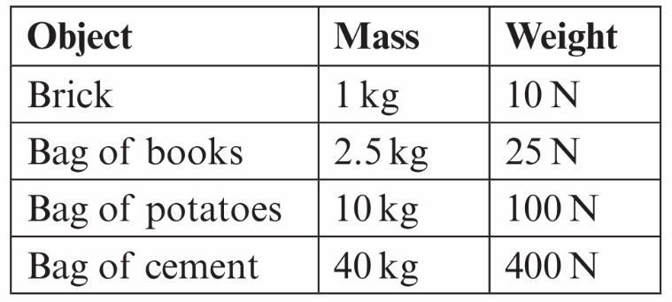
4

5 No, because you are adding to the weight.

Challenge Q6 p62:
6 a A forcemeter
b 30 N
c 3 kg

