

Rosary School – Marj Elhamam
Study Sheet (1)
Name: _________________ |  | Date: / 11 / 2025
Grade: 8 (A, B,C,D) |  | Subject: Chemistry

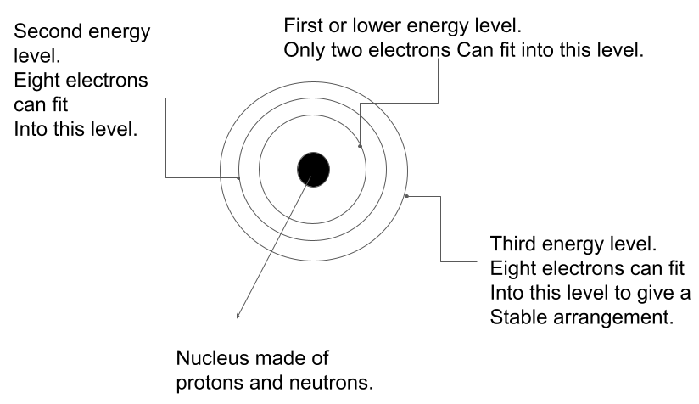
- Arrangement of electrons in an atom
- Electrons are in orbit around the central nucleus of the atom.
- The electron orbits are called shells ( or energy levels ) and have different energies.
- The shells are filled starting with the one closest to the nucleus.
- The first shell can hold only 2 electrons.
- The second and subsequent shells hold 8 electrons to give a stable arrangement of electrons.

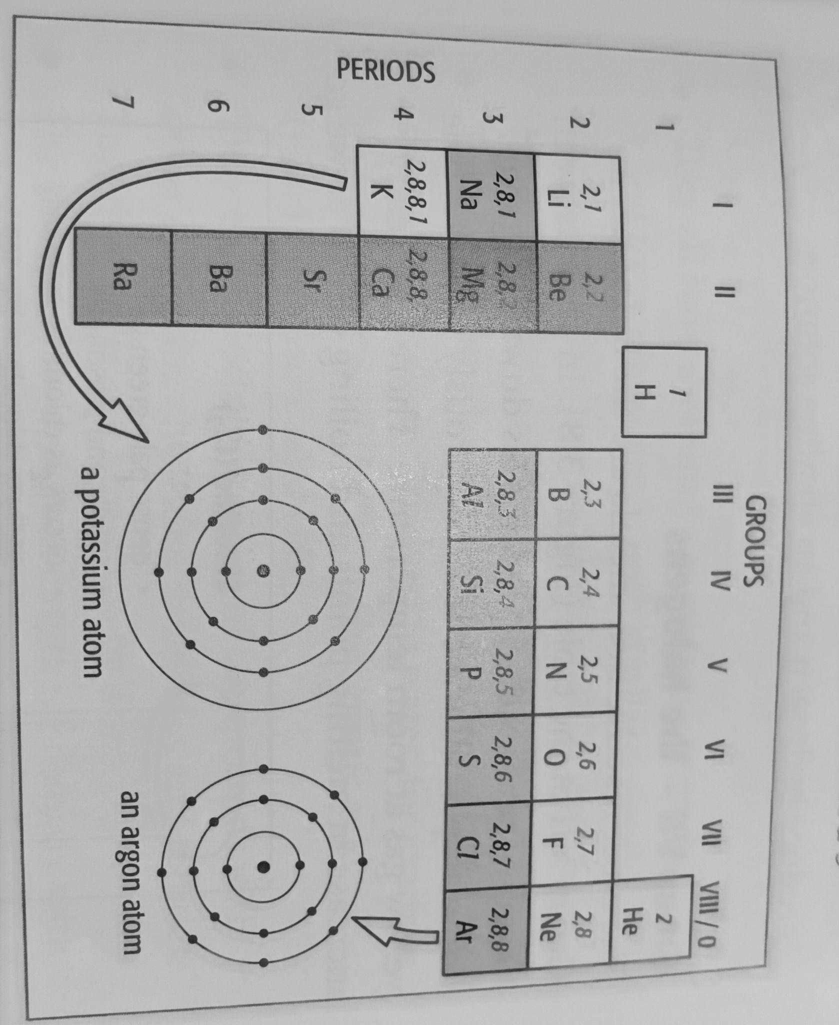
The electron arrangement of atoms are linked to position in the Periodic Table.
- Elements in the same group have the same number of electrons in their outer shell.
- The periods also have numbers. This number shows us how many shells of electrons the atom has.

Example :
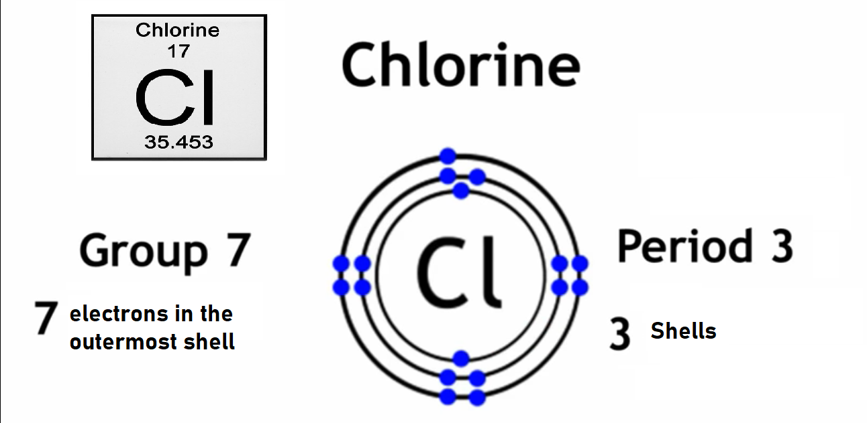

Question one:
Draw and write the arrangement of electrons for the following elements.

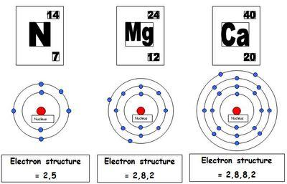
__________ ___________ ___________
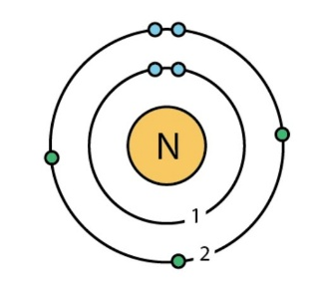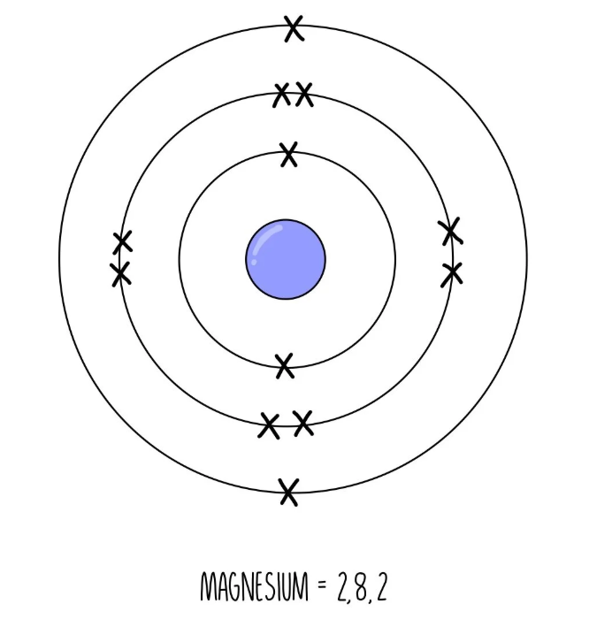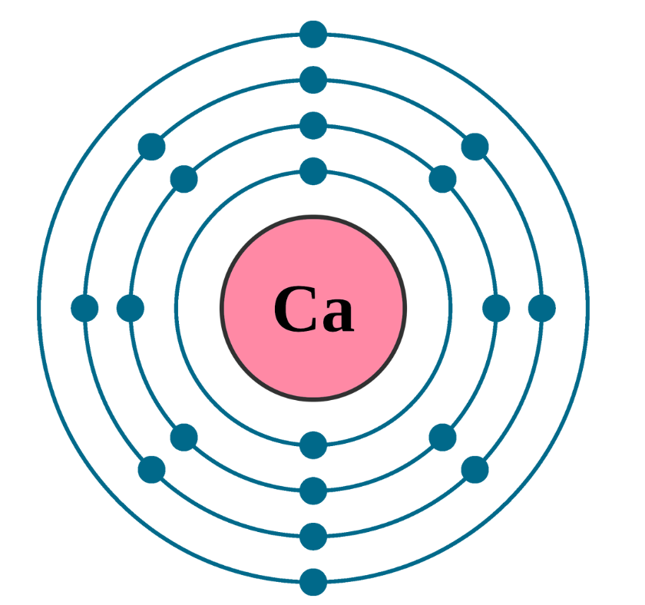
2, 5 2,8,2 2,8,8,2
Group 5 ( 5 electrons Group 2 ( 2 electrons in Group 2
in the outer shell) the outer shell) Period 4
Period 2 ( 2 shells ) Period 3 ( 3 shells)

- Ionic compounds
Compounds of metal plus a non-metal. This involves the transfer of electrons from one atom to another. This transfer of electrons results in the formation of positive and negative ions. The oppositely charged ions are then attracted to each other by attraction force called ionic bonding.

The electrons involved in the formation of ions are those in the outer shell of the atoms. Metal atoms lose their outer electrons to become positive ions, atoms of non-metals gain electrons to become negative ions.

A common example of a compound that involves ionic bonding is sodium chloride. Sodium atom, which has an electron arrangement of 2,8,1, loses its one outer electron to form a sodium ion Na+. The chlorine atom, electron arrangement 2,8,7, gains an electron released from the sodium atoms and becomes chloride ion Cl -.
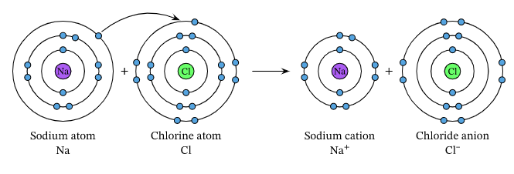

- The formula of ionic compounds
Ionic compounds are solids at room temperature, and their formulae are simply the whole-number ratio of positive to negative ions in the structure. Thus, in magnesium chloride, there are two chloride ions Cl - for each magnesium ion Mg+2

Formula of magnesium chloride
Write down the correct symbols Mg Cl
Write down the charges on the ions +2 1-
____________________________________________________________
Formula MgCl₂

The formula is MgCl2. The overall structure must be neutral. The positive and negative charges must be balanced with each other.

Example 1:
Formula of aluminium oxide
Write down the correct symbols Al O
Write down the charges of the ions 3+ 2-

Formula Al₂O₃

Example 2:
Formula for calcium oxide
Write down the correct symbols Ca O
Write down the charges of the ions 2+ 2-

Formula Ca₂O₂
Simplify the ratio CaO
Metals first

Question two:
Use the Periodic Table to help you give the formula of the following compounds. Show your work

1- Magnesium bromide
Mg Br
+2 -1 ( Group 7 need 1 electron to become stable)
____________
MgBr₂

2- Aluminium fluoride.
Al F
3+ -1
_____________
AlF₃

3- Lithium chloride
Li Cl
+1 -1
_____________
LiCl
4- potassium oxide
K O
+1 2- ( Group 6 need 2 electrons to become stable)
_______________
K₂O

