

Rosary School – Marj Elhamam
Lab report (2)
Name: _________________ |  | Date: / / 2025
Grade: 8 (A, B, C,D) |  | Subject: Chemistry
Displacement Reactions
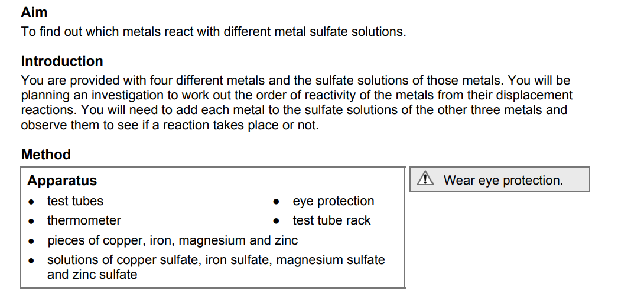
- Planning
- Consider the selection of metals and solutions that are available to you. How many experiments are possible, if you are mixing one metal with one solution each time? ________________________________________________________________________
- How will you be able to tell if a reaction has taken place? What observations or measurements will you make? Explain your choice of data collection method.
__________________________________________________________________________________________________________________________________________________________
- How can we use the reactivity series to predict whether a reaction will take place? Explain your answer using an example from the chemicals listed above.
__________________________________________________________________________________________________________________________________________________________

- Draw a results table, including a space for your predictions. Design your table in a way that allows you to see easily the number of reactions of each metal.
Metal |  | Metal Sulfate | Solutions
 | Copper sulfate | Iron sulfate | Magnesium sulfate | Zinc sulfate
Copper
Iron
Magnesium
Zinc

- Predictions
- Make predictions for the reactions between the four different metals and the metal sulfate solutions. If you think that a combination will react, put a tick (⎫) in the table. If you think there will be no reaction, put a cross.
- Recording your results
- Carry out your experiments and record the results in your table.
- Considering your results/conclusions
- Add up the total number of reactions for each of the metals. Does this agree with the order of reactivity in your prediction?
_____________________________________________________________________________
- Write word equations for the reactions that took place in your experiments.
_______________________________________________________________________________________________________________________________________________________________________________________________________________________________________
_______________________________________________________________________________________________________________________________________________________________________________________________________________________________________
- Predict what would happen if you extended the experiment to include lead and calcium metals, and lead nitrate and calcium nitrate solutions.
__________________________________________________________________________________________________________________________________________________________

