Lab Report(2) Displacement Reactions

Introduction
Aim: To find out which metals react with different metal sulfate solutions and to work out the order of reactivity of the metals from their displacement reactions.

Planning

1) Consider the selection of metals and solutions that are available to you. How many experiments are possible, if you are mixing one metal with one solution each time?
- Total combinations: 4X 4 = 16.
- Combinations where no displacement can occur (metal with its own salt): 4 .
- Total possible displacement experiments: 16 - 4 = 12

2) How will you be able to tell if a reaction has taken place? What observations and measurements will you make? Explain your choice of data collection method.
A reaction occurs if the solid metal is more reactive than the metal in the solution.
Observations and Measurements:
- Color Change: The color of the solution may change (e.g., blue copper sulfate solution fading).
- Formation of New Solid: A layer of the less reactive metal will deposit on the surface of the original metal (e.g., a reddish-brown coating of Copper metal).
- Temperature Change: An increase in temperature, as displacement reactions are typically exothermic.

3) How can we use the reactivity series to predict whether a reaction will take place? Explain your answer using an example from the chemicals listed above.
A reaction will occur only if the free metal (solid metal) is more reactive than the metal in the salt solution. The more reactive metal will displace the less reactive metal.
Reactivity Series (approximate order): Magnesium > Zinc > Iron > Copper

Recording Your Results

4) Draw a results table, including a space for your predictions. Design your table in a way that allows you to see easily the number of reactions of each metal.

5) Make predictions for the reactions...
Here is the completed table with predictions (a \checkmark for reaction and \times for no reaction) based on the Reactivity Series (\mathbf{Mg > Zn > Fe > Cu).
Metal | Copper sulfate | Iron sulfate | Magnesium sulfate | Zinc sulfate | Total Reactions (Prediction)
Copper | - | X | X | X | 0
Iron | ✔ | - | X | X | 1
Magnesium | ✔ | ✔ | - | ✔ | 3
Zinc | ✔ | ✔ | X | - | 2

Considering Your Results/Conclusions

7) Add up the total number of reactions for each of the metals. Does this agree with the order of reactivity in your prediction?
Metal | Total Reactions (Prediction)
Magnesium | 3
Zinc | 2
Iron | 1
Copper | 0

8) Write word equations for the reactions that took place in your experiments.
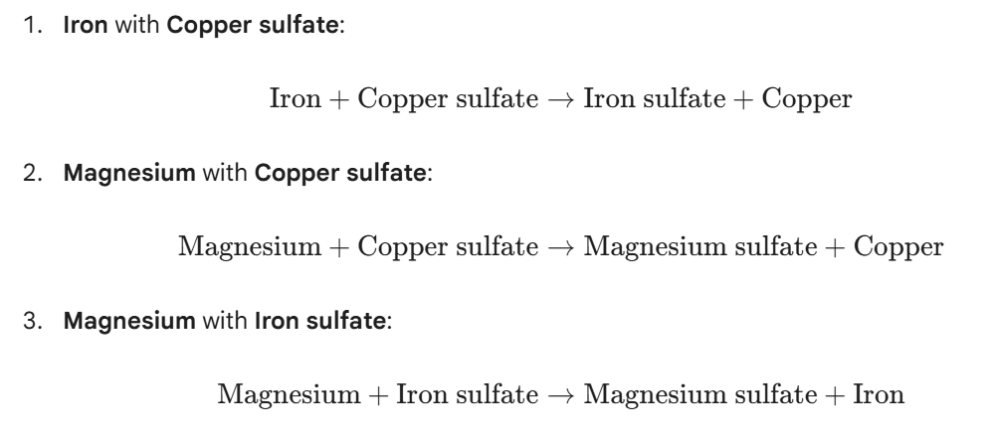
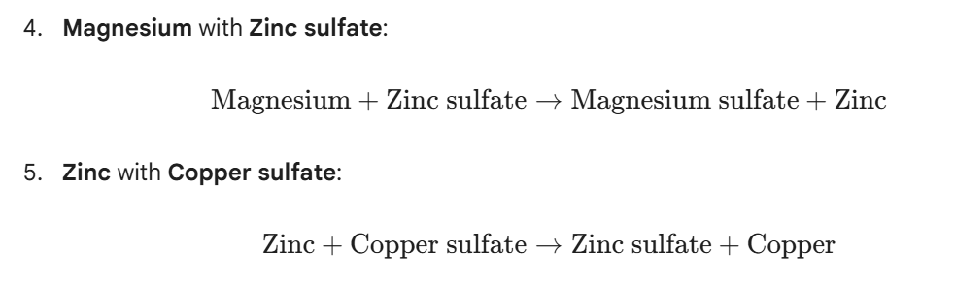
6. Zinc with iron sulfate:
Zinc + iron sulfate → iron + zinc sulfate

9) Predict what would happen if you extended the experiment to include lead and calcium metals, and lead nitrate and calcium nitrate solutions.
The extended reactivity series is (most reactive to least):
- Calcium (Ca) metal: Would react with all the other metal salt solutions.
- Lead (Pb) metal: Would only react with Copper sulfate
- Calcium Nitrate solution: No reaction would occur with any of the other metals because Calcium is the most reactive and cannot be displaced.
- Lead Nitrate solution: Magnesium, Zinc, Iron would all react and displace the Lead from the solution. Copper would not react.

