

Rosary School – Marj Elhamam
Study sheet 2
Name: _________________ |  | Date: __ /___ / 2025
Grade: 7( ) |  | Subject: Physics

8L Earth and space
8La Gathering the evidence
The Solar System
• We live on a planet called the Earth. The Earth gets energy from the Sun. The Sun, the eight planets and their moons make the Solar System. The eight planets are Mercury, Venus, Earth, Mars, Jupiter, Saturn, Uranus and Neptune.
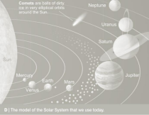
Use this mnemonic to help you remember the planets in
order:
My Very Educated Mother Just Showed Us Nature
• Early astronomers could only observe the five visible
planets from Earth with their naked eyes without using a
telescope (Mercury, Venus, Mars, Jupiter and Saturn).
• An Egyptian astronomer called Ptolemy, worked out a
(geocentric model), a model of the Solar System with the
Earth in the center and the Moon, Sun and planets moved
in circles around the Earth.
This model could explain many of the astronomers’ observations but not all of them. • Nicolaus Copernicus, a Polish astronomer, suggested another model, (the heliocentric model) a model of the Earth and the other planets moved in circles around the Sun.
• Galileo used one of the first telescopes and provided more evidence to support Copernicus’ model.
• The model used today was first suggested by Johannes Kepler. In this model, the Sun is in the center of the Solar System, but the planets move around the Sun in elliptical orbits (an ellipse is like a squashed circle).
• Most of the planets have moons orbiting them.
• The Earth orbits around the Sun. It takes one year to go around once.
• The Moon is a satellite of the Earth. We can see the Moon because it reflects light from the Sun. The Moon seems to change shape. The different shapes are called phases of the Moon. The phases happen because we cannot always see all of the part that is lit by the Sun. We see different parts of the lit up half as the Moon moves around the Earth.
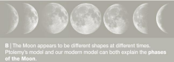
Mankind exploring space in many different ways:
1. Earth telescopes, used to help us explore space from the Earth. Some telescopes use light and some use radio waves.
2. Space telescopes, a space telescope orbits high above the Earth’s atmosphere and takes pictures of planets, stars and galaxies.
3. Space probes, a space probe is a type of unmanned spacecraft that is sent through space to gather scientific information which is fed back to Earth. Examples of space probes: fly-by probes, orbiters, landers and rovers.
4. Crewed spacecraft, some space missions involve sending astronauts into space.
Workbook page 136
8Lb Seasons
• The Earth is divided into two halves or hemispheres by an imaginary line called the Equator. Europe, North America, part of Africa and most of Asia are in the northern hemisphere.
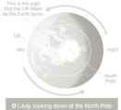
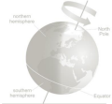
• The Earth’s axis is tilted. When the northern hemisphere is tilted towards the Sun it is summer in the UK. Days are longer than nights, and the Sun is higher in the sky. During summer The Sun’s rays are more concentrated, so it feels hotter. Summer days are also warmer than winter days because the Sun is shining for longer and has more time to warm up the air and the ground. Workbook page 138, 139

8Le Beyond the Solar System
• Planets do not make their own light. We can sometimes see the planets because they reflect light from the Sun.
• The Sun is a star. It is a ball of gas that gives out large amounts of energy. The Sun is like the stars you can see in the sky at night. The stars do not look very bright because they are a lot further away than the Sun.
• People often group stars into patterns called constellations.
• The Sun is one of millions of stars in our galaxy, which is called the Milky Way. There are millions of galaxies in the Universe.
• The stars are a very long way from Earth. Scientists measure distances to the stars using light years. A light year is the distance that light can travel in one year.
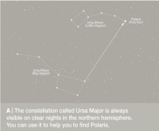
Workbook page 145

“Equipped with his five senses, man explores the universe around him and calls the
adventure Science.” -Edwin Hubble, Astronomer

Teacher: Saja Ammari, Abdullah Ramadan

