

Rosary School – Marj Elhamam
8Ld Gravity in space
Name: _________________ |  | Date: __ /___ / 2025
Grade: 7( ) |  | Subject: Physics

Study Sheet (1)
Gravity and gravitational fields
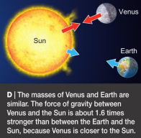
• The mass of something is the amount of substance or ‘matter’ it contains. It is measured in kilograms (kg).
• Weight is the force of gravity pulling on a mass. It is a force, so it is measured in newtons (N).
• Gravity is the force of attraction between two
masses. The force of gravity is stronger if:
o the objects have large masses
o the objects are close together (the force of
gravity gets weaker when the two objects
attracting each other get further apart) On Earth, gravity pulls on every kilogram of mass with a force of about 10 N.
• Gravity is not as strong on the Moon because the Moon has a much smaller mass than the Earth. If you went to the Moon your mass would not change, but your weight would be less than on Earth because the Moon’s gravity is weaker.
• The Sun’s gravity keeps all the planets in our Solar System moving in elliptical orbits around it. If there was no gravity from the Sun, the planets would all fly off into space.
• The Earth’s gravity keeps the Moon in orbit around the Earth.
• A satellite is anything that orbits around a planet. The Moon is the only natural satellite of the Earth.
• Artificial satellites are put into orbit around the Earth or other planets. They can be used for taking pictures or transmitting TV programs.

*Question:
These diagrams show different objects in space. Which pair of objects has the biggest force gravity between them? Explain your answer.
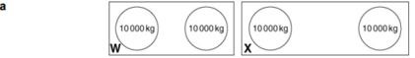
The objects in _____ (W/X) have the biggest force of gravity between them because ________________________________________________________________________

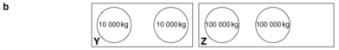
The objects in _____ (Y/Z) have the biggest force of gravity between them because ________________________________________________________________________
• You can calculate the weight of an object using this formula:
Weight (N) = mass (kg) × gravitational field strength (N/kg)

Example:
Calculate the weight of a 5 kg mass on the Earth.
Weight = mass x g
= 5 kg x 10 N/kg
= 50 N

*Questions:
1) a. Calculate the weight of a 2 kg mass on the Earth.
b. The gravitational field strength on the Moon is 1.6 N/kg. Calculate the weight of the
2 kg mass on the Moon.

2) Course book questions: 3, 5, 6 pages 190, 191
3) Workbook page: 142

Teachers: Saja Ammari &Abdallah Ramadan

