

Rosary School – Marj Elhamam
Worksheet 1
Name: ________________ |  | Date: ____ /____ / 2025
Grade: 7 (A,B,C,D,E) |  | Subject : Physics

Question 1:
For each description identify the body in the Solar System which is being described.
- The fourth planet from the sun. __________________________
- A naturel satellite orbiting a planet. _______________________
- The force which keeps satellites in orbit. ___________________
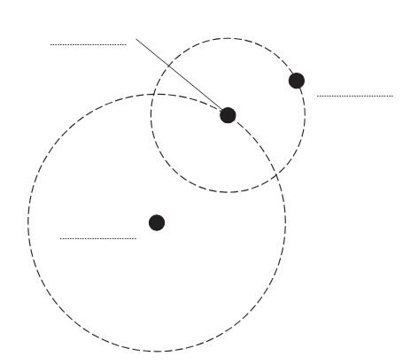
Question 2:
The diagram shows the orbits of a planet and a moon in the Solar System.
The diagram is not to scale.

On the diagram, label the planet, the moon and the Sun.
Question 3:
a. Describe the modern model suggested by Johannes Kepler.
_____________________________________________________________________
b. What are the different shapes of the moon called?
_____________________________________________________________________
c. Explain why the moon looks different as it orbits the Earth.
_____________________________________________________________________
Question 4:
The UK is in the northern hemisphere of the Earth. In the middle of summer, there are over 16 hours of daylight in the UK.
- How is the number of hours of daylight in the UK different in the winter?
________________________________________________________________________
b. Why is the length of daylight different at different times of the year? Tick one box.
□ The Earth spins on its axis faster in winter.
□ The Earth’s axis is tilted.
□ The Earth is further away in its orbit from the Sun during winter.
c. When it is summer in the UK: [1]
□ the northern hemisphere is tilted towards the Sun.
□ the southern hemisphere is tilted towards the Sun.
□ the northern hemisphere is tilted towards the moon.
d. Give one reason why the Sun feels hotter in summer than in winter in the UK.
___________________________________________________________________________
Question 5:
Diagram 2 shows the Moon orbiting the Earth.
- Draw an arrow on diagram 2 to show the gravitational force acting on the Moon due to the Earth.
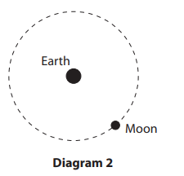
- Explain why do we see different phases of the moon.
__________________________________________________
__________________________________________________
__________________________________________________
- Give a name for a large collection of billions of stars.
__________________________________________________

