
Rosary School – Marj Elhamam
Worksheet 3
Name: _________________ |  | Date: ____ /____ / 2025
Grade: 6( A,B,C,D,E ) |  | Subject : Science

Question 1:
Jamila and Tia investigate friction. Jamila sits on a sheet of material. She moves down the slide on the material.
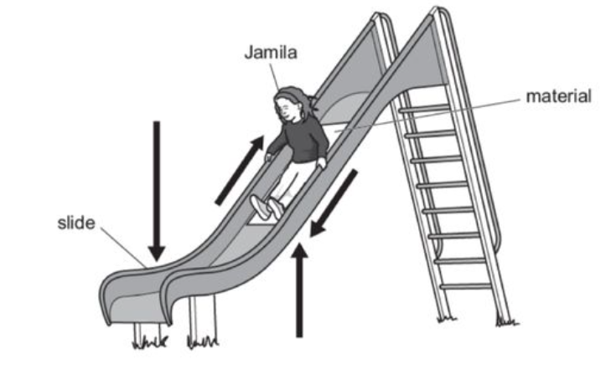
- The arrows on the diagram show the different forces acting on Jamila as she moves down the slide
Circle the arrow on the diagram that shows friction
- Tia records the time it takes Jamila to move down the slide on different materials.
Here are their results.
Material | Time taken to move down the slide in seconds
A | 2
B | 5
C | 1
D | 2
E | 3
Which material has the most friction? Explain your answer.
____________________________________________________________________________________________________________________________________________
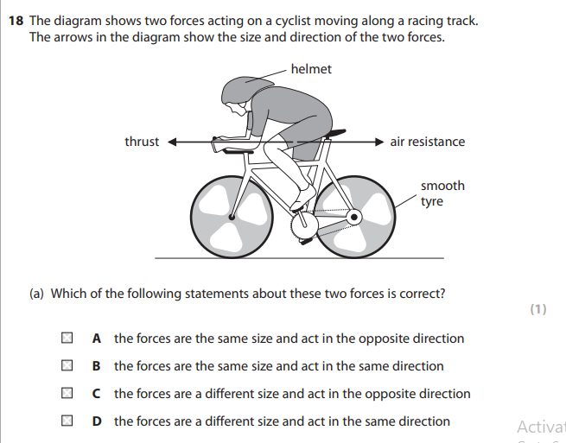
Question 2:
The diagram shows two forces acting on a cyclist moving along a racing track.
The arrows in the diagram show the size and direction of the two forces.
- Explain how will the speed of the cyclist change due to the forces acting on her.
_________________________________________________________________________________________________________________________________________________________________________________________________________________________________
- During wet conditions the racing track becomes very slippery.
State a change the cyclist could make to the bicycle to overcome the wet conditions.
_______________________________________________________________________________________________________________________________________________________
Question 3:
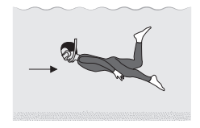
The diagram shows a person swimming underwater.
What force does the arrow represent?
__________________________________
Question 4:
There are many different types of forces.
- Ryan uses a rope to climb down the side of a mountain.
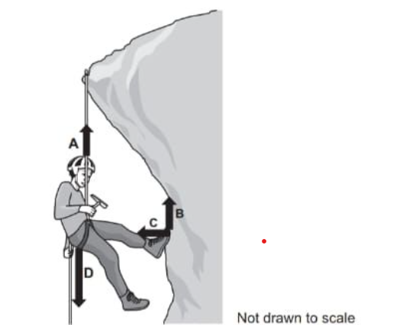
- Which arrows A, B, C, or D represents the force of gravity acting on Ryan? ________.
- Name one other force acting on Ryan as he climbs the mountain. ___________________________________________________________
- What scientific unit are forces measured in? _______________________.
- Which of the forces acting on Ryan is a non-contact force? ______________.
Question 5:
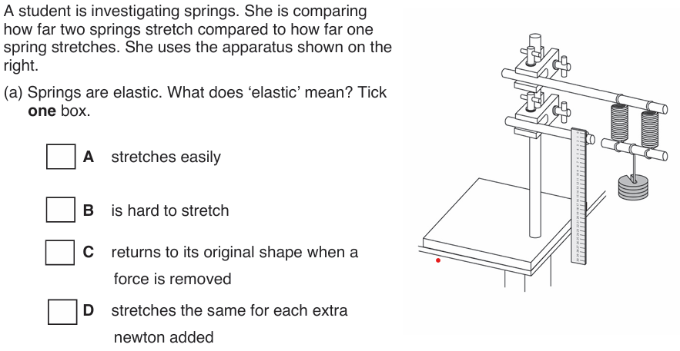
- Give one factor the student must keep the same to make the test fair.
___________________________________________________________
- Describe one safety precaution the student should take.
____________________________________________________________________________________________________________________________________________
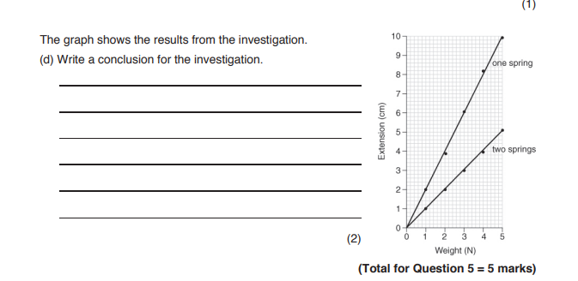
- The graph shows the results from the investigation.
From the graph write a conclusion for the investigation.
___________________________________________
___________________________________________
___________________________________________
___________________________________________

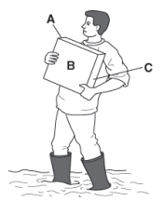
Question 6:
A man is working in a muddy garden. When he picks up a paving stone his feet sink deeper into the mud.
- Explain why his feet sink into the mud when he picks up the paving stone. Write about pressure in your answer.
__________________________________________________________________________________________________________________________________________________________________________________________________________________
- The paving stone has a weight of 600 N. Side A has an area of 300 cm².
Calculate the pressure under the paving stone if the man puts the stone on side A.

Question 7:
- A woman is applying 300 N/m² of pressure onto a door with her hand. Her hand has area 0.02m². Calculate force being applied.

- A force of 600N is applied to a square of side length 300cm. Calculate the pressure on the square in Pascal.

Question 8:
The diagram shows the forces acting on a parachutist.

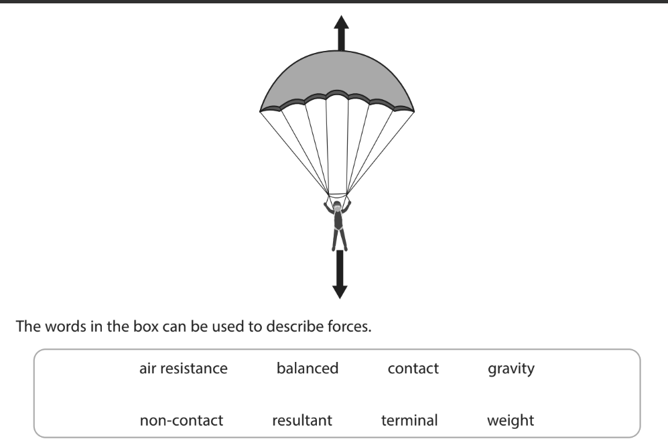
Use words from the box to complete each sentence.
Gravity is an example of a ____________________ force.
The upward force on the parachutist is caused by ________________________
When the parachute reaches terminal velocity the ______________force is zero.

Question 9
The car is moving
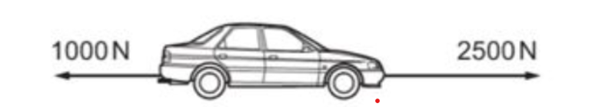

- State whether the forces are balanced or unbalanced?
________________________________________________________

- What will happen to the speed of the car?
________________________________________________________________

