
Rosary School / Marj El Hamam
Name : _____________________ Date : / / 2025
Subject :Science Grade: 6 ( )

7B Sexual Reproduction

7Bb Reproductive Organs
- Reproduction produces new living things (offspring).
- Two parents are needed for sexual reproduction.
- Males & females have reproductive systems, which contain reproductive organs.
The male reproductive system:
The human male reproductive system contains these parts:
- Testes: make sperm cells (gametes or sex cells).

Note: The testes hang outside the body in a bag of skin called the scrotum. Their position helps to keep the sperm cells at the correct temperature to develop properly.

- Sperm duct: carries sperm cells from testes to the penis.

- Glands: produce fluids that provide a source of energy for the sperm cells.

Note: The mixture of sperm cells & fluids is called semen.

- Urethra: carries semen and urine to outside the body at different times.
- Penis:
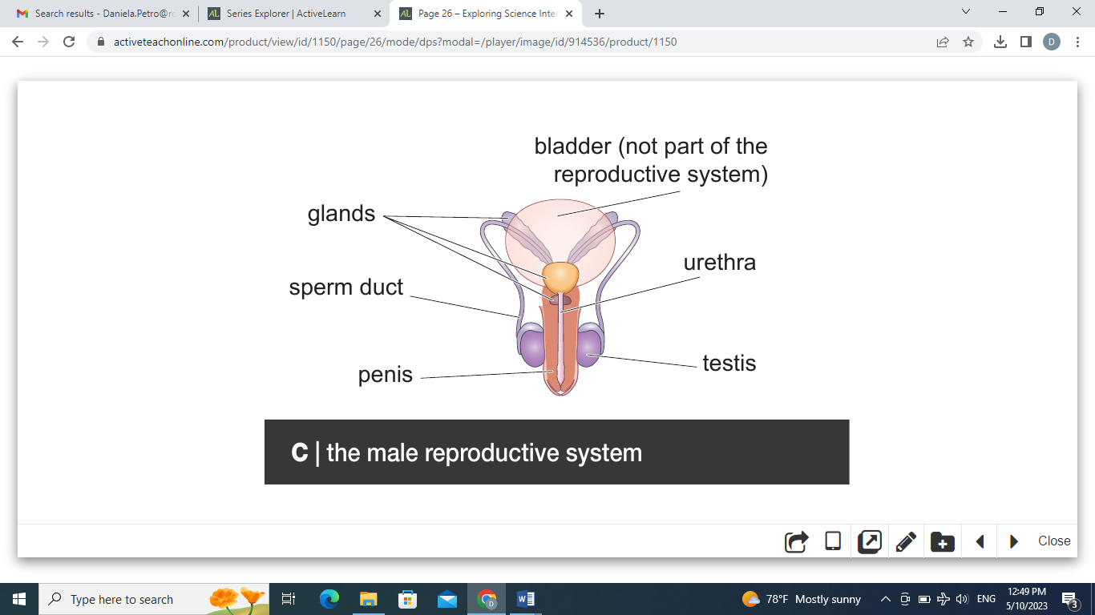

The female reproductive system:

The human female reproductive system contains these parts:
- Ovary: makes egg cells (gametes or sex cells).

- Oviduct: where fertilisation can happen.

Note: Fertilization: a sperm cell enters an egg cell (ovum) & the two cell nuclei fuse (become one). A single fertilised egg cell or zygote is formed, which can grow into a new organism.

- Uterus: where the zygote develops & grows into a baby.

- Cervix: it is made of a ring of muscle and it holds the baby in place during pregnancy.
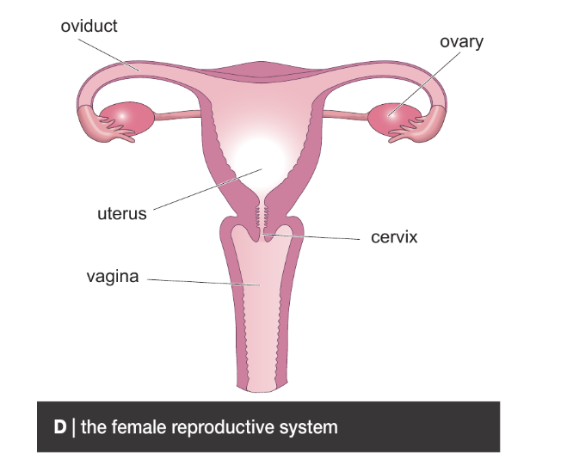
- Vagina:

In all mammals fertilisation happens inside the female. This is called internal fertilisation. In some animals (e.g. frogs, fish) fertilization happens outside the female (external fertilisation).

The fertilised egg cells of many animals also grow and develop outside their parents. This is called external development. Amphibians, birds and fish use external development. Humans use internal development and produce fewer offspring than animals using external development because the growing embryos are protected inside the mother and it helps to make sure that sperm cells reach the egg cells.

Gametes:
How sperm cells & egg cells (gametes) are adapted to their function.

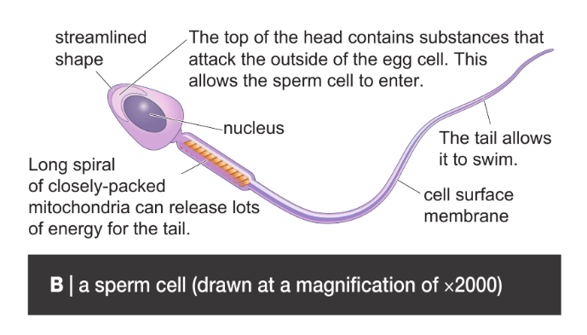

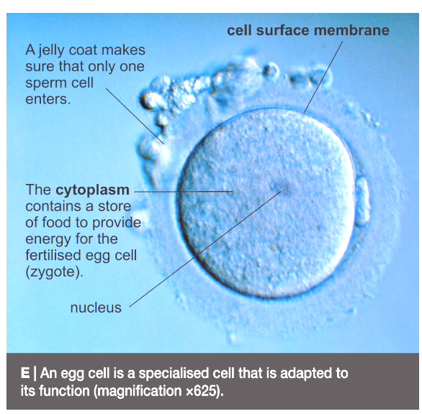

Notes:

- A sperm cell is much smaller than an egg cell.
- Men produce sperm cells for the rest of their lives. Women stop releasing egg cells at the age of 45–55 and this is called the menopause.
Questions: Workbook Pages (18 + 19 + 20)

7Bc Becoming pregnant:
Semen (sperm cells mixed with special liquids from the glands) is forced out of the penis and into the top of the vagina. This is called ejaculation. The semen travels into the top of the uterus and the sperm cells then swim down the oviducts.

Pregnancy in mammals

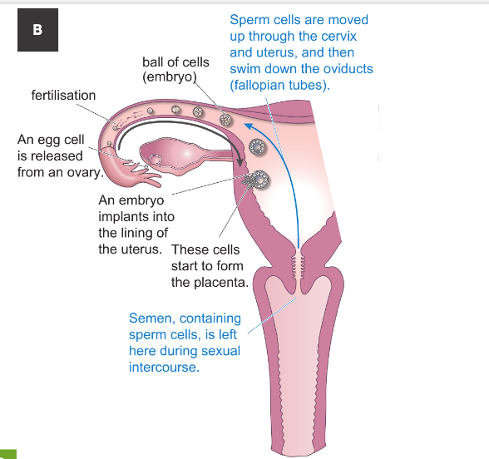
If an egg cell meets a sperm cell in an oviduct, fertilisation can occur (the nuclei from the two cells fuse). The fertilised egg cell divides to form a ball of cells (an embryo). The embryo travels to the uterus where it sinks into the uterus lining (implantation). After implantation, the embryo continues to grow and becomes surrounded by watery amniotic fluid, to protect it. The woman is now pregnant. Once the embryo has developed all its organs it is called a foetus (or fetus). It takes about 40 weeks (9 months) for a human fertilised egg cell to grow into a baby ready to be born. This time is called the gestation period (It is the time from fertilization until birth).

While inside the uterus, the foetus is supplied with oxygen and food by the placenta. The placenta also gets rid of waste (especially carbon dioxide) from the foetus. The umbilical cord connects the foetus to the placenta.
Substances in cigarette smoke, drugs and alcohol can damage the baby. The baby might be premature.
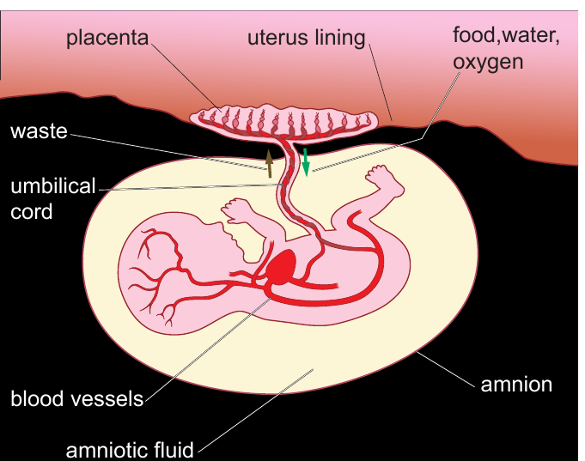

Questions: Workbook questions pages (21).
Birth in mammals
- The uterus starts contractions and the woman goes into labour.

- The muscles of the cervix relax.

- The baby is pushed out head first through the cervix and the vagina.

- The baby starts to breathe and the umbilical cord is cut. The scar left behind is the navel.

- Then the placenta is pushed out of the uterus. This is the afterbirth.

The mother’s breasts contain mammary glands that produce milk to feed the baby. Breast milk contains all the nutrients that a baby needs and antibodies, which help destroy micro-organisms that might cause diseases. After a few months the baby can start eating semi-solid food.

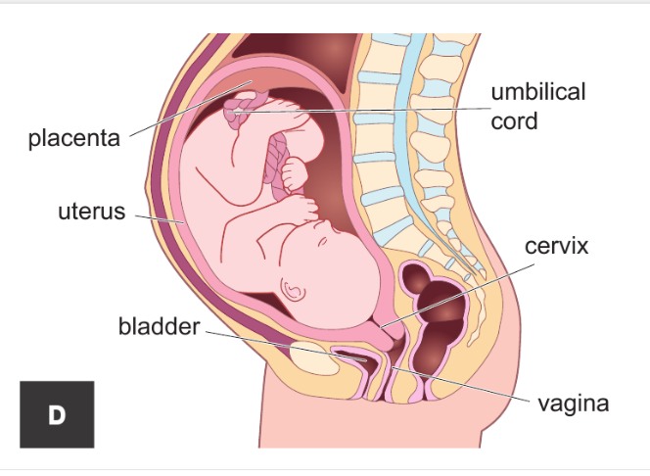

Question:
Number the stages of labour in the order in which they happen.
The first one has been done for you.
1
- The muscles in the uterus wall start to contract.
The uterus muscles contract strongly to push out the afterbirth ( placenta).

The uterus muscles contract very strongly and push the baby out through the vagina.

The cervix muscles relax, making the cervix wider.

Growing up:
The stages through which an organism goes as it grows and develops are its lifecycle. In the human lifecycle, a baby grows into a child. Between the ages of 10 and 14 years, most children start to go through puberty. During puberty, sex hormones cause big physical changes to occur. Adolescence is the time when emotional as well as physical changes occur. It ends at about 18.
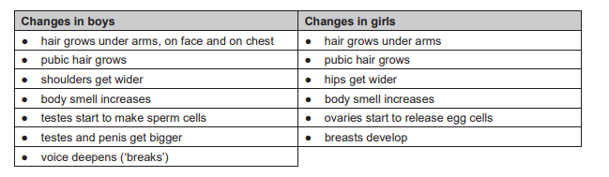

The Menstrual cycle
- It is a series of events that occur in the female reproductive system.

- It starts soon after puberty begins and stops at the menopause.

- The average menstrual cycle is 28 days long and there are four overall stages.
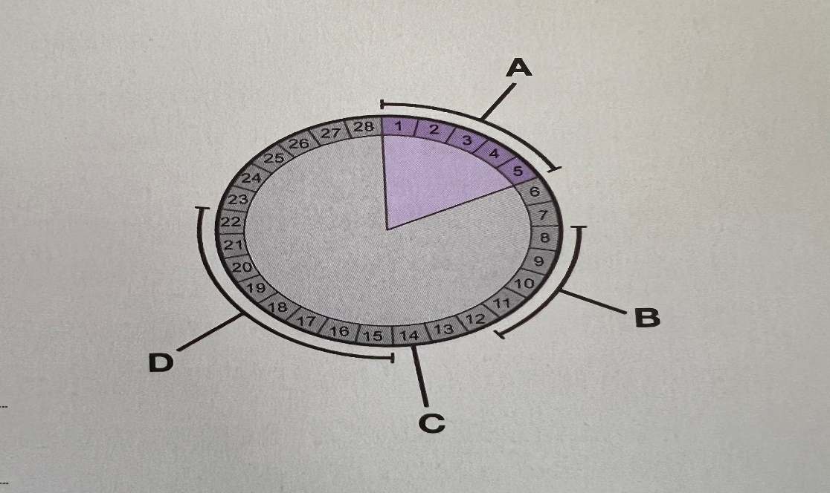

- Menstruation (period): the thick uterus lining breaks down and is lost with blood. It usually lasts for (1-5) days.

- Immediately after menstruation an egg cell starts to mature in one of the ovaries.
The lining of the uterus also starts to build up (6-12) days.

- Ovulation: an egg is released from one of the ovaries, (about day 14).

- The egg travels along the oviduct to the uterus, as the uterus lining continues to thicken (15-28) days.

If the egg is not fertilised during this cycle, then a new cycle begins and the uterus lining starts to break down again.

If the woman becomes pregnant, the cycle stops and the thick uterus lining continues to grow to provide the placenta with a good supply of nutrients and oxygen and protect the embryo.

Questions: Workbook questions pages 24+ 25.

