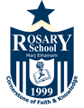

Rosary School – Marj Elhamam
7C Muscles and Bones
Study sheet
Name: _________________ |  | Date: / / 2025
Grade: 6 (A,B,C,D,E) |  | Science

7Ca Muscles and breathing:

The gas exchange or breathing system or respiratory system allows air to enter and leave the lungs, so that oxygen can get into the blood and carbon dioxide can leave the blood. Oxygen for respiration leaves the lungs and enters the blood. Carbon dioxide (a waste product from respiration) leaves the blood and enters the air in the lungs. Carbon dioxide is excreted when you exhale.

Breathing is the movement of the muscles in your diaphragm and between the ribs, which cause the changes in the volume of the lungs.

Ventilation is the movement of air into and out of the lungs as breathing occurs.
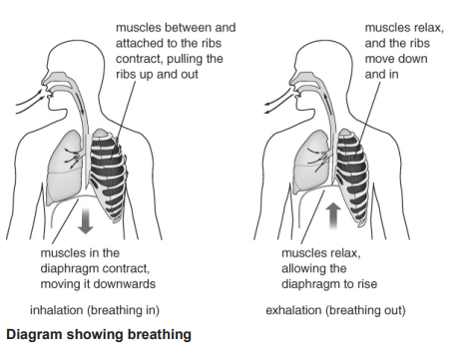
Respiration: A process in which energy is released from substances so it can be used by an organism and produces carbon dioxide.
Workbook page 28

7Cb Muscles and blood:
Circulation.
Your circulatory system is made up of three parts:
- The heart: is a muscular organ that pumps blood around the body

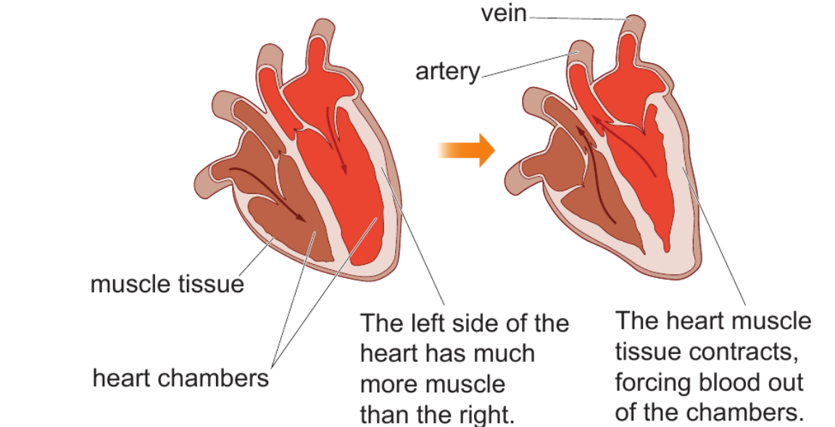

- Blood vessels: are the tubes through which blood flows. We have three main kinds of blood vessels in the body:
- Arteries: carry blood away from the heart. The walls are thick and strong to withstand the high pressure of the blood from the heart.
- Veins: carry blood back to the heart. They have very thin walls so that nutrients and oxygen can leave the blood and get to the cells in all the tissues in the body.
- Capillaries: carry blood close to every tissue in the body, where gas exchange takes place.

- Blood: is made up of different kinds of blood cells floating in a liquid called plasma.
- Plasma: transports dissolved substances such as glucose.
- Red blood cells: transport oxygen.
- White blood cells: defend us against bacteria and viruses.
- Platelets: help blood to clot.

Question: How are red blood cells adapted to their function?
_____________________________________________________________________________________________________________________________________________________________________________________________________________________________________________
Blood is carried to the heart by veins, where it enters the chambers of the heart. The blood is then forced back out when the heart muscle tissue contracts. The pumping of the heart can be felt in arteries as a pulse.

Arteries are connected to veins by capillaries, which are blood vessels with very thin walls that allow oxygen and nutrients to leave the blood to get to the cells in tissues. Carbon dioxide from the cells can easily get into the capillaries.
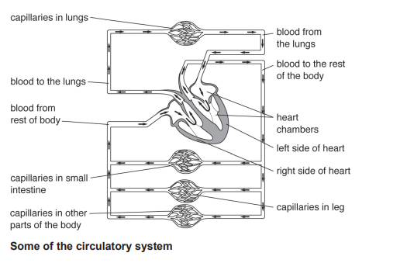
Workbook page 29& 30

7Cc The skeleton & 7Cd Muscles and moving:
Locomotor system
The locomotor system consists of bones and muscles and lets you move.
Bones are organs that form the skeleton, which:
1- protects some organs (e.g. the ribs and sternum protect the lungs; the skull protects the brain)
2- supports your body (e.g. the vertebrae in your ‘backbone’ hold you up straight)
3- allows you to move (using muscles at your joints).
4- making blood cells
Note: Bones are strong (to withstand knocks and pressure) and light (so they are easy to move). Many have a hollow centre containing bone marrow, where blood cells are made.
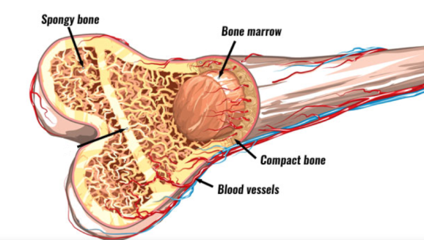
Question: Explain why a large bone can be both strong and light.
____________________________________________________________________________________________________________________________________________________
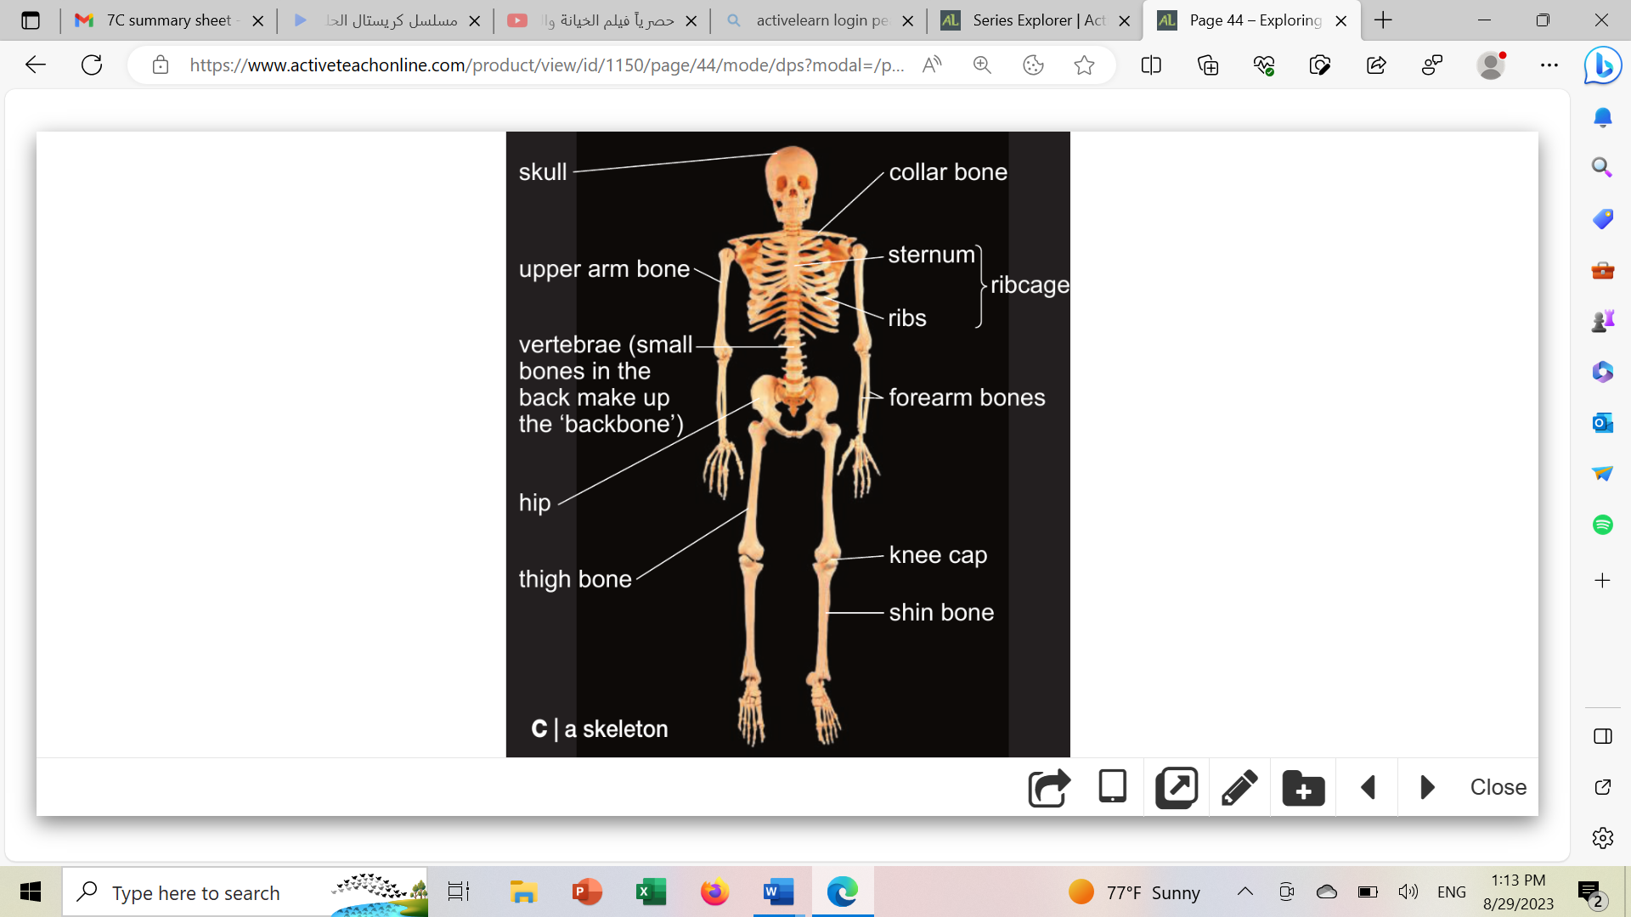
Types of joints:
- fixed joints: no movement between the bones.
Example: the bones in the skull meet at fixed joints.
- hinge joints: allows movement in one direction.
Example: the elbow joint.
- ball and socket joints: moves in many directions.
Example: the shoulder and hip joints.

7Cd Muscles and moving
The muscles and bones in your body form an organ system called the locomotor system.
It is this system that allows you to move all the parts of your body. The study of how muscles and bones work together is called biomechanics.

Muscle action
Muscles cannot push, it can only pull and so bones need pairs of muscles (antagonistic pairs) to pull them in opposite directions. One muscle contracts (gets shorter and fatter) to pull a bone. At the same time, the other muscle in the pair relaxes.
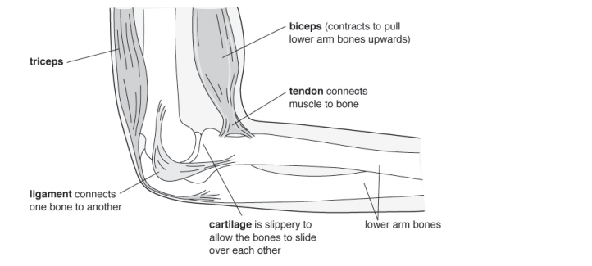

The biceps and triceps are an antagonistic pair of muscles
Workbook page 32,33,34 &35

7Ce Drugs:
Drugs are chemicals that affect how the body works. Some can damage your organs (e.g. the liver), particularly if they are abused. Some drugs are addictive.
Although may drugs are useful, they can have harmful or unpleasant side-effect. For example, paracetamol can damage the liver.
Types of drugs:
- Medicines are drugs that can help people who are suffering from diseases.
- Some medicines are used to treat diseases (e.g. antibiotics)
- Some medicines are used to reduce symptoms (e.g. paracetamol and Ibuprofen)

- Recreational drugs are drugs that people take because they like the effect that they have on their bodies (e.g. caffeine in coffee).

Some are illegal drugs (e.g. heroin, ecstasy) and have very harmful side-effects.
- Drugs that slow down the speed at which impulses pass through the nervous system are called depressants. Alcohol, heroin and the solvents found in glues are depressants.
Depressants cause the nervous system to carry impulses more slowly.

- Drugs that speed up the nervous system are called stimulants (e.g. caffeine).
Stimulants cause the nervous system to carry impulses faster.
Workbook page 37

