

Rosary School – Marj Elhamam
Study sheet
Name: _________________ |  | Date: / / 2024
Grade: 6 (A,B,C,D,E)
7D Ecosystems
7Da Variation
The place where an organism lives is called a habitat.
A species is a group of organisms that can reproduce with one another to produce offspring that will also be able to reproduce.
Usually members of two different species cannot reproduce but in rare cases it can happen. The offspring are called hybrids but they cannot reproduce.
What is variation?
The differences between organisms are known as variation.
There is often a lot of variation between different species and between members of the same species.
Continuous and discontinuous
1- Variation that has a continual range of values is continuous variation and it means that your measurements can have any value within limits)
(E.g. height) as humans vary in height. If you measure the heights of people in your class, you will find that very few people are exactly the same height.
2) Variation that only has certain values is discontinuous variation.
• 1- blue, brown or green eyes.
2- some people can roll their tongues and others cannot.
3- Blood groups are discontinuous. (A, B, AB or O)
Questions: 1- Q6 on page 55 in the main book.
2- page 40 in the workbook.
7Db Adaptation:
The conditions in a habitat are its environment. The conditions are, mainly caused by physical environmental factors, such as the amount of light, how wet it is, how windy it is and the temperature. The factors are described as ‘physical’ or abiotic because they are not alive.
- Organisms have adaptations that allow them to survive in a habitat. We say that organisms are adapted for their habitats.
• Fish have gills and fins, which are adaptations for living in water.
They have gills to take oxygen out of the water, fins to swim with and streamlined bodies to help them move easily through the water.

- Note: Carnivores: meat eaters, herbivores :plant eaters, omnivores: plant and meat eaters
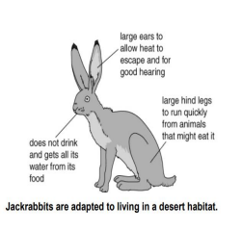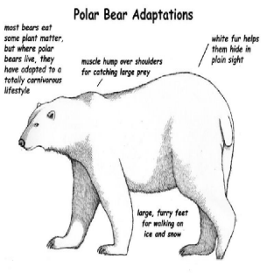
Thick fur: to keep warm, white: to hide

Question: Fill the diagram with the suitable adaptations. (Page 58 in the main book)
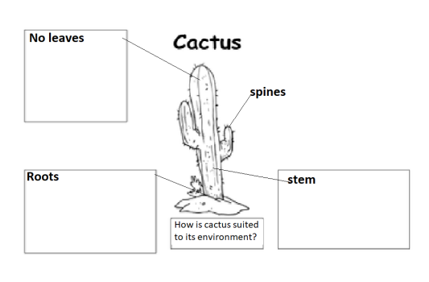The community of organisms and all the physical environmental factors in a habitat form an ecosystem.
Environmental variation is variation caused by the environment.
In humans, sunburn and having a scar, hairstyles (fashion) are examples of environmental variation. Plants are affected by environmental factors such as:
1- the amount of light. 2- water.
3- warmth. 4- mineral salts in the soil. 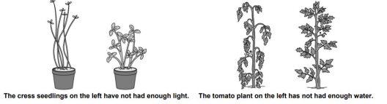
Inherited variation is caused by features being passed from parents to their offspring during reproduction. In humans, natural eye colour and natural hair colour are both examples of inherited variation.
Questions: page 43 in the workbook
7Dc Effects of the environment:
-Changes during a day are known as daily changes, and changes during a year are seasonal changes.
-Organisms are adapted to these changes.
Examples:
• Nocturnal animals such as mice and owls are only active at night, that’s why they have excellent eyesight, superb hearing and fly silently. (daily changes)
• Rabbits grow longer fur to help them keep warm in colder months. (seasonal changes) • Some animals become inactive when it is cold in winter so that they do not need food when there is less food available. This is hibernation. (seasonal changes) • Many birds fly to warmer places in winter to find food. This is migration.
(seasonal changes)
• In winter, deciduous trees lose their leaves because there is not much light for photosynthesis and their leaves lose water which cannot be replaced when the ground is frozen But evergreen trees have leaves that don’t lose much water, so they keep their leaves all year round. (seasonal changes)
Question: page 44(Q1+Q2) in the workbook
7Dd Effects on the environment:
*How do organisms affect their habitats?
To survive and grow, organisms need resources from a habitat.
- Animals need resources such as oxygen, space, shelter, food, water and mates. - Plants need light, air, water, warmth, mineral salts and space.
If any of these are missing, the numbers of an organism (its population) will go down.
Food chains and webs.
- Food chains show what eats what in a habitat.
- Organisms compete with one another for resources.
-There is competition between organisms of the same species→ intra-specific competition Competition between different species → inter-specific competition
-The organisms with the best adaptations to get the resources are more likely to survive and reproduce. The others may move away or die.
*Example of food chain:
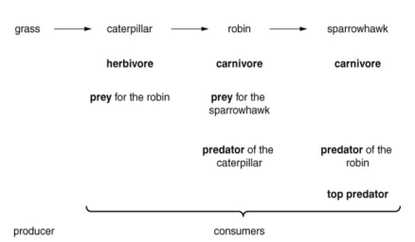
- Food chains are joined together to form food webs.
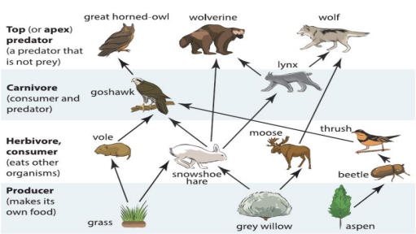Food web
_ The food web shows how different animals compete for the same food. _In the food web above, you can see that goshawks compete with lynxes for hares.
If the goshawks get a disease and die, there will be more hares. The population of lynxes may then increase.
- The organisms in an ecosystem all depend on one another for many things, not just food. We say that they are interdependent. For example, many birds use trees for shelter and plants use animals waste to help them grow (the waste contains mineral salts).
- Populations change depending on how much food is available. The lynx is a predator. Its main prey is the snowshoe hare.
-When there are a lot of hares, the lynxes have lots to eat. They reproduce successfully and their population goes up.
-When there are fewer hares, the lynx population decreases
- The size of a population is affected by several factors:
1) Competition for resources may cause populations of some organisms to decrease.
2) Disease can kill organisms.
3) Poisons may kill organisms that they are not intended for. Some pesticides are persistent and can build up in the animals as you go along a food chain, harming the top predators.
Questions: page 45+page 46 (Q3) in the workbook
7De Transfers in food chains:
Organisms contain energy stored in the substances that make up their bodies.
The arrows in food chains and webs show how this energy passes from organism to organism. Normally there are fewer organisms as you go along a food chain because energy is lost at each stage.
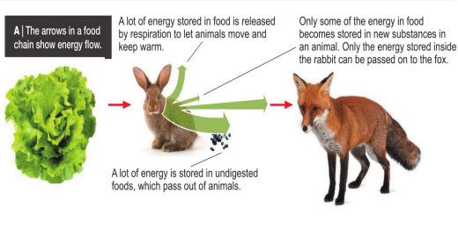
Pyramids of numbers: Energy losses at each stage of the food chain mean that hundreds of lettuce plants feed a much smaller number of rabbits. These rabbits feed an even smaller number of foxes. (what does this phyramid show?)
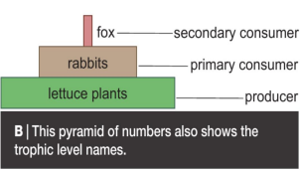
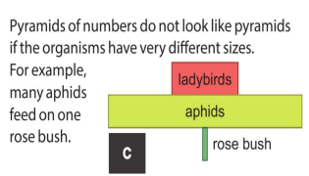
Questions: page 48 in the workbook

