

Rosary School – Marj Elhamam
7F – Study sheet

Name: _________________ |  | Date: ____ /____ / 2025
Grade: 6( A,B,C,D,E ) |  | Subject : Science
7F Acids and alkalis
● A hazard is something that can cause harm.
● Chemicals are labelled with hazard symbols to warn people of potential dangers.
-Acids and alkalis are common substances found in homes and laboratories.
● Most concentrated acids and alkalis are corrosive.
They can be corrosive, so great care must be taken when handling corrosive as they can destroy living tissue and cause permanent damage.
-Acids and alkalis are often diluted with water to make them less dangerous.
Although diluted acids and alkalis are not corrosive but it can be irritants. These solutions are unlikely to cause serious injury but can cause skin inflammation and soreness.

7Fa Hazards

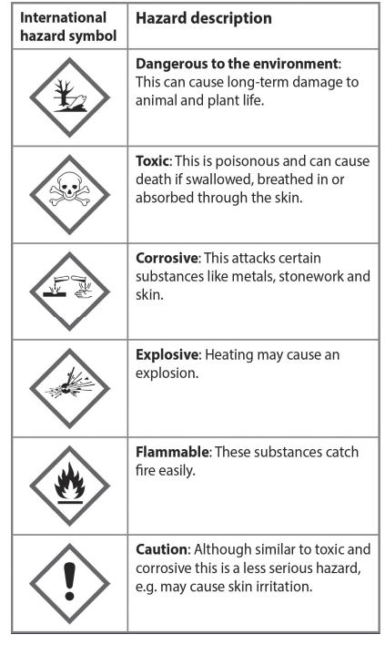

- The vinegar we use on our food contains about 5-8 percent ethanoic acid in water. It is not a hazard but stings if you get it in a cut. Above 10 per cent, ethanoic acid is an irritant and above 25 per cent it is corrosive.
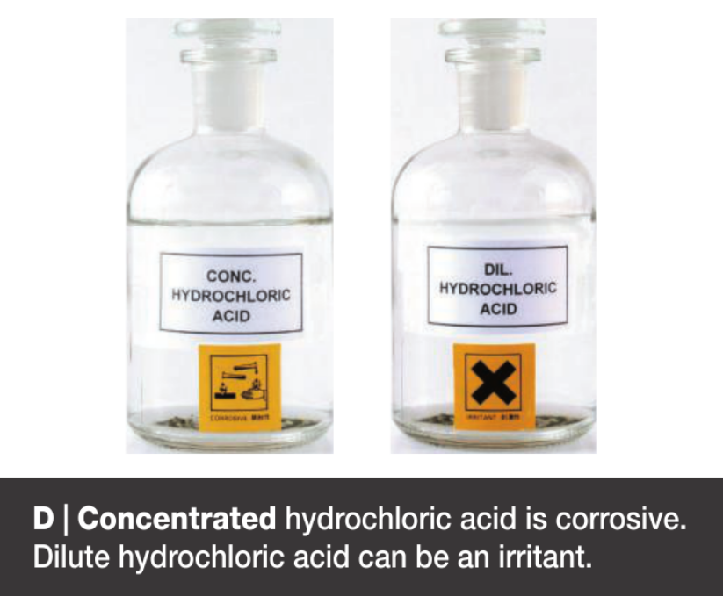
Questions:
- Name an acid found in:
- Fizzy drinks: _____________________________
- Sour tasting- fruits: ________________________
- Which international hazard symbols will be displayed on the following household chemicals:
- Turpentine-damages pond life, causes headaches and sickness, can catch fire if heated.
__________________________________________________________________________________________________________________________________________
- Soap powder- causes irritation to the skin?
__________________________________________________________________________________________________________________________________________
Workbook page 64

7Fb Indicators:
- Indicators change colour when mixed with different types of substance and can be used to detect acids, alkalis and neutral solutions.
- Some plants can be used as indicators, for example,red cabbage. If you mix soap with the red cabbage juice, it changes colour and goes greenish yellow. If you add fizzy lemonade, it changes again and goes red.
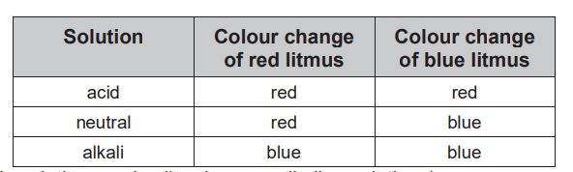
- Most acids, like vinegar and fruit juices, turn litmus red.
- Oven cleaners often contain alkalis.
- Many solutions are neither acidic nor alkaline include pure water, salt and sugar solutions. These are neutral. Neutral solutions do not change the colour of indicator.
However, being neutral does not mean that a substance is safe. Some neutral solutions are toxic, and some are corrosive.
- Other indicators include phenolphthalein (which is colourless in more acidic solutions and pink in more alkaline solutions) and methyl orange (which is red in more acidic solutions and yellow in more alkaline solutions).
Questions:
- What colour is car battery acid mixed with:
- Red cabbage juice:________________ b- litmus:_____________________ ?
- A few drops of litmus solution are added to some toothpaste. The litmus turns blue. What does this tell you about the toothpaste?
_______________________________________________________________________
- State whether these substances are acidic, alkaline or neutral.
- vinegar: ____________ b- water:_______________
c- salt solution:_____________ d-lemon juice: ___________
e- sugar solution: ____________ f- soap:________________
- Which substance(s) in question 3 will turn phenolphthalein pink?
_______________________________________________________________________

Workbook pages 67 and 68.

7Fc Acidity and Alkalinity:
● Universal indicator changes to different colours depending on the pH.
● Acids have a sour taste.
● Many alkalis are metal hydroxide solutions.
● An alkali can be described as a soluble base. A base is any substance, soluble or insoluble, that neutralises an acid forming a salt and water only.
pH scale
● A numbered scale from 1 to 14.
● Acids have a pH less than 7. The lower the pH, the more acidic the substance is.
● Neutral solutions have a pH of 7.
● Alkalis have a pH more than 7. The higher the pH, the more alkaline the substance is.
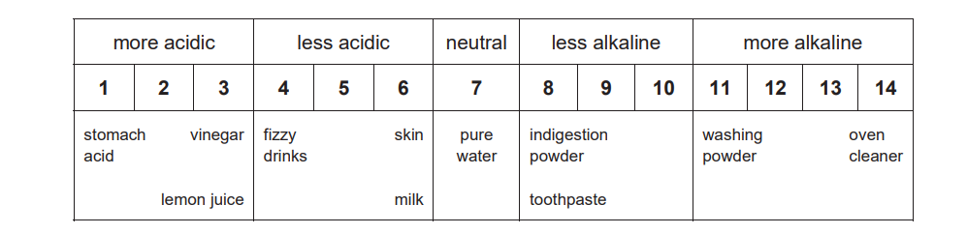
Note: Back to Diagram B, page 92 in your course book.
Questions:
- a-What is the pH of a substance that turns universal indicator orange? _____________
- Would it be an acid or an alkali? __________________________________________
- Would the substance be very acidic or alkaline or not very acidic or alkaline?
____________________________________________________________________
- Complete the table:
Name of chemical | Colour of universal indicator | Acidic, alkaline or neutral | pH
hydrochloric acid |  | very acidic
 |  |  | 7
sodium hydroxide | purple
carbon dioxide solution |  | not very acidic

- If you added some washing powder to sea water, would the pH go up, down or stay the same? Explain your answer.
________________________________________________________________________________________________________________________________________________
- Describe one way in which the man in photo E is reducing the risk of harm. Mention one hazard in your answer.
________________________________________________________________________________________________________________________________________________________________________________________________________________________
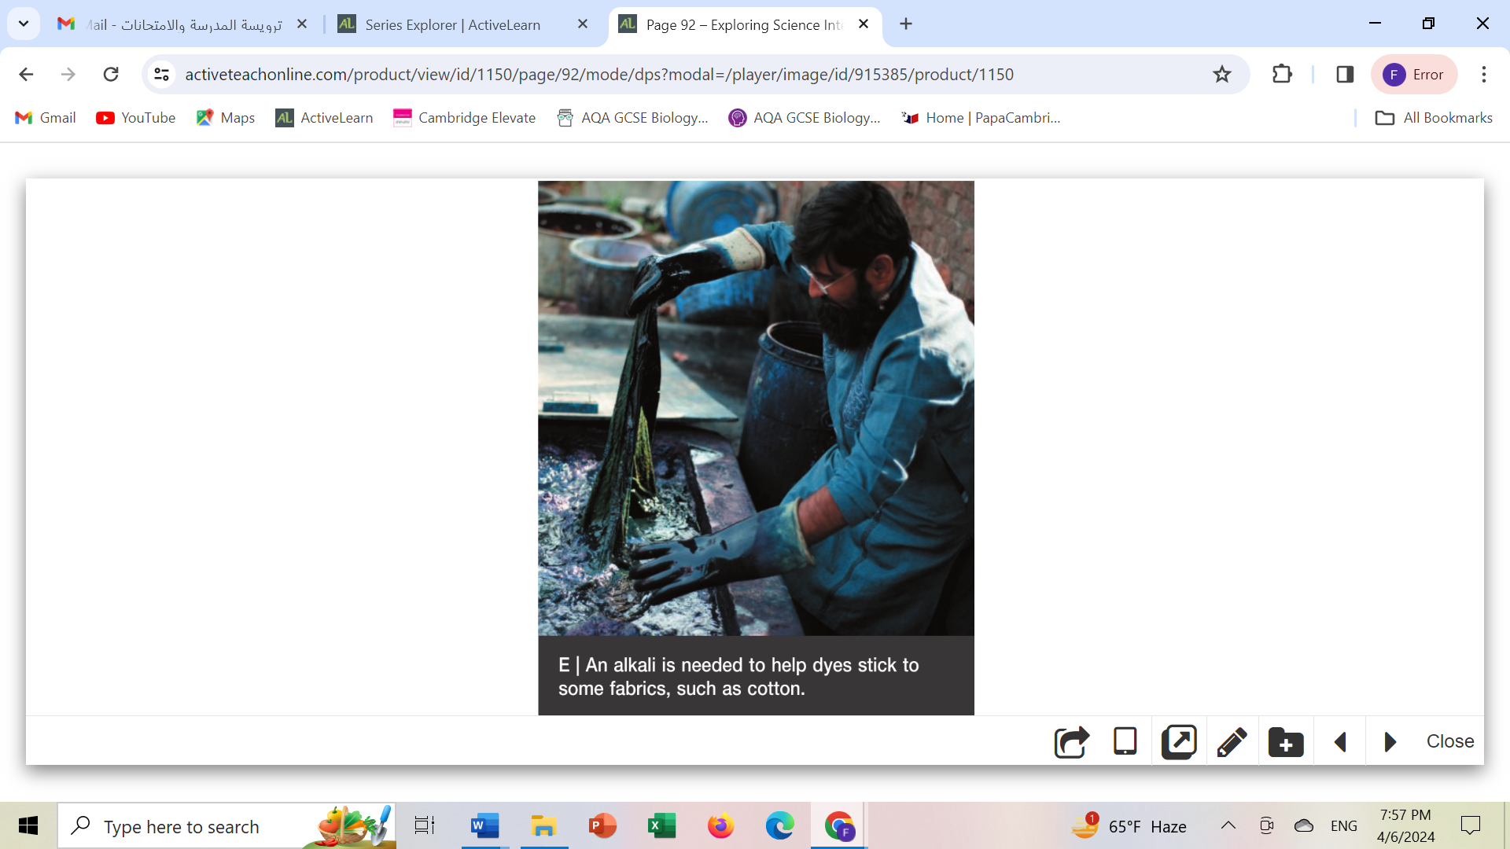

** Workbook page 69 and 70
7Fd Neutralization:
● This is a reaction between an acid and an alkali (or base).
acid + alkali → salt + water
acid + base → salt + water
This summarises a reaction.
● Reactants are the substances you start with and are written on the left side.
● Products are the new substances that are made and are written on the right side
● There is an arrow pointing to the products. The arrow means ‘react to form’.

Salts
● Salts names are made of two words:
- The first part of the name of the salt is the same as the metal in the alkali or base.
- The second part of the name of the salt comes from the acid.
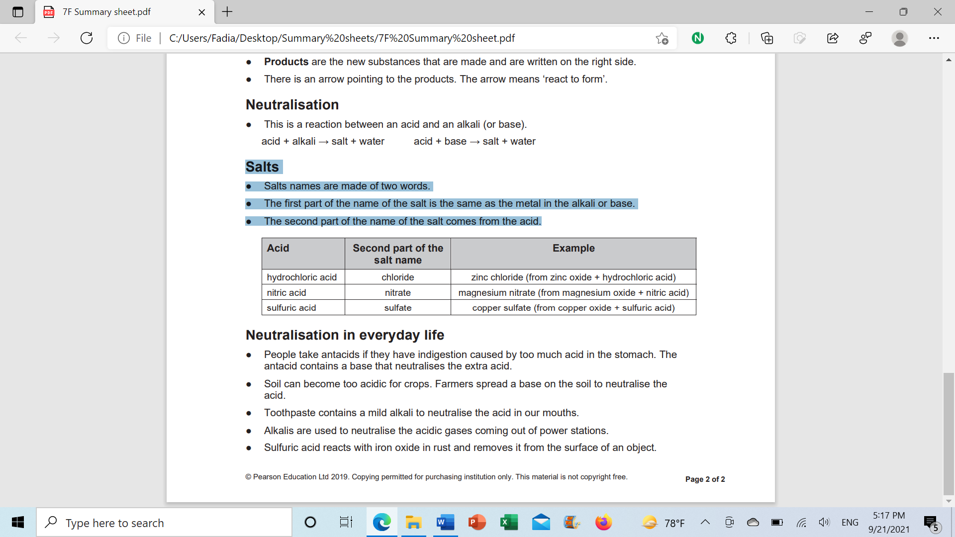
Questions:
1- Complete the equations:
- hydrochloric acid + sodium hydroxide 🡪 ______________ + ___________.
- lithium hydroxide + sulfuric acid 🡪 ____________+ water.
- ____________ + _______________ 🡪 sodium nitrate + water.
- lithium hydroxide + hydrochloric acid 🡪 ____________+___________.
- _______________+ sulfuric acid 🡪 sodium sulfate+ ___________.

2-a-Which pH values indicate an acidic soil? _____________________
- Which pH values indicate an alkaline soil?___________________

3-
Which plants grow well in a neutral soil?________________________
Which crop is least likely to need lime in the soil?________________
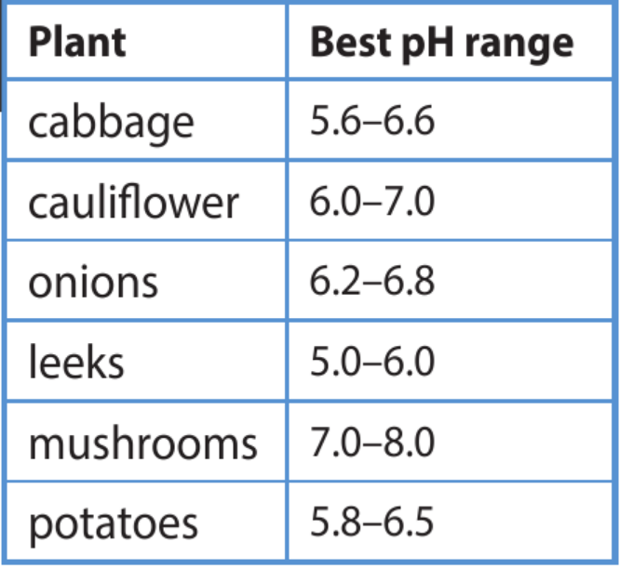
** Note: If a soil is too acidic then farmers can add an alkali called lime to their fields. The alkali cancels out the acids, making the soil more neutral.
4-a-What pH is neutral?_______________________________________________
b-How can you tell when just enough alkali has been added for neutralisation?
__________________________________________________________________________________________________________________________________________________________
5-From the word equation for the reaction between hydrochloric acid and sodium hydroxide, select substances that are:
a-alkaline:________________ b-acidic:________________ c-neutral:________________
d-reactants:________________________ e-products:_____________________________

6- Complete these word equations:
a-lithium hydroxide + hydrochloric acid 🡪 __________________+__________________
b-_______________+ sulfuric acid 🡪 sodium sulfate +___________________

7-Which acid and alkali would react to produce ammonium sulfate?
_______________________________________________________________________
8-Suggest how you could make spilled concentrated acid safe to be mopped up.
_______________________________________________________________________

Workbook page 71

7Fe Neutralisation in everyday life
● People take antacids if they have indigestion caused by too much acid in the stomach.
The antacid contains a base such as magnesium hydroxide that neutralises the extra acid.
Indigestion treatments are not very alkaline (usually about pH of 9) so that they do not lessen the acidity in your stomach too much as stomach acid helps to break down food.
magnesium hydroxide + hydrochloric acid 🡪 magnesium chloride + water
● Toothpaste contains a mild alkali to neutralise the acid in our mouths because the food we eat causes acid to be produced in our mouth.
● Alkalis are used to neutralise the acidic gases coming out of power stations.
● Sulfuric acid reacts with iron oxide in rust and removes it from the surface of an object.
sulfuric acid + iron oxide 🡪 iron sulfate +water.
●Acidic waste gases from some industries are neutralised by sprays of calcium hydroxide before they are released into the atmosphere. This reduces the possibility of creating harmful acid rain.
Questions:
- What do you call the reaction between magnesium hydroxide and hydrochloric acid?
_______________________________________________________________________
- Why is it not a good idea to use sodium hydroxide, with a pH of 13, to neutralise excess stomach acid? ___________________________________________________________
_______________________________________________________________________
- Explain why toothpaste might contain magnesium hydroxide.
________________________________________________________________________________________________________________________________________________
- Some toothpastes contain aluminium hydroxide. Write a word equation for this base reacting with hydrochloric acid.
________________________________________________________________________

- An old treatment for wasp strings was ‘to neutralise the venom with vinegar’. Wasp venom has a pH of 6.8-6.9. Explain why this remedy will not neutralise wasp venom.
________________________________________________________________________________________________________________________________________________
- Write a word equation for the reaction between calcium hydroxide and the acid gas released by power stations.
________________________________________________________________________

Workbook page 73

